L

The Duke of Cornwall Spinal Treatment Centre

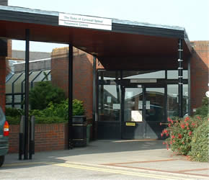

Community Liaison
A guide for Healthcare Professionals
Who Are Community Liaison?
- Two Senior Nurses experienced in Spinal Cord Injury (SCI).
- Part of a multi-disciplinary Outpatient Team based at the Spinal Centre, Salisbury.
What do they offer?
- Advisory service: telephone, email. (Consent must be given for email communication containing patient details).
- Advice and support about all aspects of life with a SCI to patients and to those involved in their care.
- Domiciliary home visits, hospital and nursing home visits. (Each case will be individually assessed to determine if a home visit is appropriate. It may be possible to deal with any issues via the telephone or by email).
- Liaise with the Community Nurses/Healthcare providers, carers, family and the patient via telephone, email or in person, to assist in the ongoing planning of care and treatment.
- Support patients who are admitted to their local hospital. We can advise them and the Healthcare professionals via telephone and email and visit if possible.
- Advice about the holistic management of complex Tissue Viability issues (particularly Pressure Ulcers).
- Information can be provided about various aspects of living with a SCI. Much of this can be found on the Spinal Centre website.
- Community Study Days for District Nurses, Continence Advisers, Carers and other Healthcare Professionals on aspects of SCI at Salisbury District Hospital. Information is available on the website.
- Pressure mapping of wheelchair seating following a healed pressure ulcer. (This service may be available through the local Wheelchair Services).
What we are unable to offer
- We are unable to provide an emergency service. Our visits are planned in advance. We can advise over the telephone prior to an agreed visit.
- Urgent advice can be sought out of office hours by contacting the hospital switchboard on 01722 336262 and asking for either Avon or Tamar Spinal wards. Staff there will be able to direct any urgent queries accordingly.
Contact Community Liaison on 01722 429130
damian.smith@salisbury.nhs.uk
rachel.stowell@salisbury.nhs.uk

http://www.salisbury.nhs.uk/InformationForPatients/Departments/SpinalTreatment_Centre/Pages/indexPage.aspx
June 2016 due for review June 2019

