Appendix 1

Travel Survey Results
(November 2018, 978 Respondents)

Q1 What ward or department do you work in?

Acute Medical & Surgical Therapy Team | 2
Acute Pain Team | 1
Admin | 4
AMESBURY | 2
AMU | 3
Anaesthesia | 9
ArtCare, Facilities | 1
Audiology | 9
Avon | 2
Bank | 9
bereavement | 5
Bowel Cancer | 1
Bowel Screening | 1
Breamore | 2
Breast | 3
Britford | 3
CANCER MDT OFFICE | 1
Cancer Services | 3
CARDIAC REHAB | 1
Cardiac Investigation Unit | 4
cardiac Suite | 5
Cardiology | 11
Catering | 3
central booking | 12
chaplaincy | 4
Chief Executive Directorate | 1
Child Health | 2
Children’s outpatients | 3
children's reception | 2
Children's Therapy | 1
Children’s Unit | 12
Chilmark | 2
CIU | 5
Cleft | 7
Clinical | 1
Clinical Audit | 3
Clinical Coding | 5
Clinical Psychology | 1
Clinical Radiology | 1
Clinical Science & Engineering | 6
Clinical Support & Family Services | 3
Colorectal | 3
Community palliative care | 1
Corporate Development | 2
Critical care outreach team | 1
CSFS | 1
Customer Care | 2
dermatology | 8
Diabetes | 7
Dietetics | 5
Discharge Team | 3
Downton | 1
DSU | 8
Durrington | 1
ED | 9
education | 1
elderly care | 2
Endoscopy | 6
ENT | 2
EROSTER | 3
ESD - Orthopaedic Therapy | 1
estates | 6
Eye clinic | 6
Facilities | 11
Family Services | 1
Farley | 4
Fertility | 3
Gastroenterology | 5
General Surgery | 4
Genetics | 46
Gynae | 3
Haematology | 3
Head Office | 1
Histology | 1
HISTOPATHOLOGY | 5
Hospice | 14
Housekeeping | 3
HR | 5
Infection Control | 2
Informatics | 36
inpatients | 1
IT | 17
Laboratory Medicine | 16
Laser | 1
laundry | 2
Library | 3
Main Theatres | 9
Management | 1
Maternity | 27
maxillofacial | 1
MDT | 1
Med / Surg Outpatients dept. | 4
Medical Devices Management Services | 8
Medical directorate | 1
Medical Engineering | 1
Medical Photography | 1
Medical Records | 13
Medical Secretariat | 2
medicine | 13
mental health | 1
Mental Health Liaison | 2
Microbiology | 13
MSK | 13
Neurology | 2
nicu | 2
Not prepared to state | 1
Nunton | 3
Nurse Bank | 3
Obstetrics & Gynaecology | 3
Occupational Health | 6
Occupational therapy | 1
OD & People | 8
Odstock | 4
OMFS | 1
Oncology | 9
Operations Directorate | 1
Ophthalmology | 12
oral surgery | 3
ortho therapy | 1
Orthopaedics | 12
Orthotics | 1
outpatients | 4
PACS | 2
Paediatric Diabetes | 1
Paediatrics | 2
palliative care | 2
Pathology | 17
Payroll | 6
Pembroke | 2
Pharmacy | 22
Physiotherapy OPD | 1
PITTON | 1
plastic outpatients | 1
Plastic Surgery | 5
Plastics | 5
PMO | 7
POAU | 2
porting | 1
Post Room | 1
Pre Op Assessment Unit | 7
Private Patient Office | 2
Procurement | 13
Psychology | 1
Quality | 17
Radiology | 39
Radnor | 10
reception rheumatology and vascular | 1
Recruitment | 1
Redlynch | 1
Research | 12
Respiratory | 6
rheumatology | 12
risk | 1
safeguarding | 1
Sal Main Theatres | 3
Sarum | 8
Screening | 1
Sexual Health | 8
Social Care | 1
Speech Therapy | 8
Spinal | 22
spire | 1
staff club | 1
Stars Appeal | 1
Stoma care | 2
stroke and elderly care | 3
surgery | 12
t&o | 1
Tamar ward | 1
Telecommunications | 1
The Trust | 1
Theatre | 8
Therapy | 5
Tisbury | 1
Tissue Viability and Odstock ward | 2
Trauma & Orthopaedic | 3
Trust HQ | 5
Urology | 4
Vascular | 13
Wessex Rehab | 3
WHITEPARISH WARD | 1
WON Physiotherapy | 1
Wrc | 1
Xray | 1

Q2 How old are you?

Answer Choices | Responses
18-24 | 3.17% | 31
25-34 | 15.46% | 151
35-44 | 20.57% | 201
45-54 | 27.74% | 271
55-64 | 27.12% | 265
65-74 | 4.50% | 44
75 or older | 0.72% | 7
Prefer not to say | 0.72% | 7

Q3 What is your gender?

What is your gender?
Answer Choices | Responses
Male | 20.27% | 198
Female | 78.20% | 764
Other | 0.20% | 2
Prefer not to say | 1.33% | 13

Q4 Do you have a disability which affects your travel arrangements?

Do you have a disability which affects your travel arrangements?
Answer Choices | Responses
No | 96.83% | 946
Yes (please state your type of disability e.g., visual, mobility) | 3.17% | 31

Spinal | 1
osteoarthritis | 1
I am not Disabled, but my Husband is and so this effects the way that I have to travel to work, so that I can get home quickly if I need to | 1
Epilepsy | 1
Arthritis & Crohn's disease | 1
Mobility | 10
visual | 2
Functional | 1
I have osteo Arthritis | 2
asthma | 2
Diabetes | 2
sensory impairment | 1
I have ulcerative colitis & so preferable to travel by car | 1
spinal stenosis/sciatica | 1
unstable pelvis | 1
Heart Rhythm Issues | 1
Fibromyalgia | 2

Q5 Please select your normal working arrangements.

Please select your normal working arrangements.
Answer Choices | Responses
Normal working day e.g. 8-4, 9-5, 10-6 | 68.37% | 668
Day shifts e.g. mornings / afternoons | 5.02% | 49
Out of hours e.g. night shifts | 0.72% | 7
Bank or temporary shifts | 3.28% | 32
24 hour shift rotation | 5.22% | 51
Other (please specify) | 17.40% | 170

“Other” responses

Q6 What time do you normally ARRIVE and LEAVE work?

Q7 How far do you travel to work?

How far do you travel to work?
Answer Choices | Responses
Less than 1 mile | 3.99% | 39
Over 1 mile, less than 2 miles | 9.52% | 93
Over 2 miles, less than 5 miles | 27.33% | 267
Over 5 miles, less than 10 miles | 20.27% | 198
Over 10 miles, less than 20 miles | 21.29% | 208
Over 20 miles | 17.60% | 172

Q8 How long does it take to get to work?

How long does it usually take you to get to work, using your normal mode of travel?
Answer Choices | Responses
Less than 15 minutes | 13.20% | 129
16-30 minutes | 48.82% | 477
31-60 minutes | 32.96% | 322
61-90 minutes | 4.81% | 47
Longer than 90 minutes | 0.20% | 2

Q9 Please enter the first part of your home postcode (this question requires analysis)

Q10 Which modes of transport do you use for your journeys to work?

Which modes of transport do you use for your journeys to work? Please select all that apply.
 | NORMALLY |  | OCCASIONALLY |  | Total
Train | 18.18% | 4 | 81.82% | 18 | 22
Bus | 51.40% | 92 | 49.16% | 88 | 179
Taxi | 6.25% | 1 | 93.75% | 15 | 16
Car - drive alone | 89.61% | 664 | 10.80% | 80 | 741
Car - drive with passenger(s) | 51.43% | 90 | 50.29% | 88 | 175
Car passenger | 33.61% | 41 | 67.21% | 82 | 122
Motorcycle/scooter | 60.00% | 9 | 46.67% | 7 | 15
Cycle | 53.77% | 57 | 46.23% | 49 | 106
Electric bike | 33.33% | 2 | 66.67% | 4 | 6
Walk | 47.31% | 79 | 53.29% | 89 | 167
Other (please specify) |  |  |  |  | 26

Q10 “Other” responses
I drive my son to school at the same time as coming to work
Share a lift
very occasionally use the car
have school run first so drive Salisbury to Amesbury to the hospital and vice versa
RUN
I drive first with my children to drop off at school and then alone
Occasionally get a lift in to work
Drop child at nursery
I drive 2 days and cycle 2 days
Drop child at nursery first
Running
run
run
Parent drives me in
run
Run
Run
car down the road and walk or walk in British summer time
bus stop 1 mile away, irregular buses
walk with snow
I always catch 2 buses to get home after work
Run
USE THE PARK AND RIDE AND THEN WALK UP TO HOSPITAL
passengers are children who I drive on the school run or to play scheme
My husband usually drops me off
Walking is sometimes car share to Bishopdown with wife and then walk from there, 2-3 times/week.

Q11 Where do you park most often? (This question requires analysis)

Q12 How do you pay to park?

How do you pay to park?
Answer Choices | Responses
Monthly from salary | 63.47% | 549
Monthly standing order | 3.82% | 33
Daily scratch card | 24.74% | 214
Other (please specify) | 7.98% | 69

Other (please specify)
bike
no charge for motorcycle
scratch card occasionally
Bus fare using Reds Key Cards for trips
scratch cards if required
Key card from Salisbury Reds.(pre-paid Trips)
Cycle parking is free :)
There is no parking fees for motorbikes
Scratch card when car used
N/A - am passenger with work colleague
use cycle
Volunteer - Free Parking
it is free. but I do have scratch cars i use if i have to park in the staff car park
Motorcycles are free parking
Community permit
Park for free
pre-paid
Community on call
Volunteer - have free permit
Scratch card (summer) monthly from salary (winter)
paid initially a 6 month instalment
free
free parking
Unable to deduct form salary since salary is paid by AWP although I am here full time
No cost at Gp s
It's free
FREE
Q13 Would you share a lift to or from work with another employee?

Would you share a lift to or from work with another employee?
Answer Choices | Responses
Yes as the driver | 24.71% | 216
Yes as the passenger | 15.33% | 134
No | 59.95% | 524

Q14 Are you aware that you can join the Trust’s lift sharing scheme?

Are you aware that you can join the Trust's lift sharing scheme?
Answer Choices | Responses
Yes | 68.65% | 613
No | 31.35% | 280

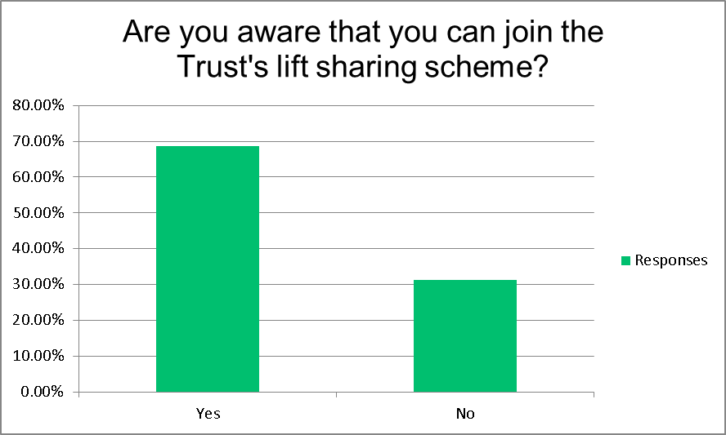

Q15 How do you normally get to/from the station to the hospital?

How do you normally get to / from the station to the hospital?
Answer Choices | Responses
Walk | 14.53% | 25
Cycle | 2.33% | 4
Motorcycle/scooter | 0.58% | 1
Bus | 31.40% | 54
Car share | 2.33% | 4
Taxi | 5.81% | 10
Other (please specify) | 43.02% | 74

Other (please specify)
Walk from home into centre of Salisbury and catch a bus
Running
if i needed to use public transport
run
Car and Car share privately
Walk to bus stop in town and get bus to hospital site

Q16 We would like to understand any personal factors that affect your choice of travel to work. Please tick any of the following statements that apply to you.

We would like to understand any personal factors that affect your choice of travel to work. Please tick any of the following statements that apply to you.
Answer Choices | Responses
I don’t own / have access to a bike I could use | 20.08% | 147
I’m not sure how to find safer cycling routes that avoid heavy traffic | 15.44% | 113
My bike is in need of repair before I could use it | 3.28% | 24
I’m unsure of how to find someone to car share with | 10.52% | 77
I have to drop off / pick up children at school | 22.13% | 162
I don’t know how to find out about bus routes and services that I could use | 0.27% | 2
Other (please specify) | 58.47% | 428

Q16 “Other” responses

Q17 What do you think would most encourage you to cycle / motorcycle / scooter / walk to work? Please tick all that apply.

What do you think would most encourage you to cycle / motorcycle / scooter / walk to work? Please tick all that apply.
Answer Choices | Responses
Access to showers and changing facilities | 21.30% | 177
Information about cycle friendly cycle routes | 14.92% | 124
Access to storage lockers | 15.28% | 127
More dedicated motorcycle / scooter parking | 6.02% | 50
Nothing as I already cycle / motorcycle / scooter / walk | 9.27% | 77
Nothing would make me consider cycle / motorcycle / scooter / walk | 49.34% | 410
Other (please specify) | 26.71% | 222

Q17 “Other” responses

Q18 Electric bicycles can be used comfortably for journeys up to 10 miles and make it easy to get up hills. Several bike shops will allow you to spread the cost with 0% finance over 12 to 24 months. What would make you consider using an electric bike?

Answer Choices | Responses
More secure cycle parking | 10.00% | 89
Opportunity to trial ride an electric bike | 12.13% | 108
Information about where to buy an electric bike | 7.19% | 64
Nothing (I already walk or cycle) | 10.45% | 93
Nothing would make me consider an electric bicycle | 59.78% | 532
Other (please specify) | 20.22% | 180

Q18 “Other” responses

Q19 Please let us know if you have suggestions / comments about travel to the hospital.

