The Concept
Let's start with a simple science experiment (this really is relevant, so stay with me for a moment please).
You'll need to sit down for this one. You're sitting? Good. Now, what's keeping you in the chair?
Well, there are two answers really. One is gravity which is pushing you down into the chair. A driving force, if you like.
The other is the chair itself, which provides an opposing force, pushing up against gravity, and stopping you falling to the ground.
So it would seem that while you are sitting you're in an equilibrium of sorts.
Two forces keep you there. Gravity pushes down, keeping you in the chair, and the chair resists this, stopping you from falling to the ground.
Two equal forces, a driving force and a resisting or restraining force, working to keep the equilibrium or status quo.
Agreed? Okay, now let's play. Let's say we want to move away from this equilibrium and get you to fall to the floor. What could we do?
Well, on the one hand we could increase the amount of gravity (our driving force). The chair will give way eventually and you will fall.
On the other hand, we could leave gravity alone and decide to weaken the chair (our restraining force) to get the same result.
If you've followed me this far then you've just completed a force field analysis and understood the basic concepts of the model. It also helps to explain why our science experiment is relevant.
You see, Kurt Lewin applied exactly this thinking to his theory of change within social situations - to people.

May the Force be with you, or against you.
Kurt Lewin wrote that "An issue is held in balance by the interaction of two opposing sets of forces - those seeking to promote change (driving forces) and those attempting to maintain the status quo (restraining forces)".
This is much the same as the experiment we just did and is summarised in the diagram below.
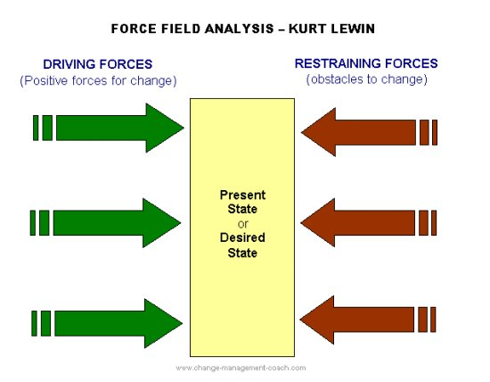
So before change the force field is in equilibrium between forces favourable to change and those resisting it. Lewin spoke about the existence of a quasi-stationary social equilibrium.
For change to happen the status quo, or equilibrium must be upset – either by adding conditions favourable to the change or by reducing resisting forces.
What Kurt Lewin proposes is that whenever driving forces are stronger than restraining forces, the status quo or equilibrium will change.
Now that's useful. Especially if we apply this to understanding how people move through change and why they resist change.
There will always be driving forces that make change attractive to people, and restraining forces that work to keep things as they are.
Successful change is achieved by either strengthening the driving forces or weakening the restraining forces.
The force field analysis integrates with Lewin’s three stage theory of change as you work towards unfreezing the existing equilibrium, moving towards the desired change, and then freezing the change at the new level so that a new equilibrum exists that resists further change.

Using the Force Field Analysis
Lewin's force field analysis is used to distinguish which factors within a situation or organisation drive a person towards or away from a desired state, and which oppose the driving forces.
These can be analysed in order to inform decisions that will make change more acceptable.
'Forces' are more than attitudes to change. Kurt Lewin was aware that there is a lot of emotion underlying people's attitude to change.
To understand what makes people resist or accept change we need to understand the values and experiences of that person or group.
Developing self awareness and emotional intelligence can help to understand these forces that work within us and others. It’s the behaviour of others that will alert you to the presence of driving and restraining forces at work.
The following steps are a guide to using the force field analysis:
You might find it useful to follow the process using the Force Field AnalysisApplication Tool available here,free of charge of course! You'll need Adobe Reader to open the application tool.
- Define the change you want to see. Write down the goal or vision of a future desired state. Or you might prefer to understand the present status quo or equilibrium.
- Brainstorm or Mind Map the Driving Forces - those that are favourable to change. Record these on a force field diagram.
- Brainstorm or Mind Map the Restraining Forces - those that are unfavourable to, or oppose change. Record these on the force field diagram.
- Evaluate the Driving and Restraining forces. You can do this by rating each force, from 1 (weak) to 5 (strong), and total each side. Or you can leave the numbers out completely and focus holistically on the impact each has.
- Review the forces. Decide which of the forces have some flexibility for change or which can be influenced.
- Strategise! Create a strategy to strengthen the driving forces or weaken the restraining forces, or both. If you've rated each force how can you raise the scores of the Driving Forces or lower the scores of the Restraining Forces, or both?
- Prioritise action steps. What action steps can you take that will achieve the greatest impact? Identify the resources you will need and decide how to implement the action steps.Hint: Sometimes it's easier to reduce the impact of restraining forces than it is to strengthen driving forces.
Criticism of the force field analysis usually focuses on the subjectivity of attributing scores to the driving or restraining forces.
Some writers suggest the model applies within limited settings and that there are situations outside of these settings in which Lewin’s theory may be less applicable.
At the end of the day this model of analysis is a tool that may or may not be useful in your situation. You can decide this or allow others to make a decision.
The force field analysis is backed by the Lewin change management model and has, over time, developed credibility as a professional change management tool.

