Appendix D, NON-PATIENT HANDLING PRACTICE

The Hierarchy of Measures to be followed in all instances to remove or reduce the risks from manual handling are as follows:
• AVOID hazardous manual handling operations as far as is reasonably practicable
• ASSESS any hazardous manual handling operations that cannot be avoided
• REDUCE the risk of injury so far as is reasonably practicable
• REVIEW
The emphasis is on ‘Task’ based risk assessment (TILEE (0)
- Task
- Individual capability
- Load
- Environment,
- Equipment/Other
With any risk assessment, the workforce should be involved in the process the key factors to consider in each element are:
• The Task - Does the activity involve twisting, stooping, bending, excessive travel, pushing, pulling or precise positioning of the load, sudden movement, inadequate rest or recovery periods, team handling or seated work?
• The Individual - Does the individual require unusual strength or height for the activity, are they pregnant, disabled or suffering from a health problem. Is specialist knowledge or training required?
• The Load - Is the load heavy, unwieldy, difficult to grasp, sharp, hot, cold, difficult to grip, are the contents likely to move or shift?
• The Environment - Are there space constraints, uneven, slippery or unstable floors, variations in floor levels, extremely hot, cold or humid conditions, poor lighting, poor ventilation, gusty winds, clothing or Personal Protective Equipment that restricts movement? Environmental risks must be highlighted on the trusts risk register.
• Other Factors - Is the equipment clean and fit for purpose, are staff that use the equipment trained and competent to do so? Are instruction manuals readily accessible in all areas where equipment is to be used? Has equipment been regularly serviced and inspected.
This section will give some practical ideas for reducing the amount of effort needed to complete some everyday tasks’. e.g.:-
- Kinetic lifting/ adoption of base movement (ergonomic working posture) with your spine in line and with flexed hips and knees.
- Only filling refuse/clinical waste bins 1/3rd full.

- Only filling linen bags 1/3rd full for wet laundry and 2/3rd full for dry laundry.

- Use of mechanical aids to move larger objects.
- If Roll Cages are moved and being pushed then the cage should be 2/3 full only. Only one at a time pushed using two hands over a short distance of 20 metres otherwise they should be towed or power driven. If being pushed in busy areas a ‘safety spotter’ or a ‘second person’ may be required to assist to prevent hitting pedestrians.
- Hospital beds / patient 4 wheeled trolleys: one person to move around a bed space (depending on the load). 2 people to move around ward/ interdepartmental transfer of a patient generally require bed movers.
- 5 wheeled patient trolleys: one person may move the trolley if the patient’s weight / size is appropriate.
- Bariatric bed movement may require up to 4 staff dependant on the weight of the patient and environmental factors.
- Clinical / wheelie bins: Lid to be lifted using two hands from the side of the bin and rest the lid against the wall is possible then place the bags into bin.
- Medical records boxes should not be over filled or stacked on the floor.
- When lifting of medical records and /or medical records boxes the use of kinetic lifting methods must be used with the adoption of good core stability and a safe working posture, keeping your spine in line with flexed knees and hips.

Kinetic Lifting - Summary
Plan the route, the lift and the set down point
Position your feet - bent knees, straight back
Firm grip, lift smoothly,
Move the feet - do not twist body
Keep the load close to the body
Put down smoothly - then adjust for final position
On no account should any member of staff push and pull equipment at the same time or move two pieces of equipment together i.e. trolley, cages, or environmental bins. If any member of staff needs further information/instruction or training then they can contact the manual handling keyworker for their department/area or the Trust Manual Handling Advisor on Bleep 1013.

Guideline Weights for Manual handling Operations
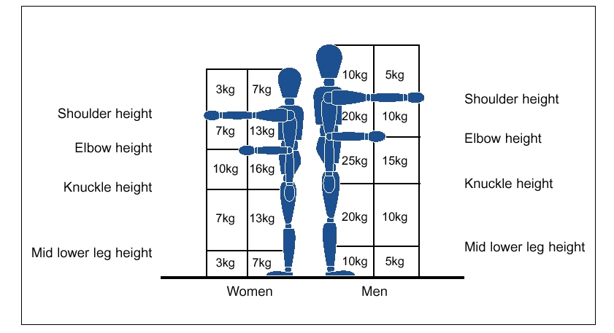

Principles of Safer Lifting
When applying the principles in load handling you will need to-
PLAN- Stop and think assess the weight of the load and where it is going PREPARE - Give yourself a stable base with the feet apart have your leading leg as far forward as is comfortable
POSITION - Slightly bend the back, hips and knees at the start of the lift. Take a firm grip of the load
PERFORM - Using your leg muscles to aid lifting, come up to standing keeping the load as close to the body as possible, keep the head up, move smoothly.
Don’t lift more than can be easily managed
When turning to avoid twisting move the feet.
Ensure that when the load is put down that the same principles of safe lifting are applied.
Put down the load, and then slide into desired position

Think before handling/lifting.

- Plan the lift / handling activity.
- Where is the load going to be placed?
- Use appropriate handling aids where possible.
- Will help be needed with the load?
- Remove obstructions, such as discarded wrapping materials.
- For long lifts, such as from floor to shoulder height, consider resting the load mid-way on a table or bench to change grip.

Keep the load close to the waist.

- Keep the load close to the waist for as long as possible while lifting.
- The distance of the load from the spine at waist height is an important factor in the overall load on the spine and back muscles.
- Keep the heaviest side of the load next to the body.
- If a close approach to the load is not possible, try to slide it towards the body before attempting to lift it.

Adopt a stable position.

- The feet should be shoulder width apart with one leg slightly forward to maintain balance (alongside the load if it is on the ground).
- Be prepared to move your feet during the lift to maintain a stable posture.
- Wearing over-tight clothing or unsuitable footwear may make this difficult.

Ensure a good hold on the load.

- Where possible hug the load as close as possible to the body. This may be better than gripping it tightly only with the hands.

- Moderate flexion (slight bending) of the back, hips and knees at the start of the lift is preferable to either fully flexing the back (stooping) or fully flexing the hips and knees (full/deep squatting).

Don't flex the back any further while lifting.
- This can happen if the legs begin to straighten before starting to raise the load.

Avoid twisting the back or leaning sideways especially while the back is bent.
- Keep shoulders level and facing in the same direction as the hips.
- Turning by moving the feet is better than twisting and lifting at the same time.
Keep the head up when handling.
- Look ahead, not down at the load once it is held securely.

Move smoothly.
- Do not jerk or snatch the load as this can make it harder to keep control and can increase the risk of injury.

Don't lift or handle more than can be easily managed.
- There is a difference between what people can lift and what they can safely lift. If in doubt, seek advice or get help.

Put down, and then adjust.
- If precise positioning of the load is necessary, put it down first and then slide it into the desired position.

(HSE Guidance on Regulations-Manual Handling Operations Regulations 1992 (as amended 2004)

Good Handling Technique for Pushing and Pulling

- Handling Devices. Aids such as trolleys should have handle heights that are between the shoulder and waist. Devices should be well maintained and comply with any relevant standards, e.g. British Standards, with wheels that run smoothly (the law requires that equipment is maintained). When purchasing new trolleys etc., ensure they are of good quality with large diameter wheels made of suitable material and with castors, bearings etc. which will last with minimum maintenance.

- Lifting may be replaced by controlled pushing or pulling in certain cases, such as sliding or rolling an object along. However uncontrolled sliding or rolling, particularly of large or heavy loads, may introduce additional risks thus increasing the risk of injury.

- For both pulling and pushing a secure footing is necessary and the hands need to be applied to the load between waist and shoulder height wherever possible.

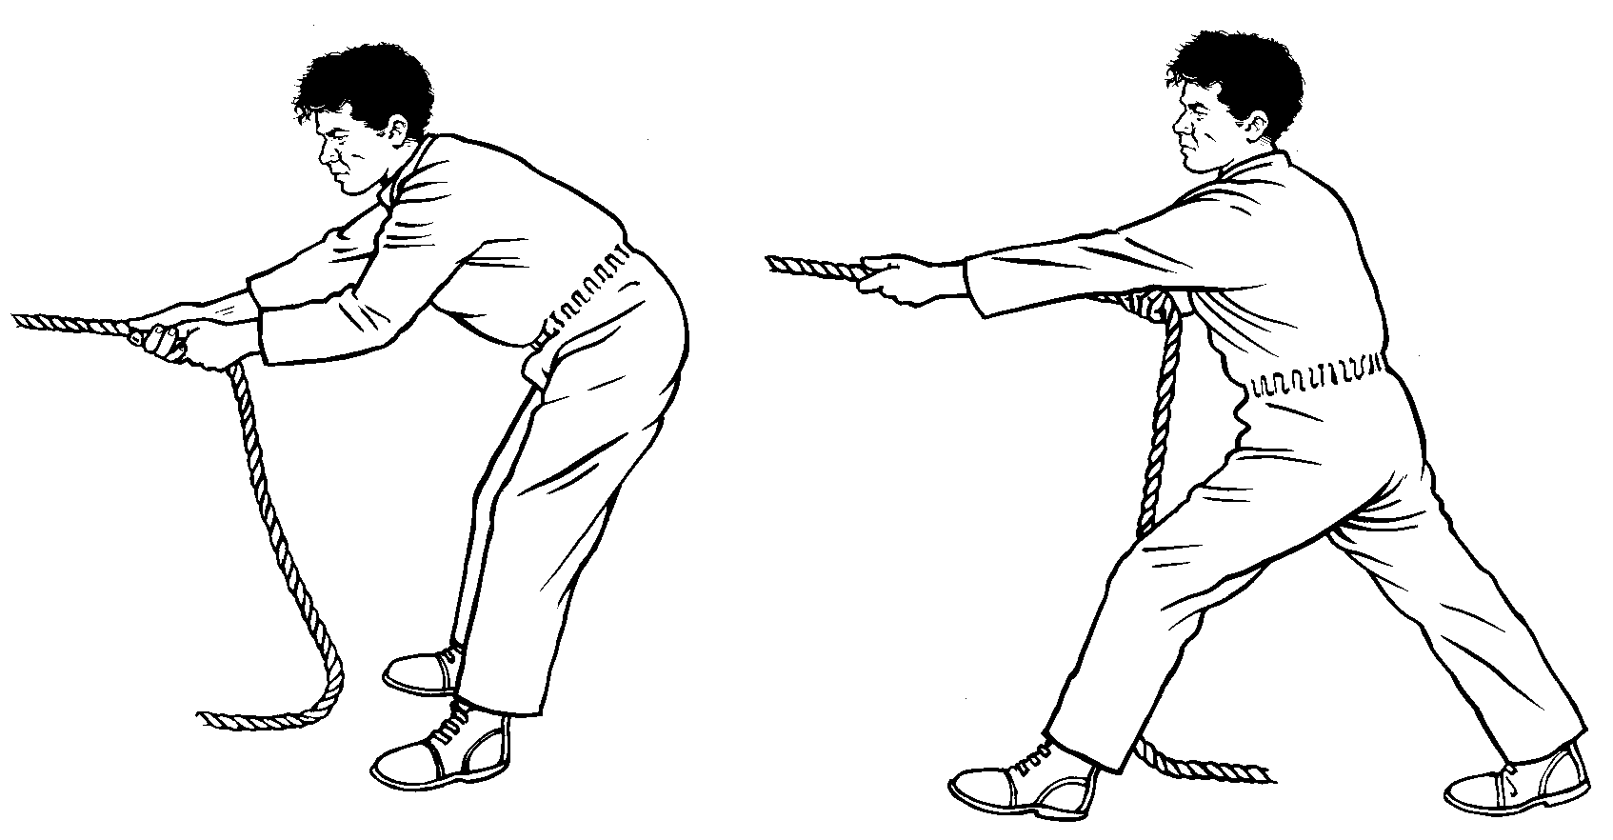
Wrong
Right
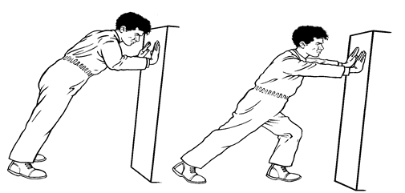

Mechanical Handling

Mechanical assistance involves the use of handling aids – an element of manual handling is retained but bodily forces are applied more efficiently, reducing the risk of injury. There are many examples trolley, sack truck or roll conveyor can greatly reduce the effort required to move a load horizontally.

Handling devices such as hand-held hooks or suction pads can simplify the problem of handling a load that is difficult to grasp.

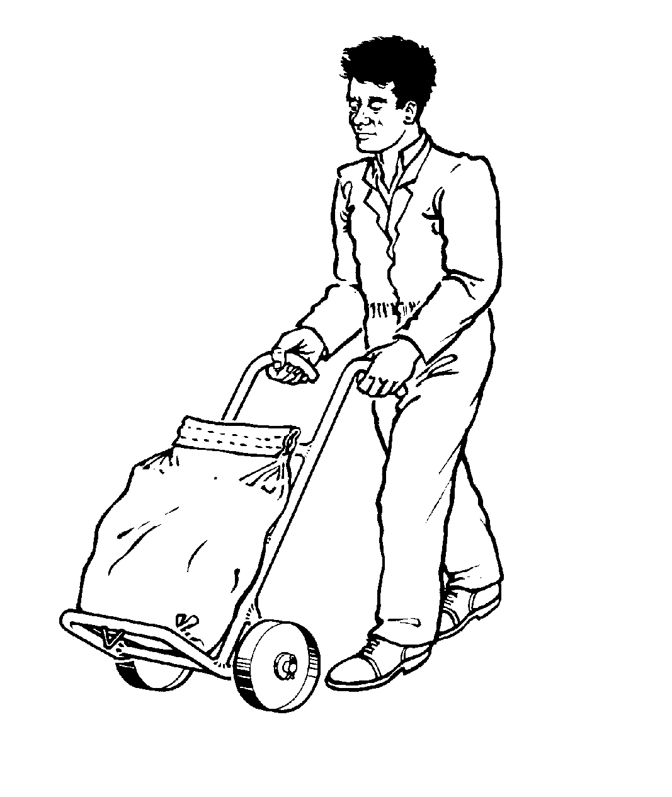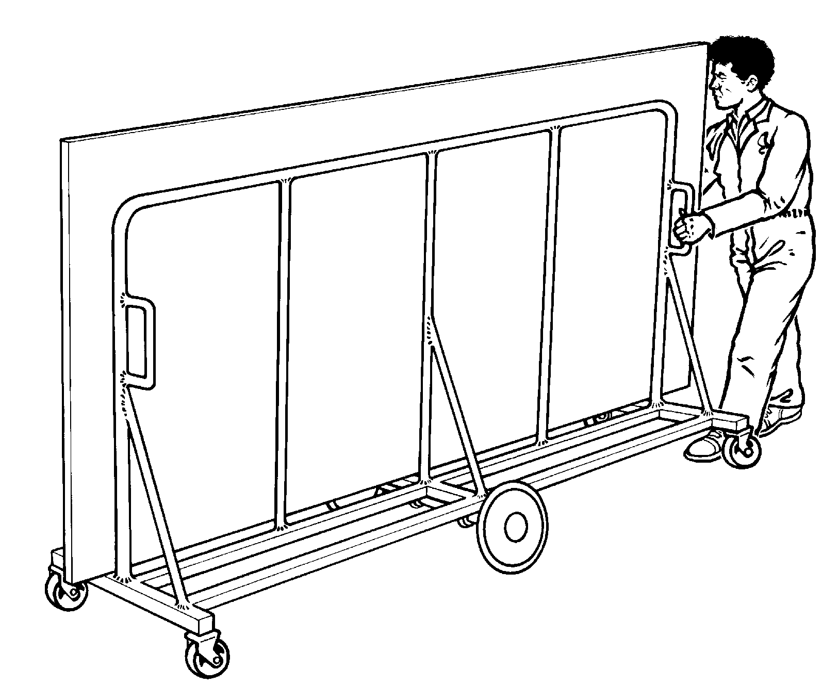

Remember you must be in control of the load and not the load in control of you.

Personal Protective Equipment (PPE)

Where the wearing of personal protective equipment cannot be avoided, its implications on moving and handling activities, e.g a uniform restricting movement and gloves making gripping difficult, should be taken into consideration. Restrictions on the handler’s movement caused by wearing protective clothing need to be recognised in the design of the task and the types of personal protective equipment provided must be suitable. The nature of the load or the environment in which it is being lifted will both affect the type of personal protective equipment necessary.

POSTURE

Good posture encourages your muscles, joints and ligaments to work in correct alignment. Your vital organs are in the right position and can function at peak efficiency. Good posture also contributes towards the normal functioning of the nervous system.

Standing

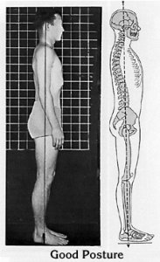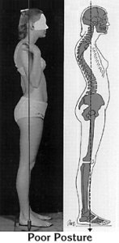

Sitting at a computer

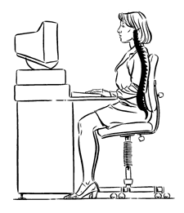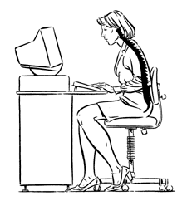
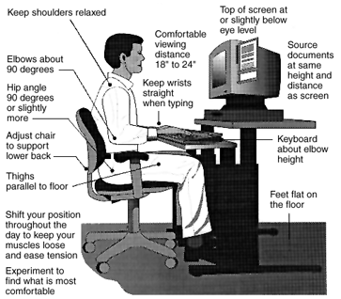

Static loading
Our bodies work better when they're moving than when they are standing still. Staying in one position, particularly with arms raised or outstretched, is likely to lead to muscle spasm and back pain. This state of prolonged muscle contraction is called static loading and can be particularly dangerous. It places a great strain on muscles and tendons and may cause mechanical damage to the discs of the spine. It is extremely tiring and could result in a much
greater strain on the heart. For these reasons the reduction of static loading should be a priority in the workplace.
Activities which lead to static loading may include:
- Working with your body leaning forwards or sideways.
- Trying to move objects that are too heavy for you.
- Carrying heavy objects for any length of time.
- Trying to hold a load still or to support it.
Lifting whilst sitting
Lifting whilst sitting is also particularly dangerous although many mistakenly believe that it may be safer than lifting when standing up.
- When sitting the lower spine loses its "S" shape which makes it less able to tolerate loads.
- The work is being performed by the relatively weak arm muscles instead of the much stronger muscles of the legs.
- The arm muscles will get tired more quickly and this leads to other muscles having to compensate.
Principles of safe lifting
- Avoid any manual lifting if possible.
- Use lifting equipment wherever possible.
- Assess the situation carefully.
- Prepare the area.
- Prepare any equipment.
- Make sure that all team members are aware of what is being done and what is expected of them.
Assessing risk
An employer's risk assessment will need to consider all of the aspects of the manual handling tasks that an employee would be asked to perform. The assessment should be based upon the experience of the tasks involved and should include consultation with the employee.
The task
- Holding or moving loads at a distance?
- Bad posture or body movements such as stooping, twisting, and over reaching
- Excessive movement, particularly: excessive carrying distance? Excessive lifting or lowering distance?
- Excessive pushing and pulling of loads?
* Precise positioning of loads?
- Frequent or prolonged physical effort?
- Insufficient rest or recovery periods.
Are the loads?
- Very heavy?
- Large bulky or difficult to manage?
- Difficult to grasp?
- Unstable, or could the contents move?
- Sharp, hot or otherwise potentially harmful?
The working environment
Are there:
- Space problems which might prevent a good working posture?
- Uneven or slippery floors?
- Differences in heights and levels of floor or working surfaces?
- Extremes of temperature or humidity?
- Problems with gusting winds or ventilation problems?
- Poor lighting conditions?
- Is movement likely to be hindered by the use of personal protective equipment or by clothing?

If in any doubt speak with the department lead or the Manual Handling Advisor on bleep 1013. Do not proceed if you have any concerns regarding safety and the environment.

