Finger FLEXOR tendon injury
Manchester Short Splint
The injury you have sustained is to the tendons that bend the fingers. You have received very delicate surgery to repair the tendons(s) that bend the fingers.
Although the tendon(s) have been repaired surgically, it will take 2-3 months for the repair to be strong enough to cope with normal use of your hand.
Care of your hand after the operation
Preventing swelling
If you let your hand hang down, it will make swelling worse. This will make your hand painful and stiff, and stop it from working properly. Your hand must be kept above the level of your heart until it is no longer swollen, which may take a few weeks. At night you should rest your hand on pillows.
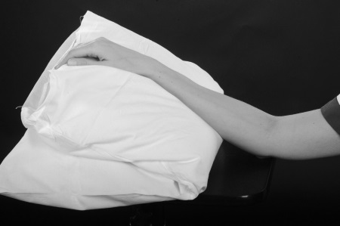
To stop your hand becoming too swollen and to stop your elbow and shoulder from becoming stiff you will need to do ‘pumping exercises’ with your whole arm 10-15 times every half an hour. This is done by reaching up towards the ceiling and then back down to shoulder level.
Looking after your wound
To assist with healing and make it easier to do your exercises, your wound will be left with minimal or no dressings. It is important that you keep your wound clean and dry until it is fully healed. You must monitor your wound for signs of infection which include increasing pain and swelling, redness and discharge/fluid which may be foul smelling. If you are concerned that your wound may be infected please contact the Plastic Dressings Clinic on the telephone number below.
Protecting the repaired tendon from breaking
In order to protect your repaired tendon, a light plastic splint will be made which you will wear at all times until your tendon has healed. Your therapist will advise you when you can start to remove your splint.
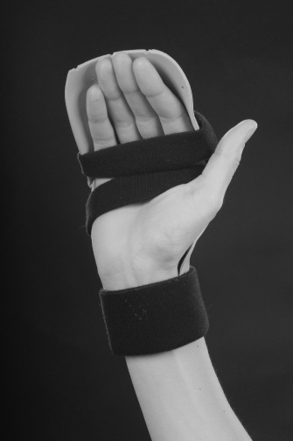
Exercises
As you move your fingers your tendons will glide in your hand. After a tendon repair they will not glide so well. The following exercises will help your tendon(s) to glide as it heals.
Weeks 1-4
Your splint should be worn at all times.
You must do the following exercises as instructed:
- Push each of the fingers, one at a time, into a hook position, using the other hand.
Hold for ____ seconds, repeat ____ times, every ____ hour(s).
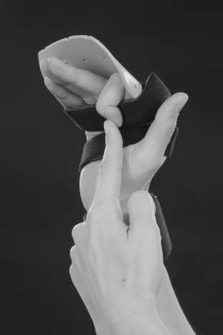
- With your wrist held forwards, straighten all the fingers to touch the back of the splint, relax fingers as you bring your wrist into a straight position.
Hold for ____ seconds, repeat ____ times, every ____ hour(s).
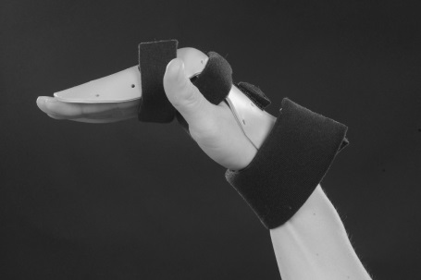
- Hold your wrist backward, gently curl all the fingers, starting movement at the tips, towards a hook position.
Hold for ____ seconds, repeat ____ times, every ____ hour(s).
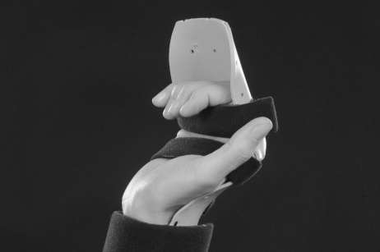

You must never force the fingers to make a full fist.

- Aim for ¼ hook fist in weeks 0 – 1
- Aim for ½ hook fist in weeks 2 – 3
- Aim for ¾ hook fist in weeks 3 – 4

Your therapist will clarify this with you at your appointments.

Your hand may become stiff or you risk damaging the tendon repair if you do not do the exercises as instructed.

Additional advice/exercises
………………………………………………………………………………………………………………………………………………………………………………………………………………………………………………………………………………………………………………………………………
You should not use your affected hand for anything unless specifically advised by your therapist.
Week 2
You may be able to begin to use your hand in the splint for very light function. Your therapist will clarify this with you at your appointment.
Week 4
At this stage you can progress towards making a full fist. Your therapist may show you some additional exercises including light functional tasks that you can do out of the splint.
You should still be wearing your splint at all times unless your therapist has told you otherwise.
Weeks 6-8
Continue to wear the splint at night and for protection only
You will be taught exercises by your therapist to improve the movement of your hand and wrist. If you do not do the exercises exactly as instructed, your hand may become stiff or you may risk damaging the tendon repair.
You will be advised by your therapist how much you can use your hand at this stage.
Weeks 8 – 12
At this stage you usually do not need to wear your splint any more.
You will be instructed on further exercises and activities to improve the movement and use of your hand, these exercises may involve strengthening you hand.
You can return to normal daily activities and driving at this stage.
You will also be advised by your therapist whether you can return to you specific job or sport.
Weeks 12+
Normal use of your hand with no restrictions.
Points to remember
- Keep your hand above your heart all day and night
- Do ‘pumping exercises’ every half an hour
- Do your exercises as frequently as you have been advised to
- Do not remove your splint unless you have been advised to
- Do not attempt to alter your splint
- Do not get your splint wet
- Do not use your injured hand for anything unless you have been advised to
- Do not drive until you have been told you can do so.
Contact numbers
Hand therapy: 01722 345530 (08:00 – 17:00 Monday to Friday)
Hospital switchboard: 01722 336262
Plastic Dressing Clinic nurses: ext 3254 (08:00 – 17:00 Monday to Friday)
Odstock ward: ext 3507/3139 (out of the above hours)
Your GP or NHS 111 is another source of assistance out of hours.
Follow up
You will be seen in the Outpatient Department within 5 days of your surgery. After this you will be seen every 1 to 2 weeks. Depending on where you live, you may be referred to a local hospital for hand therapy after your second appointment.

Author: M Robson
Date written: April 2020
Date for review: April 2023
Version: 1.0

