Finger EXTENSOR tendon injury
Modified Relative Motion Splinting (mRMS) regime
The injury you have sustained is to the tendons that straighten the fingers. You have received very delicate surgery to repair the tendon(s) that straighten the fingers.
Although the tendon(s) have been repaired surgically, it will take 2-3 months for the repair to be strong enough to cope with normal use of your hand.
Care of your hand after the operation
Preventing swelling
If you let your hand hang down, it will make swelling worse. This will make your hand painful and stiff, and stop it from working properly. Your hand must be kept above the level of your heart until it is no longer swollen, which may take a few weeks. At night you should rest your hand on pillows.
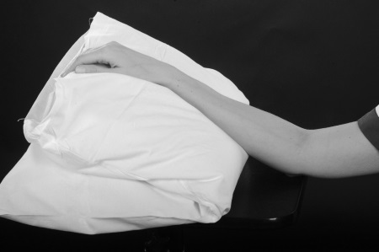
To stop your hand becoming too swollen and to stop your elbow and shoulder from becoming stiff you will need to do ‘pumping exercises’ with your whole arm 10-15 times every half an hour. This is done by reaching up towards the ceiling and then back down to shoulder level.
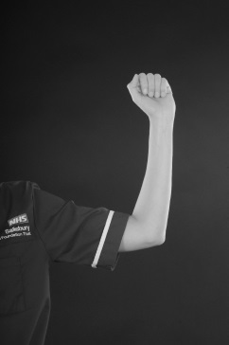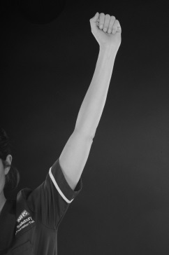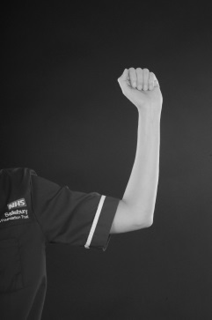
Looking after your wound
To assist with healing and make it easier to do your exercises, your wound will be left with minimal or no dressings. It is important that you keep your wound clean and dry until it is fully healed. You must monitor your wound for signs of infection which include increasing pain and swelling, redness and discharge/fluid which may be foul smelling. If you are concerned that your wound may be infected please contact the Plastic Dressings Clinic on the telephone number below.
Protecting the repaired tendon from breaking
In order to protect your repaired tendon, a light plastic splint will be made which you will wear at all times until your tendon has healed. Your therapist will advise you when you can start to remove your splint.
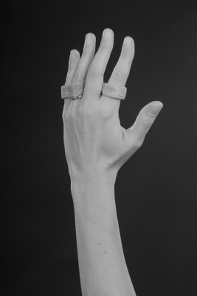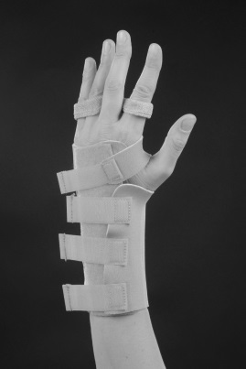
Exercises
As you move your fingers your tendons will glide in your hand. After a tendon repair they will not glide so well. The following exercises will help your tendon(s) to glide as it heals.
Weeks 0 – 4
Splint:
Your finger splint should be worn at all times.
The wrist splint must be worn at night time and any other time the therapist advises you to wear it.
Exercises:
You must do the following exercises as instructed:
- Curl your fingers into a hook position and straighten back up again.
Hold for ___ seconds, repeat ____ times, every ____ hour(s).
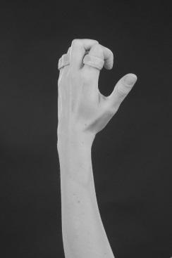
- Keeping your finger joints straight, bend at your main knuckles and straighten back up again.
Hold for __ seconds, repeat ____ times, every ____ hour(s).
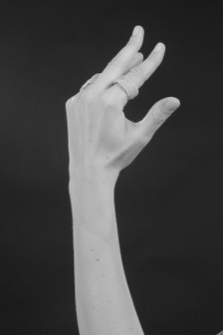

- Gently curl all the fingers together into a fist and straighten back up again.
Hold for ____ seconds, repeat ____ times, every ____ hour(s).
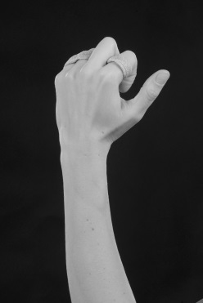
You must not bend your fingers and wrist together until 8-10 weeks.
Function:
You can use your affected hand for light functional tasks up to 1 kg.
Please discuss in detail regarding your work so that your therapist can support you and make a plan for your return to work at an appropriate time.
Additional advice/exercises
………………………………………………………………………………………………………………………………………………………………………………………………………………………………………………………………………………………………………………………………………
Weeks 4-6
Your wrist splint can be discarded now.
Your finger splint must be worn for functions more than 1kg and at night.
You will be taught exercises by your therapist to improve the movement of your hand and wrist. If you do not do the exercises exactly as instructed, your hand may become stiff or you may risk damaging the tendon repair.
Function:
You are allowed to use your hand with the finger splint for functions up to 5 kg.
Weeks 6-8
Continue wearing finger splint for function more than 5kg and at night.
Slowly you can increase the amount of weight you lift with your hand with the finger splint on such that by the end of 8 weeks you are able to lift up to 15- 20 kg within the splint.
You can return to driving.
You will be instructed on further exercises and activities to improve the movement and use of your hand, these exercises may involve strengthening you hand.
Weeks 8 – 10
You must wear finger splint for functions over 10kg.
You will also be advised by your therapist whether you can return to you specific job or sport.
Weeks 12+
Normal use of your hand with no restrictions.
Points to remember
- Keep your hand above your heart all day and night
- Do ‘pumping exercises’ every half an hour
- Do your exercises as frequently as you have been advised to
- Do not remove your splint unless you have been advised to
- Do not attempt to alter your splint
- Do not get your splint wet
- Do not use your injured hand for anything unless you have been advised to
- Do not drive until you have been told you can do so.
Contact numbers
Hand therapy: 01722 345530 (08:00 – 17:00 Monday to Friday)
Hospital switchboard: 01722 336262
Plastic Dressing Clinic nurses: ext 3254 (08:00 – 17:00 Monday to Friday)
Odstock ward: ext 3507/3139 (out of the above hours)
Your GP or NHS 111 is another source of assistance out of hours.
Follow up
You will be seen in the Outpatient Department within 7 days of your surgery. After this you will be seen every 1 to 2 weeks. Depending on where you live, you may be referred to a local hospital for hand therapy after your second appointment.

Author: M Robson
Date written: April 2020
Date for review: April 2023
Version: 1.0

