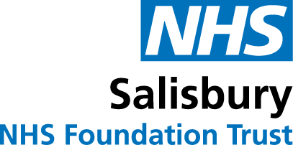

Testing for the COVID-19 Coronavirus
One of the most challenging things about the COVID-19 coronavirus is the uncertainty of not knowing who has the infection, or when it’s safe to return to normal life. High-quality, accurate testing can help provide us with greater certainty and will play a big part of how we’re going to defeat this disease.
Now, in line with all other NHS organisations, every patient admitted as an emergency to Salisbury NHS Foundation Trust will be tested for the virus. This is because a number of people who show no symptoms at all will have the virus and therefore may infect other people. So this testing will help us protect both patients and staff, particularly our most vulnerable patients.

Shortly after your admission you will be asked for a swab of your throat and nose. The results usually take up to 48 hours to process, and you will be informed of the results. If you have been discharged before the results are available, you will have been given a number to call to find out your result. If you have any queries about your test results please contact a member of our PALS team on 01722 429044 or by email on sft.PALS@nhs.net.

You can reduce, but not eliminate, the risk of catching or spreading infection by:
- Ensuring that you if you have a cough or sneeze you ‘catch it and bin it’ by using tissues.
- Disposing of dirty tissues promptly and carefully.
- Washing your hands regularly and thoroughly for 20 seconds
- Ensuring you keep a safe social distance from other patients of at least 2 metres.
- Keeping your bed space clear of clutter so that all hard surfaces can be kept clean.
- Wearing a face covering when you come to the hospital. This can be a handmade one – see our Facebook page for a simple guide on making a mask https://www.facebook.com/salisburydistricthospital/

Version 1.3 June 2020
Due for review: May 2021

