Dear d r a f t - FOR MYELOMA PTNTS

Now that your Haematology outpatient follow-up is under Remote Monitoring please find enclosed the following:

- Blood form: Your blood test is due in (insert number) months. This form can be taken to your GP surgery, the Hospital Pathology Department, or the mobile chemotherapy unit.

- An information sheet with details of signs and symptoms to be aware of, how to contact the Haematology Team and how we will review your blood results

- A holistic needs assessment form; you can use this to identify any areas of concern which can be discussed with me should you wish.

- General wellbeing information and signposting to further support.

If you have any questions or concerns please contact me. I work part time but the Cancer Support Team can be reached Monday to Friday during office hours on 01722 336262 ext 2417. There is a confidential answerphone which is monitored daily. Any member of the team will be happy to take a message if I am not available.

Yours sincerely

Debi Webley
Cancer Support Worker (Haematology)

Dear d r a f t - FOR MGUS PTNTS

Now that your Haematology outpatient follow-up is under Remote Monitoring please find enclosed the following:

- Blood form: Your blood test is due in (insert number) months. This form can be taken to your GP surgery, the hospital Pathology Department, or the mobile chemotherapy unit.

- An information sheet with details of signs and symptoms to be aware of, how to contact the Haematology Team and how we will review your blood results

Remote monitoring for MGUS is managed by the Cancer Support Team for administrative purposes. I support MGUS patients and those with Myeloma and would be very happy to hear from you if you have any questions or concerns.

I work part time but the Cancer Support Team can be reached Monday to Friday during office hours on 01722 336262 ext 2417; there is a confidential answerphone which is monitored daily. Any member of the team will be happy to take a message if I am not available.

Yours sincerely

Debi Webley
Cancer Support Worker (Haematology)

D R A F T INSERT logo
Myeloma Remote Monitoring
Your Health and Wellbeing

There is a wealth of information and support available for people with Myeloma. The following wellbeing advice may be helpful to you. If you are unable to access the online resources suggested and you would like paper copies please contact your Cancer Support Worker.

www.myeloma.org.uk
Myeloma UK is a charity focused on the discovery, development and access to new effective treatments for myeloma.

The following address will take you to the Myeloma UK website with information to help you understand Myeloma relapse
https://www.myeloma.org.uk/understanding-myeloma/treating-myeloma/treatment-for-relapsed-myeloma/
The video at the following address (a Myeloma UK video) will talk about one patient’s experience of relapse https://youtu.be/Zkmb9iGypW8

www.bloodcancer.org.uk
Bloodcancer UK provides Information and support and funds research into blood cancers

Cancer Related Fatigue
The enclosed Macmillan booklet ‘Coping with Fatigue’ gives some practical advice and tips for improving fatigue symptoms.

Late effects of cancer treatment
You may have had treatment for your Myeloma and need to be aware of some possible late effects of chemotherapy. The following address will take you to the Macmillan website with detailed information on the possible late effects of cancer treatment

https://www.macmillan.org.uk/cancer-information-and-support/after-treatment/late-effects-of-treatment

Diet, nutrition and alcohol
Please see enclosed guides for information on a healthy diet and sensible drinking guidelines These have been produced by the Living with and Beyond Cancer Dietitian.

Smoking cessation
Please see enclosed information.

Activity and exercise
Regular exercise and remaining physically active can improve your physical and emotional wellbeing and help to improve fatigue.
The most important thing for you to think about when planning any sort of exercise is the effect it might have on your bones. You should avoid strenuous exercises like weightlifting or contact sports.
Gentle forms of exercise such as walking, swimming, cycling, gentle aqua-aerobics, gentle gym work, yoga and tai chi are good for overall health and for muscle strengthening.
Further reading is available at Myeloma UK
https://www.myeloma.org.uk/help-and-support/living-well-with-myeloma/diet-exercise/
Emotional impact of cancer
Many people struggle with the emotional effects of a cancer diagnosis for a long time after diagnosis. There are lots of ways to seek help and support. Please see the enclosed details of counselling support available through Jane Scarth House. The following links for Myeloma UK and Macmillan website also have advice:

https://www.myeloma.org.uk/help-and-support/living-well-with-myeloma/emotional-psychological-support/

https://www.macmillan.org.uk/cancer-information-and-support/treatment/coping-with-treatment/getting-help-with-your-emotions

Counselling, Aromatherapy, Reflexology and meditation Jane Scarth House is a charity in Romsey opened in 1995, to provide emotional and practical support to anyone whose life is affected by cancer. This can be the person living with cancer, or a family member, close friend, carer or partner. During the COVID-19 pandemic you can contact 01794 830374 or email info@janescarthhouse.co.uk for a chat or to book phone or video counselling
Further information is available at: www.janescarthhouse.co.uk
Financial impact of cancer
The Macmillan Citizens Advice advisors provide comprehensive, independent, confidential advice and support on allowances, benefits and grants to people affected by cancer.
Contact 01722 441393 email: macmillan@citizenadvicewiltshire.org.uk

https://www.macmillan.org.uk/in-your-area/local-dashboard/detail/Benefit%20advice%20services/8254/Macmillan-Wiltshire-Citizens-Advice-Wiltshire-Benefits-Advisers

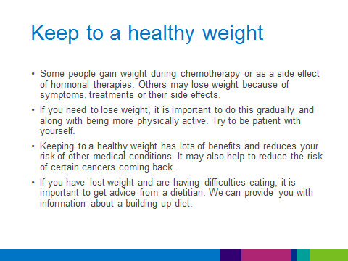
Diet and nutrition
