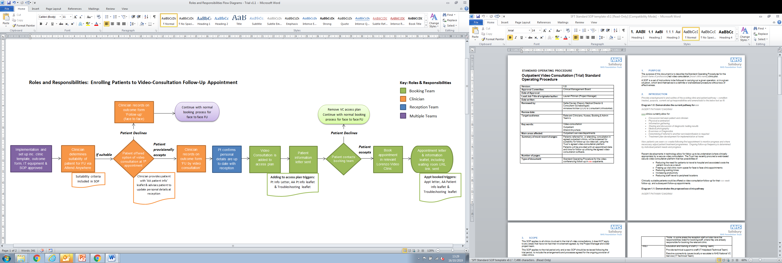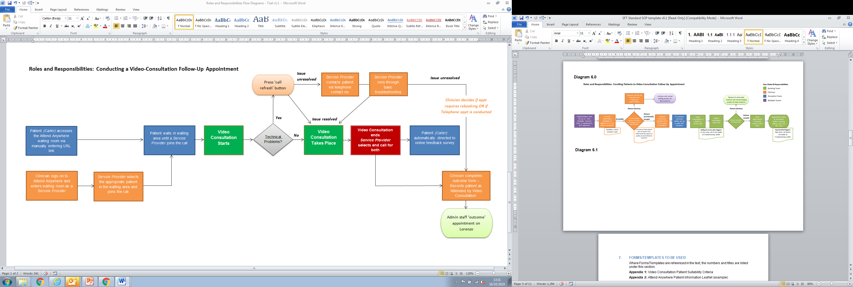

**Appendix 1:** Roles & Responsibilities Diagrams 6.0 & 6.1

**Diagram 6.0**

**Diagram 6.1**