Ferinject® for adult inpatients
With heart failure
Intravenous iron treatment for iron-deficiency in adult patients with heart failure

Patient consent and prescription form
This form contains:
- Information about when to prescribe intravenous iron
- Risks, side effects and patient consent form
- Ferinject prescription form and dose calculation table
Date ____________ Patient’s consultant ____________ Clinical Area___________
Weight (kg) ________________ See pre-prescription checks on page 3
ALLERGIES: ________________________________________________________________
When to offer treatment with intravenous iron (Ferinject®):
Ferinject is indicated when ALL the following are true:
- The patient has a functional iron deficiency

- The patient consents to intravenous iron

Tick to confirm if true

Risks and side effects of Ferinject®
Ferinject® is generally given without issue. The most frequently reported side effect, nausea, occurred in 2.9% of patients during clinical studies¹. It is important to ensure the patient is aware of the risks and potential side effects below:

CONTRAINDICATIONS
1st Trimester pregnancy (see separate prescription for Maternity services), severe asthma, severe renal or hepatic impairment, eczema, atopy, active rheumatoid arthritis, infection

Risks
Hypersensitivity and anaphylaxis can occur with parenteral iron infusion although this is uncommon².

SIDE EFFECTS²
Common (1 in 10 to 1 in 100) – Headache, dizziness, flushing, hypertension, nausea, injection site reactions.
Uncommon (1 in 100 to 1 in 1000) - Abdominal pain, vomiting, cramps, dyspnoea, arthralgia, numbness, itching, rash chest pain, diarrhoea, dizziness, fatigue, hypotension, myalgia
Rare (1 in 1,000 to 1 in 10,000) – Angioedema, impaired consciousness, anxiety, bronchospasm

Patient consent for intravenous iron (Ferinject®) injection
I acknowledge and understand that the proposed treatment of an intravenous iron injection(s) (Ferinject®) has been explained to me and is to be performed on me, the patient:
- Benefits – To treat iron deficiency
- Risks – Intravenous iron can cause serious hypersensitivity reactions which can be fatal. The risk of sensitivity is increased in patients with known allergies, immune or inflammatory conditions as well as patients with a history of severe asthma or eczema.
- Side effects as listed above
- I have been given a copy of the patient information leaflet about intravenous iron.
- I have been given the opportunity to ask questions about the treatment.
- I understand I can withdraw my consent at any time.
Patient signature: _________________________________ Date: ________________
Patient name: ____________________________________

Pre-prescription checks
Both ferritin and TSAT should be checked prior to starting iron treatment and rechecked at the next scheduled clinic visit (preferably after 3 months). Levels should continue to be monitored usually once or twice a year but more frequently if clinically indicated.
Date | Ferritin µg/l | TSAT % | Hb g/l | Gender
 |  |  |  | M/F

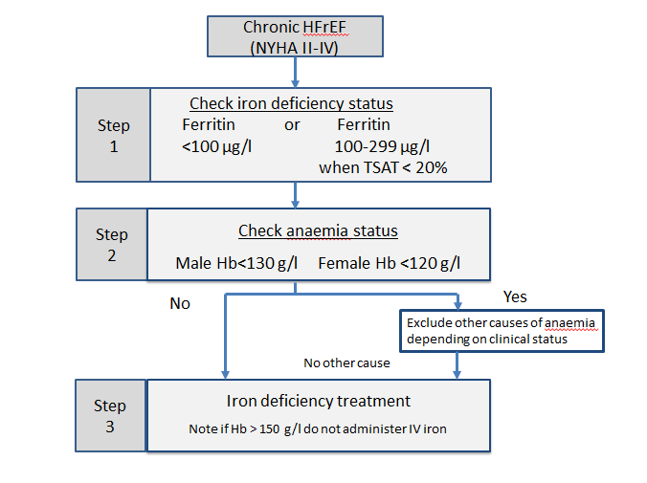

Ferinject® prescription and dose calculation table
- The figure in the box represents the dose of IV iron (Ferinject®) required in mg.
- Ferinject® may be administered by intravenous injection using undiluted solution up to a maximum single dose of 1000 mg of iron or not exceeding 15 mg/kg body weight.
- The recommended doses and numbers of injections are shown in the table below.
- For some clinical circumstances a clinician may decide to administer fewer injections but the doses must not exceed those stated below.

Weight | Current Haemoglobin (g/l)
 | <100 | 100-<140 | ≥140 to 150
35 kg- <70 kg | 1500 mg total  (As three 500 mg injections) | 1000 mg  (As two 500 mg injections) | 500 mg
≥ 70 kg | 2000 mg total  (As two 1000 mg injections) | 1500 mg  (As 1000 mg first injection then 500 mg second injection) | 500 mg

TOTAL DOSE OF IV IRON (Ferinject®) = ……………..…mg to be administered over ……….. injection(s).

*Planned injection dates | *Ferinject® dose | Administered by / date | Pharmacy  Screen | Pharmacy  Disp.
Injection 1: | …………mg
Injection 2: (if required) | …………mg
Injection 3: (if required) | …………mg
*Signature of prescribing Consultant/Registrar…………………………………..Date:………………

Appendix
Preparation
Ferinject® injections will normally be prepared at ward/clinic level by nursing staff. Please send the prescription to the hospital pharmacy dispensary in advance to obtain Ferinject® supplies
Administration
Inject the undiluted Ferinject® by the intravenous route over 15 minutes for 1000 mg and 5 minutes for 500 mg.
Monitor the patient during the injection and for 30 mins after each administration of an IV iron product. IV iron products should only be administered when staff trained to evaluate and manage anaphylactic reactions as well as resuscitation facilities are immediately available. Patients should be monitored for signs or symptoms of anaphylaxis, mild allergic reactions, hypotension and extravasation.
PLEASE RETAIN A COPY OF THIS COMPLETE FORM IN THE PATIENTS NOTES

References
- Ferinject Summary of Product Characteristics, Electronic Medicines Compendium accessed 09/07/2020. (https://www.medicines.org.uk/emc/product/5910#CLINICAL_PRECAUTIONS)
- JOINT FORMULARY COMMITTEE, 2020. British National Formulary. 78. London: BMJ Group and Pharmaceutical Press.

