Exercise & Pacing after Covid-19 & other Respiratory illness
Exercise is a key part of recovery when you have been unwell with a respiratory condition. It is important that you know how much exercise is beneficial, when to get started and the best way to continue once you are fit enough to leave hospital.
If you have specific rehabilitation needs that will ensure a safe discharge from hospital you will be referred to see the physiotherapist on your ward by the nursing staff when appropriate.
If you have started to mobilise independently and safely then this information leaflet will help to guide you towards the next steps to return to your normal functional level either with guidance from the ward staff or independently. This may take some time and will need to continue once you get home.
What is Post Viral Fatigue?
- Post viral fatigue is when you have an extended period of feeling unwell and fatigued after a viral infection.
- Fatigue is a common symptom of COVID-19 infection so it is likely that some people will continue to experience fatigue for some time after the infection has cleared.
If you have had symptoms of COVID-19 or any respiratory illness it is common to feel fatigued and more short of breath. This may make everyday activities more difficult than usual, but this should not stop you from doing them as this is part of the recovery process, you will just need to use techniques to manage your breathlessness. This will help you to return to your usual level of function. As your stamina improves, you will be able to do more before feeling short of breath.

How to manage symptoms of fatigue
Breathing control
- Ensure that you are sitting comfortably, supported on a chair or in bed.
- Try to relax and release tension in your shoulders.
- Place one hand on your tummy and one on your chest feeling the rise and fall as you breathe.
- Breathe in through your nose and out through your mouth.
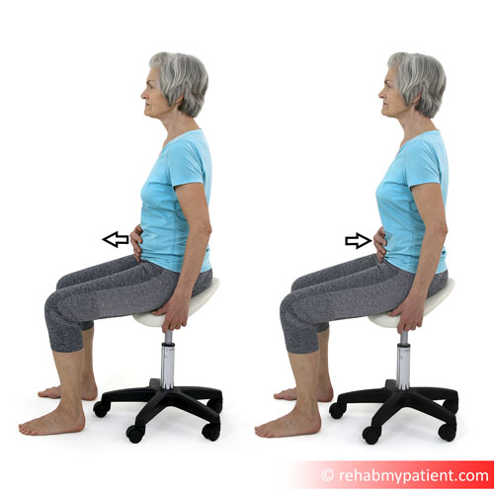
- Try to focus on your breath filling up your lungs from the bottom so you should feel your stomach rise under your hand. You should maintain relaxed breathing throughout and not take deep or fast breaths.
- Practice for a few minutes several times a day.
Once you can control your breath at rest you should be able to start practicing in standing and when you walk.
Pacing during exercise
It is tempting to try to get back to exercising as you did prior to your admission to hospital. However, this may take some time as your body is still recovering. As you start to exercise again it is important that you become aware of how much you can do and when you need to stop and rest.
- Plan ahead
- Pace yourself
- Use breathing exercises
- Sit during necessary tasks/activities
- Avoid bending, reaching and twisting
- Use good posture
- Use the Rating of Perceived Exertion (RPE) (see later in leaflet)
Don’t get tempted to do a lot more on good days as this may affect your body more than it used to. You may then feel fatigued and more short of breath which could then affect you for several days requiring more rest.
Try to keep activity levels steady with a gradual increase to improve exercise tolerance and fitness over time. Trying to ‘push through’ the fatigue is normally unhelpful. Be realistic and kind to yourself.
Plan your activities:
- Think about what you need to do over the coming days and weeks.
- What is necessary, what can wait, can someone else help?
- Spread the necessary tasks out so that you can rest in between and do not have two busy days in a row.
- Save tasks for when you have the most energy for example, if you have the most energy in the morning then this is the best time to do this task.
- If you can break down the task and do it in stages, this will conserve energy.

Set short realistic goals - for example, walking to the toilet, walking to the front door and increase these as you feel able.
Rest - as you are improving your body needs rest to continue healing. Continue to have short rests throughout the day. If you’re not sure if you need to rest, take one. Whilst you are resting, stop and do nothing, calm your mind, use breathing control or relaxation techniques as described in this leaflet.
Daily routine - try to resume a daily routine for sleeping, eating and daily activities. If your previous routine isn’t possible set a realistic one for now and follow it. It helps the body to stabilise itself again. Gradually change it back to your normal routine. Remember do not rush!
Thinking activities - when starting to improve it is easy to forget that everyday ‘thinking’ such as checking emails, planning activities, making decisions, worrying about other people all take energy. You will need to limit these activities, for example doing them for set times and take a rest between them. If in doubt, rest sooner.
Work – you may have to take longer off work than initially anticipated and may have to have a gradual return to work. Speak to your manager and get occupational health advice. You may also need a fit note from your GP.
Have fun – don’t forget to keep things fun in life – as people start to get back to daily life they prioritise all the things that seem necessary but we need to balance this with enjoyment so choose to spend some energy on fun activity too – increasing gradually like other activities.
Nutrition – Keep eating and drinking as normally as possible. Little and often may help if your appetite is low, rather than big meals. Increase your fluid intake, especially if you are not managing to eat as much and if you are starting to exercise. We need to drink at least two litres a day. Keep hydrated!
Mobilising
When standing, do not immediately move away from the bed or chair. Stand for a few seconds to ensure your breathing and blood pressure is settled and you do not go lightheaded.
Move away from the bed/chair using a walking aid if required and mobilise as far as is comfortable.
As you start to get short of breath, find a suitable place to stop. You can lean on something that is unmoveable to regain your breath or sit down leaning forward onto your knees before then moving on further.
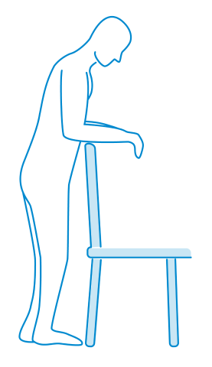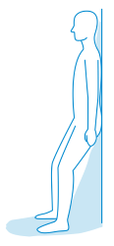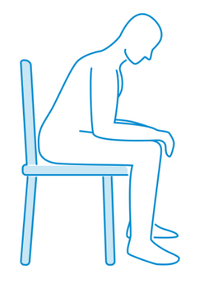
Always remember where you need to get back to and plan further rest stops to enable you to be able to get there without becoming severely short of breath and unable to recover.
Everyone needs to become slightly short of breath in order for the body to increase its stamina. After exercise your breathing should return to its resting rate within 2-3 minutes, if it is taking longer than this and you are unable to talk then you have worked too hard and need to practice pacing yourself.
You will be advised on the best exercises for you at your current stage of recovery and how to progress. It will be your responsibility to then continue these exercises to ensure the best recovery possible.
SEEK ADVICE – If after 3-4 months you aren’t seeing any improvement in fatigue after having a virus then you should ask your GP for advice so that they can check there aren’t any other causes for the symptoms.

Rating of Perceived Exertion (RPE)
This scale can be used to measure how you feel when you are exercising or doing an activity. It can be used to adjust how much effort you are putting into the activity through how your body feels. You are then able to monitor whether you need to put in more effort for the exercise to be beneficial or whether you need to slow down so as not to overdo it.
Rating of Perceived Exertion (RPE)
6 No exertion at all
7 Extremely light
8
9 Very light
10
11 Light
12
13 Somewhat hard
14
15 Hard (heavy)
16
17 Very hard
18
19 Extremely hard
20 Maximal exertion

Exercise Diary
Keep a daily record of your exercise and Rating of Perceived Exertion (RPE) to ensure that you are increasing your exercise tolerance.
Date/time | Exercise | Duration/reps/sets | RPE
If you have any queries, please contact a member of the ward staff or the physiotherapist (8.30am- 4.30pm).
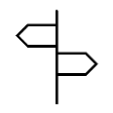
For further information or advice, there are some online resources available:

- NHS England – Recovery information
www.yourcovidrecovery.nhs.uk
- Chartered Society of Physiotherapists - Information for post Covid19 recovery – www.csp.org.uk/public-patient/covid-19-road-recovery
- British Lung Foundation – www.blf.org.uk Online videos, Stay
Active, Stay Well. Free information leaflets on exercise and
managing breathlessness
- Chartered Society of Physiotherapists, The Physiotherapy Pain
Association. http://ppa.csp.org.uk/content/keeping-active
Gentle exercise videos including chair exercises, tai chi,
strength and balance exercises.
- The Association of Chartered Physiotherapists in Respiratory
Care, online self-management Programme www.acprc.org.uk
- AgeUK – looking after yourself physically and mentally https://bit.ly3eF4qrQ
- British Dietetic Association – General advice https://bit.ly/2VHi9FR
- IAPT - Improving Access to Psychological Therapies www.nhs.uk
- FreeMindfulness – Mindfulness https://bit.ly/3amvl8l
- Mind – psychological wellbeing during coronavirus https://bit.ly/2KlGRX4
Credit to:
Lancashire Teaching Hospitals and Yorkshire Fatigue Clinic www.yorkshirefatigueclinic.co.uk
Liverpool Heart and Chest Hospital NHS Foundation Trust
Images used with permission from The British Lung Foundation www.blf.org.uk
Jenna Wippell (Respiratory Physiotherapist) and
Emma Horseman (Occupational Therapist) Original April 2020 Edited Nov 2020

