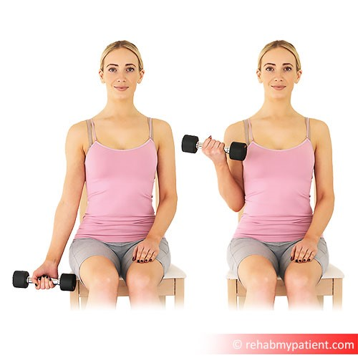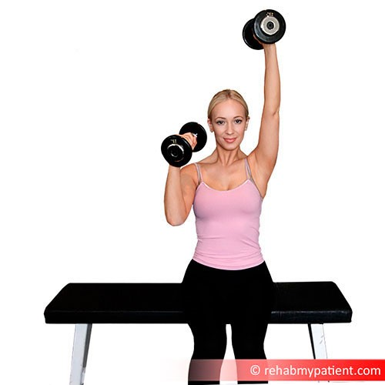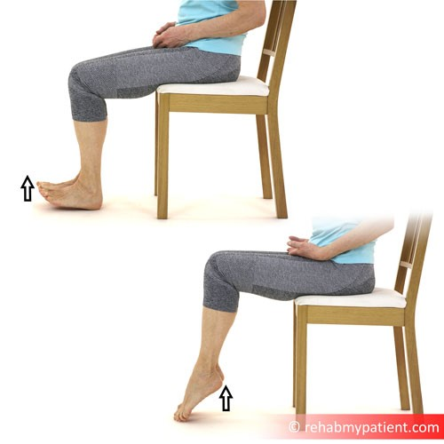
Salisbury FT Therapy Dept
Salisbury Hospital
Odstock Road
Salisbury
SP2 8BJ
Phone:
01722 336262
Email:
sft.therapyexercises@nhs.net
Website:
http://www.salisbury.nhs.uk/foundation/Pages/Home.as
px
Exercise plan:
Chair exercises
Patient:
Med/Surg Template
Date:
23
rd May
2020
Elbow Flexion Bicep Curl Sitting with Dumbbell
Sittin in a chair, hold on to a dumbbell/tin can. Bend your elbow.
At the top of the movement, slowly lower the dumbbell in a
controlled way. Keep your elbow tucked in to your side. This is a
strengthening exercise for your elbow and upper arm (Biceps
muscle).
Repeat 8 times | Perform 3 times daily | Perform both sides
Video:
http://youtu.be/BtiD0LsWyC
0
Shoulder Push
Sitting in the chair, grasp a dumbbell in each hand, and lift the
dumbbell above your head with one arm, and then the other.
This exercise strengthens the deltoid muscle group.
Repeat 8 times | Perform 3 times daily | Perform both sides
Video:
http://youtu.be/ddRR7SFmuu
g
Heel Raises and Toe Lifts Sitting
Sit upright with good posture, with your feet flat on the floor. You
can do this exercise in your shoes, or with bare feet. Lift your
heels going up on to your toes, and then return to the floor. Lift
your toes going up on your heels, and then return to the floor.
This exercise will help strengthen your lower legs and ankles.
Repeat 8 times | Perform 3 times daily | Perform both sides
Video:
https://youtu.be/-7AF6kP3n-
8
http://www.salisbury.nhs.uk/foundation/Pages/ Page: 1 / 2
Home.aspx
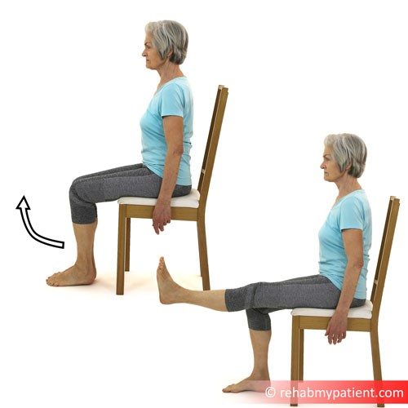
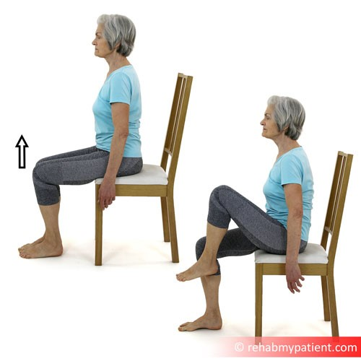
Please stop any exercise that causes pain. If you have any questions with an exercise, please speak to your ward physiotherapist (8.30am-4.30pm). Good luck and keep with it!
Knee Extensions Sitting
Sit upright with good posture. Slowly straighten your leg out in
front of you as far as feels comfortable. Slowly lower back to the
floor, then repeat with the other leg.
Repeat 5 times | Perform 3 times daily | Perform both sides
Video:
https://youtu.be/uklsfS5YTX
A
Hip Flexion Sitting
Sit upright with good posture. Slowly lift your left leg upward
bending your knee towards your chest. Slowly lower back down
and repeat with the right leg. Only go as far as feels comfortable.
Do not bend your back forwards during the exercise. This
exercise will mobilise your hip joint and strengthen your hip and
leg muscles.
Repeat 5 times | Perform 3 times daily | Perform both sides
Video:
https://youtu.be/Qh65cLC8Oa
I
http://www.salisbury.nhs.uk/foundation/Pages/ Page: 2 / 2
Home.aspx

