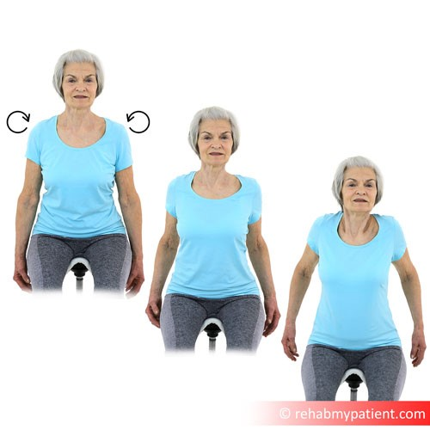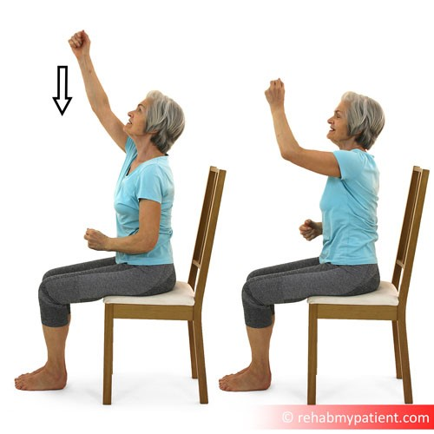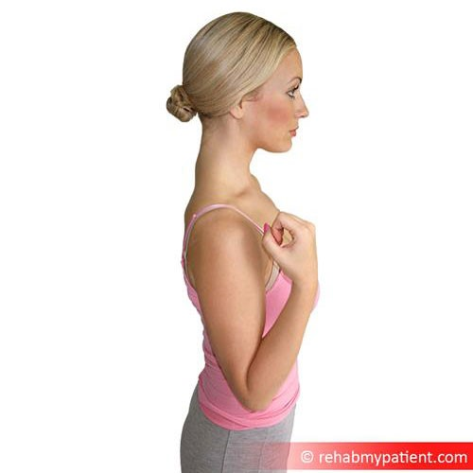
Salisbury FT Therapy Dept
Salisbury Hospital
Odstock Road
Salisbury
SP2 8BJ
Phone:
01722 336262
Email:
sft.therapyexercises@nhs.net
Website:
http://www.salisbury.nhs.uk/foundation/Pages/Home.as
px
Exercise plan:
Bed exercises
Patient:
Med/Surg Template
Date:
23
rd May
2020
Shoulder Rolls Sitting
Sit upright with good posture and with your arms resting by your
side. Pull your shoulders back by pulling your shoulder blades
together, then raise them up towards your ears and then forward
and down in a circular motion. This exercise will improve posture
and shoulder mobility. Then reverse direction
Repeat 5 times | Perform 3 times daily
Video:
https://youtu.be/TLhoMLmze_
k
Climb a Rope Sitting
Sit upright with good posture, and imagine you have a rope in
front of you. Climb up the imaginary rope using your arms. This
exercise will help improve posture and strengthen your arms and
core.
Repeat 5 times | Perform 3 times daily | Perform both sides
Video:
https://youtu.be/x8vuJPisFO
g
Elbow Flexion
Bend your elbow as far as possible, and then relax to allow
your arm to hang down. This will help mobilise your elbow joint.
Repeat 5 times | Perform 3 times daily | Perform both sides
Video:
http://youtu.be/HiyVS_7hrG
8
http://www.salisbury.nhs.uk/foundation/Pages/ Page: 1 / 2
Home.aspx
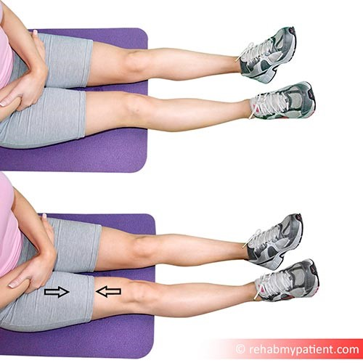
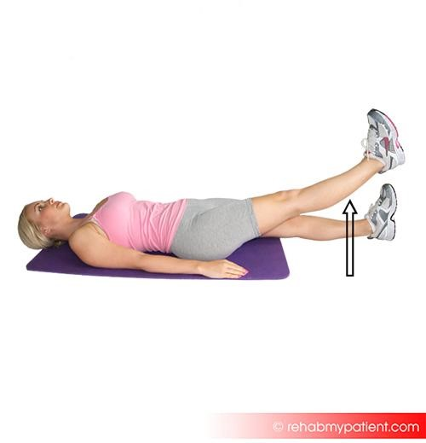
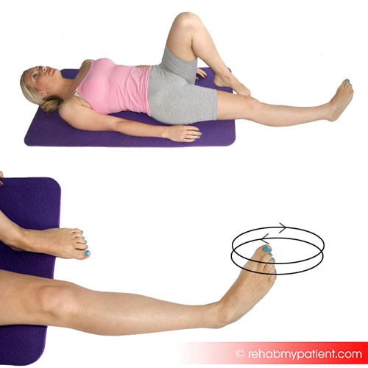
Please stop any exercise that causes pain. If you have any questions with an exercise, please speak to your ward physiotherapist (8.30am-4.30pm). Good luck and keep with it!
Static Quadriceps Contraction Sitting
Sit on the bed, and tighten your right thigh (quadriceps) muscle
by actively tensing/squeezing the muscle. To finish, just relax the
quadriceps muscle.
Repeat 5 times | Perform 3 times daily | Perform both sides
Video:
http://youtu.be/ltZhmKM9KT
4
Leg Lift
Lift your leg off the bed. This exercise will mobilise your hip joint
and strengthen the hip flexor muscles. Lift your leg as far as feels
comfortable, but with the aim to increasing your leg lift as your
leg becomes stronger and more mobile.
Repeat 5 times | Perform 3 times daily | Perform both sides
Video:
http://youtu.be/67ajrE4Aja
k
Ankle Circles Lying
Lying/sitting up in bed, move your ankles around in circles both
anti-clockwise and clockwise. This is a great mobility exercise to
the ankle.
Repeat 5 times | Perform 3 times daily | Perform both sides
Video:
http://youtu.be/Za8PFXDFp_
M
http://www.salisbury.nhs.uk/foundation/Pages/ Page: 2 / 2
Home.aspx

