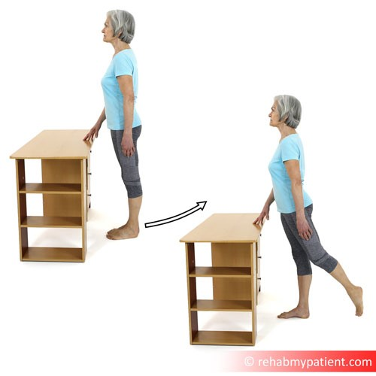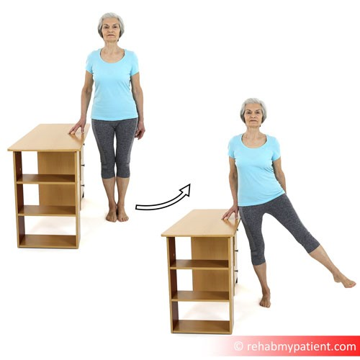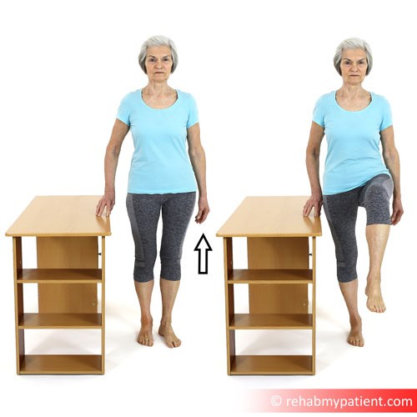
Salisbury FT Therapy Dept
Salisbury Hospital
Odstock Road
Salisbury
SP2 8BJ
Phone:
01722 336262
Email:
sft.therapyexercises@nhs.net
Website:
http://www.salisbury.nhs.uk/foundation/Pages/Home.as
px
Exercise plan:
Standing Exercises
Patient:
Med/Surg Template
Date:
24
th May
2020
Hip Extension Standing with Support
Stand upright with good posture. Hold on to a firm surface for
support. Extend your leg behind you, then back to starting position.
You should feel a pull in your buttock (gluteal) muscles on the leg
you are moving, and some mild pressure on the leg you are
standing on.
Repeat 8 times | Perform 3 times daily | Perform both sides
Video:
https://youtu.be/_DS9WZdBFO
E
Hip Abduction Standing with Support
Stand upright with good posture. Hold on to a firm surface for
support. Put your weight through one leg and take the other leg
out to the side, asa far as comfortable then back to neutral.
Repeat as required. You can also hold the leg out to the side and
maintain this position. This exercise predominantly strengthens
your outer hip and gluteal (buttock) muscles, but also mobilises a
stiff hip joint.
Repeat 8 times | Perform 3 times daily | Perform both sides
Video:
https://youtu.be/b50m4n6bem
M
Hip Flexion with Bent Knee Standing with Support
Stand upright with good posture. Hold on to a firm surface for
support. Put your weight through one leg and bend the other
knee towards your chest. This exercise will mobilise your hip joint
and strengthen the hip flexor muscles.
Repeat 10 times | Perform 3 times daily | Perform both sides
Video:
https://youtu.be/E_16XRcyCo
c
http://www.salisbury.nhs.uk/foundation/Pages/ Page: 1 / 2
Home.aspx
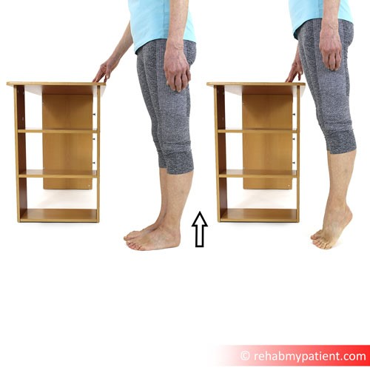
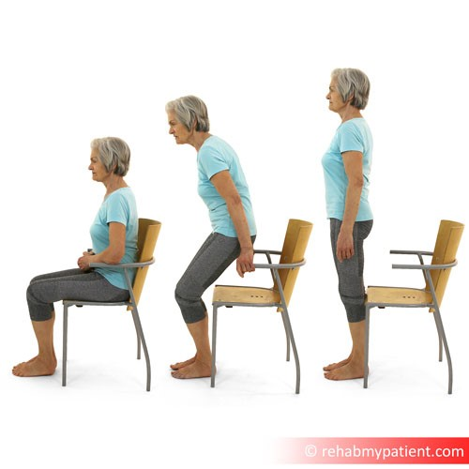
Please stop any exercise that causes pain. If you have any questions with an exercise, please speak to your ward physiotherapist (8.30am-4.30pm). Good luck and keep with it!
Calf Raises Standing with Support
Stand upright with good posture. Hold on to a firm surface for
support. Slowly raise up onto your toes, and control the
movement back down. This exercise will strengthen the calf
muscles and ankle joints.
Repeat 10 times | Perform 3 times daily | Perform both sides
Video:
https://youtu.be/6cqQXAaZ8C
U
Sit to Stand - Two Hands
Sit upright with good posture, and place your hands on the side
of the chair. Gently lean forwards and use as much leg strength
as you can to push yourself up. Use your hands and arms to
assist. Once upright, stand up straight. When you feel
comfortable, slowly sit back down, guiding yourself by using your
arms. Try to keep a straight spine during the sitting rather than
let your back round forwards too much. This exercise will
strengthen your legs and core. As this gets easier, try without
using your hands.
Repeat 10 times | Perform 3 times daily
Video:
https://youtu.be/4uc6Hljwb1
8
http://www.salisbury.nhs.uk/foundation/Pages/ Page: 2 / 2
Home.aspx

