Standard Operating Procedure
Follow Up Waiting List Conversion to PIFU
Letter Drop:
- Use PIFU master spreadsheet to identify the patients to send the letter to

- Order spreadsheet to start with earliest APE GAD date

- Search for patient in Lorenzo and go to Access Plan tab and select the specialty outpatient APE. To ensure the correct APE is selected please check that the access plan name, GAD date and comments match those in the columns on the spreadsheet

- Check TCI / Appointment date column on Lorenzo. If there is an appointment booked DO NOT send a letter. On spreadsheet please record ‘Appt booked’ in the ‘Date PIFU Letter Sent’ column

- If letter needs to be sent select Modify Access Plan and add the following:
  - On the Access Plan Details tab add ‘PIFU Letter sent dd/mm/yy’ to the start of the APE comments
  - On the Resource Monitoring tab amend the Guaranteed Activity Date to 6m from the date the letter is being sent e.g. if sent 22/05/21 amend to 22/11/21
  - On the Coding and Grouping tab add the PIFU coding using the Category of Investigations, the Coding Scheme of RNZSPFLG 1.0, and searching for the PIFU code
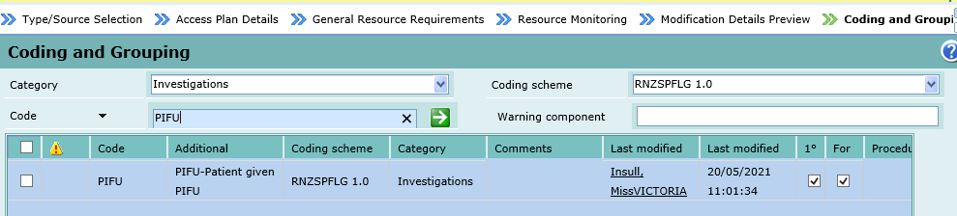
- Once this is completed click Finish and the Print Letter Screen should generate automatically. If it does not select Print Access Plan Letter from the Access Planning menu bar. Select the ‘PIFU conversion letter’ letter template and print to in-house printer

- Add date to ‘Date PIFU Letter Sent’ column in spreadsheet and save

Patient Options 1 – 3:
- I have concerns about my current situation and would like to speak to my clinician by phone about how I am, my treatment, and what I would like to do next.
- My symptoms are better and I am happy to be discharged.

- My condition has not changed and I wish to continue on the 6 month patient initiated follow up pathway suggested.

Admin Team:
- All patients who call following receipt of this PIFU letter, whether they wish to request an appointment, be removed from the waiting list, or remain on the suggested PIFU pathway need to be put through to the appropriate team to record and action their response

Booking Team: Actioning patient response 1 – 3:
- Response 1 – Record ‘PIFU response 1’ in the APE comments and book an urgent telephone follow up appointment for the patient with their consultant. If this cannot be booked within 21 days of the patient calling to request the appointment escalate to .. by email. Send email to .. with ‘PIFU response 1’ in the subject line and containing the patient initials and hospital number

- Response 2 - If a patient is calling to request removal from the waiting list. Please close the APE and record ‘PIFU response 2 – discharged’ in the closure comments

- Response 3 - Record ‘PIFU response 3’ at the start of the APE comments. No further action required

