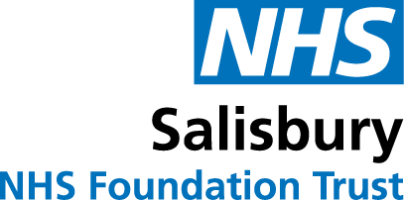
Surgical treatment during the Covid-19 pandemic
Like all hospitals we are working hard to tackle the impact of the Covid-19 virus.
Due to the increased health and safety risk caused by the Covid-19 virus, we need to take some extra precautions to safeguard patients and staff and ensure the best patient care.
Your specialist has recommended that your treatment includes surgery. It is important that you follow the advice below to make sure your treatment is as safe and effective as possible.
Planning for your surgery:
Before your surgery, your clinical team will explain the new procedures we have put in place to ensure your safety, and to safeguard our staff, during the pandemic. The clinical team will also address any concerns you may have and answer your questions. You will only be able to have surgery if your Covid-19 test proves negative and you display no Covid-19 symptoms. Not only is this is important to ensure that you have the best outcome from your surgery, but to protect you, other patients, and our staff. Some patients, who are at greater risk of getting COVID-19 or having a poorer outcome if they get it, may be advised to self-isolate for 14 days before a procedure.
Before your surgery:
- You will be asked to agree to being tested for Covid-19 no longer than 72 hours prior to admission for your operation with strict self-isolation required after this.
- Your hospital team will make arrangements for you to have a Covid-19 test 48 hours before the day of your surgery and this may also include a chest X-ray or scan if they consider it appropriate.
- Whenever you come to the hospital you must wear a face mask.
If you experience Covid-19 symptoms prior to your procedure date you should inform your clinical team and follow government guidance: https://www.nhs.uk/conditions/coronavirus-covid-19/check-if-you-have-coronavirus-symptoms/
Recovering after your surgery:
Your clinical team will tell you how best to look after yourself when you are discharged home after surgery. They will also talk through any concerns you may have and answer your questions.
Additional Information:
Visiting
We currently have some visiting restrictions – these are subject to change and so please see our web site for more information https://www.salisbury.nhs.uk/coronavirus/visitor-restrictions/
If you have any concerns or questions about how to prepare for your surgery, please contact a member of your hospital team who will be able to help you.
Keeping in touch when visiting is restricted
All our wards have access to IPads so can set-up and support video calls to your family members if you not have your own (or do not bring yours with you to hospital).
If your loved ones want to keep in touch they can send messages and photos by email to our PALS team at: sft.messagetoalovedone@nhs.net. Messages can also be phoned through to the team (Monday to Friday) on 07393 267852.
Messages are printed out, stuck onto a card and delivered to the wards every day.

Version: 1.4 August 2021
Due for review: August 2022

