Salisbury Hospital COVID-19 Mouth Care Guidance
We advise that patients who have COVID-19, or who are suspected of having COVID-19, should follow careful steps to ensure good mouth care during and after their illness.
This advice is based on 1) research demonstrating that the mouth is a reservoir of SARS-CoV-2 (the virus that causes COVID-19) and is a site of virus copying; and 2) research which suggests that the virus could pass from saliva into the blood vessels of the mouth and then travel to the lungs via the bloodstream, rather than just by inhalation into the airways of the lungs.
Why this is important for you
- A teaspoon of saliva can contain 500 million copies of the SARS-CoV-2 virus.
- The more virus there is in someone’s saliva the more likely they are to get more severe COVID-19.
- Having high virus numbers in saliva is a stronger predictor of death than a patient’s age.
- Having severe gum disease increases the risk of getting severe COVID-19.
- Research shows that those who die from COVID-19 are 8.8 times more likely to have had severe gum disease.
Put another way, the increased risk of death from COVID-19 in people with severe gum disease is 780% higher.
- Research shows that the SARS-CoV-2 virus can be killed in the test tube with the use of some specific mouthwash products which are cheap and easily available in supermarkets, pharmacies, and online (see list below).
- Oral healthcare measures have also been shown to improve the chance of recovery from other types of pneumonia in hospital patients. The same might be true for COVID-19.
Guidance
Here are the simple steps that adults can take every day to protect and improve their oral health. These steps are based on advice from Public Health England: Delivering Better Oral Health, and The European Federation of Periodontology: Primary Prevention of Periodontitis.
- Clean between the teeth by interdental brushing, or floss where the gaps are too tight to use interdental brushes.
- Brush your teeth at least twice a day for at least 2 minutes using a fluoride toothpaste.
- Brush last thing at night so there are lower numbers of troublesome bacteria in your mouth while you sleep.
- Brush all surfaces of each tooth carefully and specifically clean well along the gum line.
- Spit out after toothbrushing but do not rinse away the toothpaste from your mouth as it contains protective agents against gum disease and tooth decay – spit, don’t rinse!
- Use a mouthwash. (See guidance below).
- In view of 5, use mouthwash at a separate time from when you brush your teeth (not within 30 minutes).
- If you wear dentures it is important to clean them after meals to remove debris. The mouth should also be cleaned with a soft toothbrush twice a day.
Which mouthwash should I use?
The following specific products have been shown to be active against SARS-CoV-2 in test tubes.
- Dentyl Dual Action (contains CPC) – (requires shaking)
- Dentyl Fresh Protect (contains CPC)
- Listerine Advanced Defence Gum Treatment (contains ELA / LAE)
- Corsodyl (contains Chlorhexidine which has only limited evidence for anti-SARS-CoV-2 effects)
These products are safe enough to be sold without prescription. Follow the instructions on the bottle.
Mouthwash should not be swallowed. If someone does not understand that the mouthwash should not be swallowed, then it should not be used, or only used under supervision.
Note: Mouthwashes containing only alcohol or chlorhexidine are effective at killing plaque bacteria which possibly encourage entry of SARS-CoV-2, but there is limited evidence that they directly kill the virus. Only products containing Cetylpyridinium Chloride (CPC) or Ethyl Lauroyl Arginate (ELA / LAE) have evidence for killing SARS-CoV-2 in the test tube. We await the results of clinical trials of their effect in the mouth.
Should I use these mouthwashes if I have COVID-19?
Yes, even if you feel well, we suggest you start using one of these mouthwashes immediately after a positive test for COVID-19 and continue its use for at least 2 weeks. The SARS-CoV-2 virus can stay in the saliva in the mouth for more than two months after infection.
Note: Alcohol and benzoic acid can irritate the mouth, so products containing these (such as the Listerine product) should not be used for prolonged periods, unless advised by your dentist.
Any questions?
If you have any questions, please ask staff in the ward or department, or seek advice from your dentist.

Document author: Graham Lloyd-Jones (Consultant Radiologist, Salisbury NHS Foundation Trust)
Reviewed by: Iain Chapple (Professor of Periodontology, Birmingham University)
Mili Doshi (Consultant in Special Care Dentistry, Surrey and Sussex Healthcare NHS Trust)
Katy Kerr (Associate Postgraduate Dental Dean, Health Education England, South East)

Date written: May 2021 Last amended: September 2021 Version: 1.6 Review due: December 2021
Updated version available here - https://www.salisbury.nhs.uk/coronavirus/covid-19-mouth-care/

Salisbury Hospital COVID-19 Mouth Care

(Please also see the separate guidance document.)

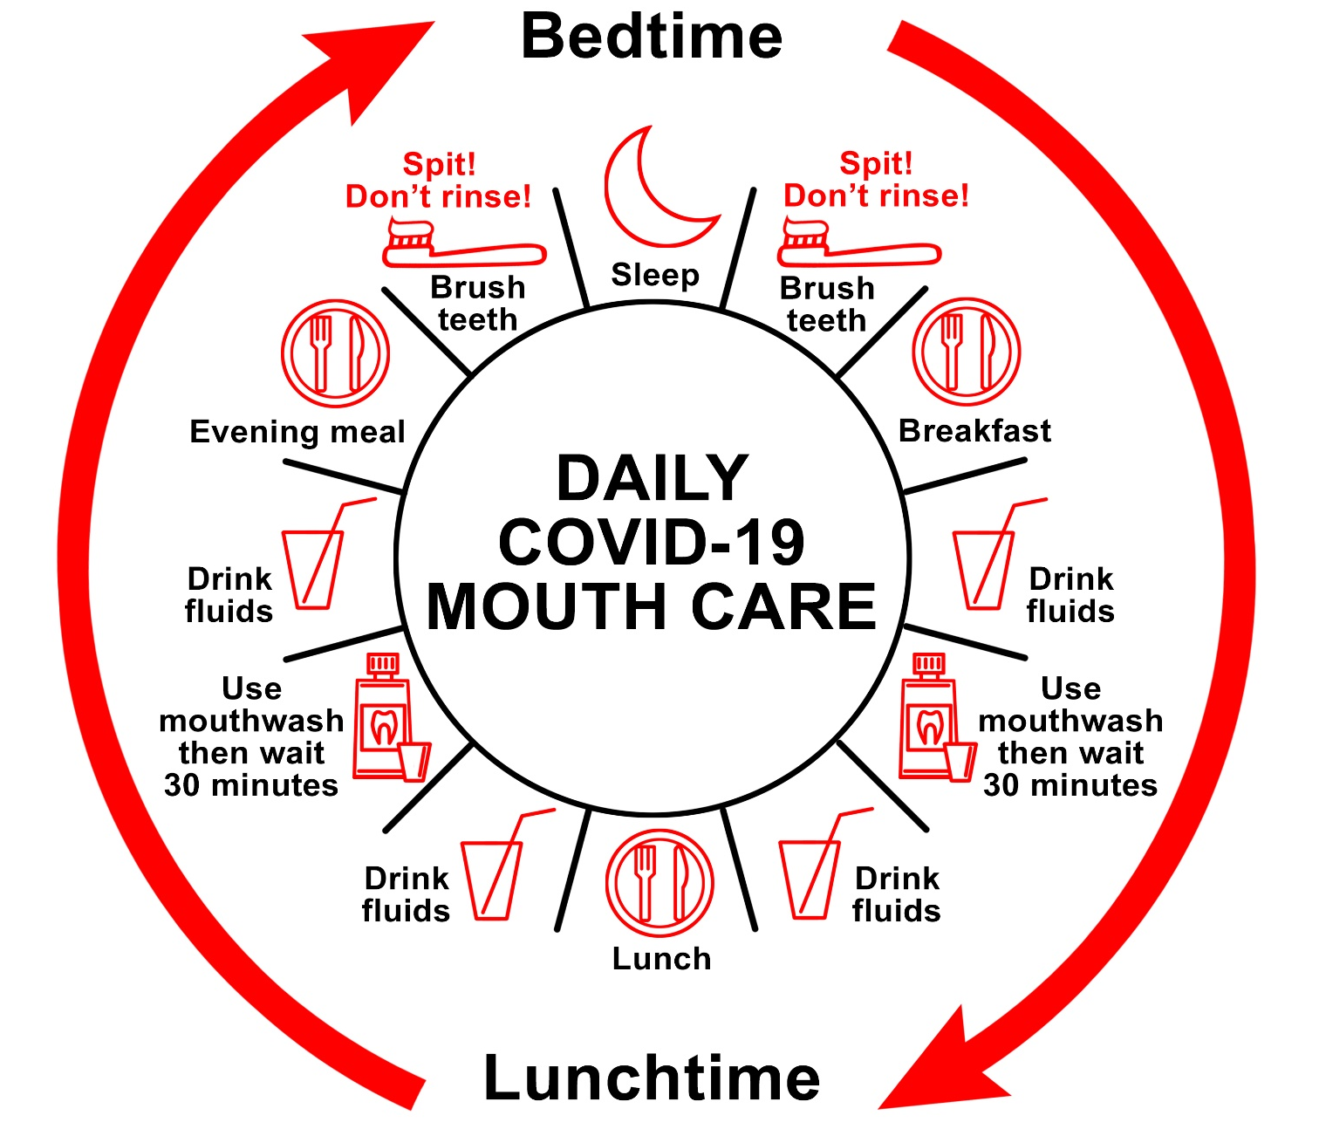

- Drink plenty of fluids throughout the day
- Do not allow your mouth to dry out
- Keep your mouth healthy and clean. Brush your teeth last thing at night and at one other time of day. After brushing – Spit! Don’t rinse!
- Use the mouthwash provided at a different time from brushing your teeth, for example, after a morning or afternoon drink, or after eating
- Do not swallow the mouthwash – rinse for 30 seconds then spit it out
- Wait 30 minutes after using the mouthwash before eating or drinking
- If you need assistance with mouth care while on the ward, please ask a member of staff for help

