Salisbury Hospital COVID-19 Mouth Care

(Please also see the separate guidance document.)

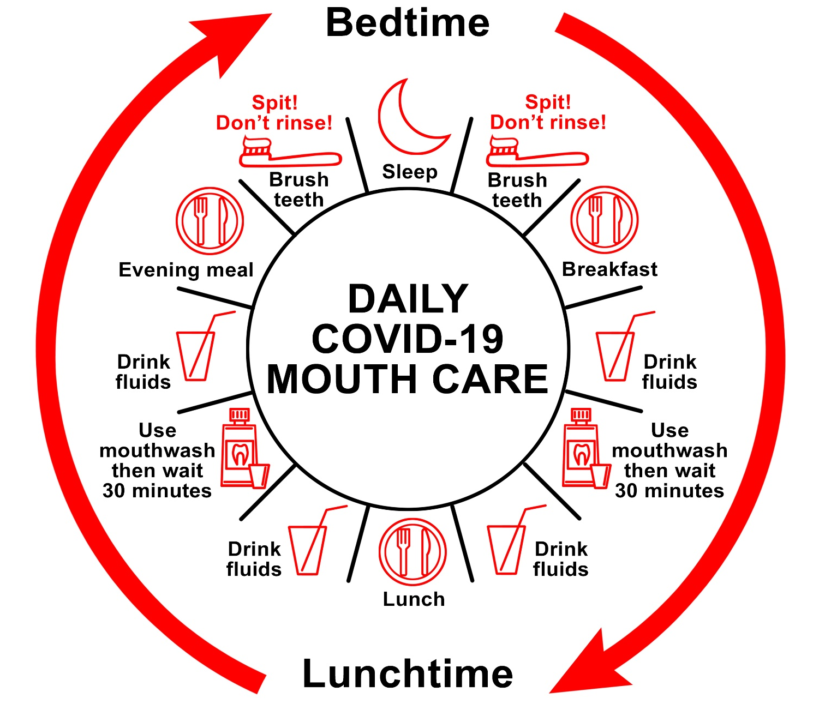

- Drink plenty of fluids throughout the day.
- Do not allow your mouth to dry out.
- Keep your mouth healthy and clean. Brush your teeth last thing at night and at one other time of day. After brushing – Spit! Don’t rinse!
- Use the mouthwash provided at a different time from brushing your teeth, for example, after a morning or afternoon drink, or after eating.
- Do not swallow the mouthwash – rinse for 30 seconds then spit it out.
- Wait 30 minutes after using the mouthwash before eating or drinking.
- If you need assistance with mouth care while on the ward, please ask a member of staff for help.

