Living with COVID-19 Infection: Information for your in-patient stay.
In April 2022, Government guidance for hospitals changed. This means that if you are a contact of a positive COVID-19 (SARS-CoV-2) case, you will not be required to isolate if you do not have symptoms. We will continue to tell you if you have come into contact with a patient who has tested positive for COVID-19.

What happens if I have contact with a patient who tested positive for COVID -19?
If you are considered a contact of positive COVID-19 (SARS-CoV-2) case, you will not be required to isolate if you do not have symptoms.

What happens if I develop symptoms of COVID-19 whilst I am in hospital?
If symptoms do occur, you will be tested for COVID-19. You may need to be isolated or placed with other patients who have symptoms or if you test positive, with other patients who have also tested positive.
Will I be routinely tested for COVID-19 during my admission?
You will be tested on admission to Hospital. You will only be tested again if:
- A test result is required to discharge you to a care facility
- You become unwell and a test is required to help make decisions about your treatment
If you have any questions regarding your care, please ask the Doctor or Nurse looking after you.
What is the Hospital doing to stop me from getting COVID-19 when I am an in-patient?
As the COVID pandemic has unfolded we have recognised that, despite the best efforts of our staff to continue to deliver high quality care at a very difficult time, a proportion of patients develop COVID whilst in NHS hospitals and we offer our sincere apologies for that. We continue to review all new guidance and make changes to support all patients in hospital.

What can I do to help stop the spread of infection?
It is helpful for us to know if you have received COVID-19 vaccinations, please tell the ward staff this information.

Please wear a face mask when you can. We will also continue to ask any visitors to the Hospital to wear face masks.

Follow the basics of good hygiene as shown in the table below.
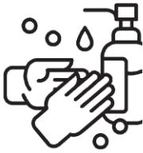 | 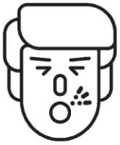
Wash your hands frequently and thoroughly, for at least 20 seconds. Use alcohol-based sanitizer if soap and water aren’t available | Cover your mouth and nose with a tissue when you cough or sneeze and then throw the tissue in the bin and wash your hands. Alternatively, cough or sneeze into your elbow | Avoid touching your eyes, nose and mouth with unwashed hands.

