New Mouth Care Equipment
Reusable Oralieve 360 Toothbrush | For use with patients who have complex oral health needs or those who are receiving EOLC  - 360 soft bristles clean multiple surfaces of the mouth simultaneously providing a gentle clean to sore mouths  - A small head to access hard to reach areas of the mouth  - Can be dipped in water to deliver moisture to the mouth or tastes for pleasure  - Can be used to deliver mouth moisturising gel to the tongue, cheeks, and roof of the mouth  Directions: Move the brush up and down in the mouth like a standard toothbrush. Rinse clean with water after use. Dry with paper towel and store in original packaging.  Replace after three months or if the head is showing signs of wear or rotates.
Single Use Sage Mouth Swab  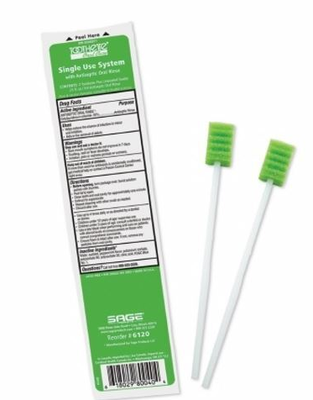 | Single Use individual mouth swabs:  For use only  - When 360 toothbrushes are ineffective in providing adequate moisture to the mouth  - Patient’s preference over 360 toothbrushes  - May be used to apply mouth moisturiser.  Directions: Moisten swab with water immediately prior to use. Apply moisture to tongue, hard palate, cheeks, and lips. Discard immediately after single use. Do not allow patient to bite down on the oral care tool. If patient has altered levels of consciousness or cannot comprehend commands, please use 360 toothbrushes instead. Failure to follow these safety precautions may damage the device and present a choking/aspiration hazard.
Low Foaming (SLS free) Toothpaste  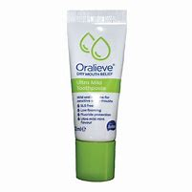  Must be prescribed | This low foaming (SLS free) toothpaste is for use with patients with conditions such as dysphagia, dry mouth or individuals who are nil by mouth or unable to follow direction due to cognitive issues.  - Very mild mint flavour  - SLS-free (low foaming)  - Contains 1450ppm fluoride to help protect teeth  - Suitable for vegetarians  - Contains milk proteins so must be prescribed and not suitable for vegans or pts with lactose intolerance  Directions: A smear of non-foaming SLS free toothpaste should be used and the paste should be pressed into the bristles of a normal or 360 toothbrushes. You do not need to wet the bristles or rinse the mouth after brushing.
Toothette Mouth Moisturiser  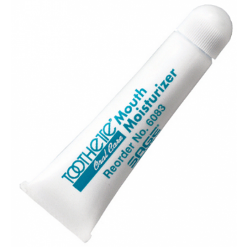  Must be prescribed | A healthy, moisturized mouth can make it easier to eat and communicate and is essential for healing mouth sores. It can be applied to the lips and inside of the mouth.  - Soothes and hydrates lips and mouth.  - Water-based formula contains Vitamin E and coconut oil.  - Mild spearmint flavour is a refreshing taste.  - Alcohol-free and formulated with moisturizing ingredients.  - Should be prescribed.  Directions: Can be applied to the lips and/or inside of the mouth. Can be used by patients requiring oxygen. Other mouth moisturisers can be prescribed depending on individual need and patient preference.

