

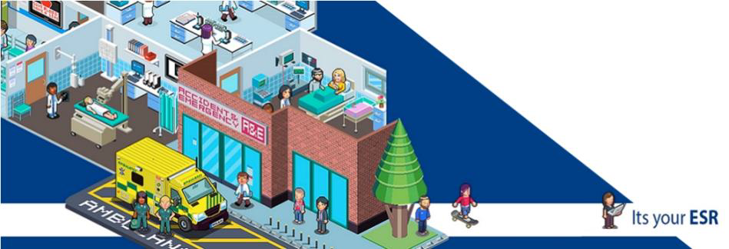

**THE ESR MANAGER SELF-SERVICE (MSS) DASHBOARD**

**How to request Flexible Working in ESR**

**ESR EMPLOYEE SELF-SERVICE DASHBOARD**

**How to request Flexible Working in ESR**

Log in to ESR (as you would to view Payslips) <https://my.esr.nhs.uk>

From **My Pages** (left hand side of screen)

* Select ‘**My Employment**’
* Select ‘**Flexible Working**’
* Select **Assignment/Superviso**r this flexible working request is for
* Select ‘**Create new reques**t’ on the top right-hand side of screen
* *Complete form*
* Select **‘Submit’** on top right hand side of screen to send request to Manager

**Your Manager receives email notification that request has been made.**

**How to manage a Flexible Working Request in ESR**

Manager receives email notification that request has been made.

In ESR Portal click on **‘Notification’** on top right hand of screen **‘OR’** click on ‘**Request received’** on automated email (do not change email recipient).

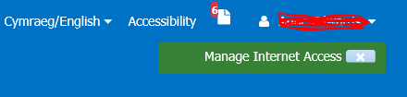

* From ‘**Worklist’** select **Flexible Working**
* Click on ‘**Request Received’** top right of screen

Manager arranges a meeting with employee to review and discuss. Once outcome is agreed, Manager updates Flexible Working request on ESR:

* Select **Manager Dashboard** (tab)
* Select **‘My Team Assignment’**
* Select ‘**Flexible Working’**
* Select **person in Hierarchy**
* Select **‘Action’**
* Select ‘**Update the request’**

* Check details andcomplete **‘Outcome’** in **Arrangements and Outcomes**
* Select **‘Submit’**

**\*\* IMPORTANT ** MANAGERS ** PLEASE NOTE \*\*** If a flexible working request results in a **change in assignment or contractual hours** – assignment changes need to be actioned separately via ESR MSS.

**Comments and Feedback**

Thank you for taking the time to read this guide, we hope you found it useful.

However if there are any improvements we could make please let us know at

[sft.ess.support@nhs.net](mailto:sft.ess.support@nhs.net)