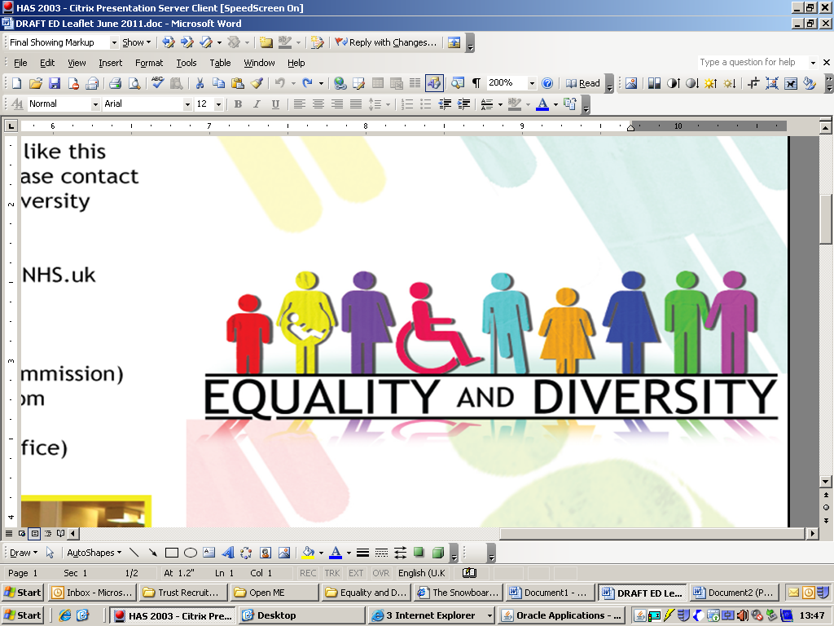
GUIDANCE ON THE COMPLETION AND APPROVAL OF

EQUALITY ANALYSIS (EA)

Appendix C
Equality Act 2010

The Government has stated its intention to make sure that equality and fairness are at the centre of its overall approach and the Equality Act is a key means of achieving this.

Equality legislation has developed over several decades in response to the lack of equity experienced by individuals and groups in society. The Equality Act has strengthened and harmonised the law which now covers a range of 9 protected characteristics:

- Religion or Belief
- Age
- Race
- Sex
- Disability
- Marriage and Civil Partnership
- Gender reassignment
- Pregnancy and maternity
- Sexual orientation

Everyone identifies with one or more of these characteristics so it is important to think across the spectrum of potential disadvantage when assessing the impact on the decision-making process and equality analysis.

We must make sure that all our policies, strategies, functions and activities are given due regard to Section 149 of the Equality Act 2012. The Public Sector Equality Duties (PSED) has 3 aims and we must have due regard:
- To eliminate discrimination, harassment and victimisation
- To advance equality of opportunity
- To foster good relations

Equality Analysis

Under the Equality Act 2010 the Trust has an obligation to:

- Evidence the analysis that has been undertaken to establish whether our policies and practices have (or would) further the aims of the general equality duty.
- Provide details of information that we have considered when carrying out an analysis.
- Provide details of engagement (consultation / involvement) that we have undertaken with people whom we consider would have an interest in furthering the aims of the general equality duty.

In order to meet the requirements of this duty the Trust will use the Equality Analysis which has been developed to be compliant with the Equality Act 2010.

An equality analysis is most effective when used at the primary stages of planning and is expected to be used for the following activities:

- Organisational change
- Considering any new or changing activity
- Developing or changing service delivery
- Procuring services
- Developing projects
- Developing a policy / procedure / guidance or changing or updating existing ones

It is used to assess whether there may be any barriers or difficulties, harassment or exclusion, or in fact any positive impact such as promotion of equality of opportunity, developing good community relationships, encouraging participation and involvement as experienced by service users, patients, carers, relatives, staff, the general public and key stakeholders.

When completing an Equality Analysis also consider whether the Trusts values and behaviours are addressed. These are:

Patient Centred and Safe:
This centres on patient safety, team work and continuous improvement.

Professional:
This focuses on being open and honest, efficient and acting as a good role model.

Responsive:
The expectation here is that staff will be action orientated, with a "can do" attitude and that they innovate, take personal responsibility and listen and learn.

Friendly:
We would expect staff to be welcoming, treat people with respect and dignity and value others as individuals.

The Equality Analysis form should be completed alongside the ‘Equality Definitions’ guidance and an action plan completed.

Process for approving Equality Analysis

All Equality Analysis should be sent to the line manager as soon as they have been completed for sign off, with a copy sent to the Equality and Diversity Department.

Some Equality Analysis will be available on the Trust intranet and website, and some subject to audit by external organisations such as the Equality and Human Rights Commission and it is therefore important that the documents are of a high quality and accurately reflect the time and effort which staff devote to ensuring that Trust services, activities and policies or procedures are progressive, seek to remove barriers and promote equality and diversity.

Who should complete an Equality Analysis?

The Equality Analysis should be completed by staff who have undertaken the MLE online Equality Analysis training which will equip staff with the tools needed to complete the Equality Analysis template.

Support and advice can be obtained from members of the Equality and Diversity Team.

Further advice and support

If you would like further advice or support to complete the Equality Analysis Template please contact the Head of Inclusion Health and Wellbeing: harjinder.bahra@nhs.net

Equality Analysis (EA’s) Template

1.Title of policy, programme, framework or organisational change being analysed.

Managing Implications of Organisational Change Policy (including Redundancy)

2. Please state the aims and objectives of this work and the intended equality outcomes. How does this
proposal link to the organisation’s business plan or Values and Beliefs?

This Organisational Change policy outlines how change should be managed and explains the procedures for consultation and communication, staff development and support. It also outlines the measures to be taken, as far as possible, to maintain job security and to avoid redundancy and details the redeployment processes and the procedure to be followed when redundancy is unavoidable.

3. Who is likely to be affected? Eg: staff, patients, service users (please refer to appendix 1)

Staff
4. Using the ‘Equality Definitions’ template - What evidence do you have of the potential impact (positive or negative)? Include any supporting evidence eg: research, data or feedback from engagement activities

4.1 Disability
Positive impact – the policy does not discriminate and applies to all protected characteristics under the Equality Act 2010
4.2 Sex (Male or Female)
Positive impact – the policy does not discriminate and applies to all protected characteristics under the Equality Act 2010

4.3 Race
Positive impact – the policy does not discriminate and applies to all protected characteristics under the Equality Act 2010

4.4 Age
Positive impact – the policy does not discriminate and applies to all protected characteristics under the Equality Act 2010

4.5 Transgender
Positive impact – the policy does not discriminate and applies to all protected characteristics under the Equality Act 2010

4.6 Sexual Orientation (this will include lesbian, gay and bi sexual as well as heterosexual people)
Positive impact – the policy does not discriminate and applies to all protected characteristics under the Equality Act 2010
4.7 Religion or belief (includes religion, beliefs or no religion or belief)
Positive impact – the policy does not discriminate and applies to all protected characteristics under the Equality Act 2010

4.8 Marriage and civil partnership
Positive impact – the policy does not discriminate and applies to all protected characteristics under the Equality Act 2010
4.9 Pregnancy and maternity (this can include impact on working arrangements and infant caring responsibilities)
Positive impact – the policy does not discriminate and applies to all protected characteristics under the Equality Act 2010

5.0 This table should be completed with all actions identified to mitigate any negative effects  List of Actions: | Action Plan | Target  Date | Review Date | Person Responsible

6.0 Sign off

Name and signature of person who carried out this analysis: Gary Dawson

Date analysis completed: December 2019

Name and signature of line manager: Glennis Toms

Date analysis approved by line manager: December 2019

Copy forwarded to Equality and Diversity Department:

Equality Definitions

The Equality Act 2010 identifies a number of groups or ‘characteristics’ protected against discrimination.
Protected  Characteristic | Who to consider | Issues
Age | Refers to a person belonging to a particular age (eg, 32 year olds) or range of ages (eg, 18-30 year olds)  Equality Act legislation defines age as 18 years and above | - Assumptions based on the age range, capabilities, experience, eg children / young people as carers, teenage parents.  - Access to services – physical, information for older population, technology issues.
Sex | A man or a woman | - Issues which can particularly affect women (who are predominantly the main carers) include physical access, eg pushchairs, and restrictions on time because of caring duties, eg difficulty in arranging appointments or attending events.  - Under-representation, isolation, domestic violence.  - Pensions, low incomes.
Race | Refers to an individual or group of people defined by their race, colour, and nationality (including citizenship) ethnic or national origins.  Romany Gypsies and Irish Travellers are protected from discrimination under the Race protected characteristic | - Access to services – communication, language, translation, different cultural traditions, customs, lifestyles  - Difficulty in arranging appointments/attending events due to work patterns.  - Social isolation, vulnerable to harassment and hate crime
Religion or Belief | Religion has the meaning usually given to it but belief includes religious and philosophical beliefs, including lack of belief (e.g Atheism). Generally, a belief should affect your life choices or the way you live for it to be included in the definition. (Excludes political beliefs) | - Assumptions about lifestyle, disrespect for certain viewpoints.  - Timings for events; some days and times have religious significance so attending appointments or events can become an issue.  - Space for worship or reflection
Sexual Orientation | Whether a person’s attraction is towards their own sex, the opposite sex or both sexes. | - Assumptions about lifestyle, family type, partners.  - Isolation, invisibility, vulnerable to harassment and hate crime
Marriage and Civil  Partnership | Marriage is defined as a ‘union between a man and a woman’. Same-sex couples can have their relationships recognises as ‘civil partnerships’. Civil Partners must be treated the same as married couples on a wide range of legal matters. | - Same rights for same sex couples – pensions, childcare etc
Disability | A person has a disability if they have a physical or mental impairment which has a substantial and long term effect on that person’s ability to carry out normal day-to-day activities. Includes mobility, sight, speech and language, mental health, HIV, multiple sclerosis, cancer. | - Access issues – physical, communication, formats, signage, carers, low income  - Vulnerable to harassment and hate crime
Pregnancy&  Maternity | Pregnancy is the condition of being pregnant or expecting a baby. Maternity refers to the period after the birth and is linked to maternity leave in the employment context. In non-work context, protection against maternity discrimination is for 26 weeks after giving birth. This includes treating a woman unfavourably because she is breastfeeding. | - Includes treating a woman unfavourably because she is breastfeeding.
Gender  Reassignment | The process of transitioning from one gender to another. | - Assumptions and ignorance.  - Social isolation, vulnerable to harassment and hate crime.  - Changing rooms and toilets can become an issue.
Additional  characteristics  important to area | Eg - areas of rurality - can affect the way we deliver services. Rural issues are an important factor when completing an EA’s. | - Access to transport – public and personal, travel can be expensive. Transport issues affects all groups.  - Isolation  - Poorer ICT connections/access to broadband

