**Finger Flexor tendon injury**

**Manchester Short Splint**

The injury you have sustained is to the tendons that bend the fingers. You have received very delicate surgery to repair the tendons(s) that bend the fingers.

Although the tendon(s) have been repaired surgically, it will take 2-3 months for the repair to be strong enough to cope with the normal use of your hand.

**Care of your hand after the operation**

**Preventing swelling**

If you let your hand hang down, it will make any swelling worse. This will make your hand painful and stiff and stop it from working properly. Your hand must be kept above the level of your heart until it is no longer swollen, this may take a few weeks. At night you should rest your hand on pillows.

 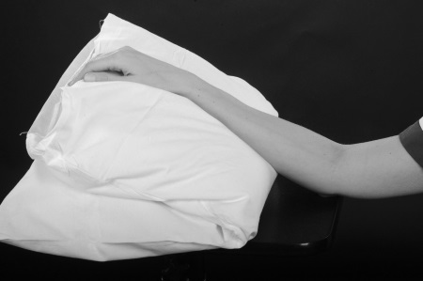

To stop your hand becoming too swollen and to stop your elbow and shoulder from becoming stiff you will need to do ‘pumping exercises’ with your whole arm 10-15 times every half an hour. This is done by reaching up towards the ceiling and then back down to shoulder level.

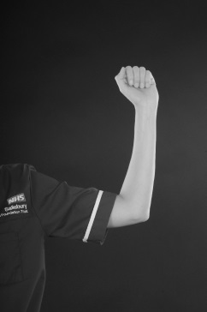  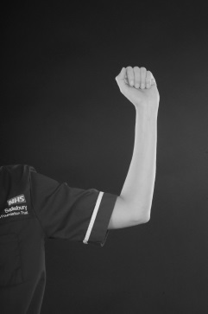

**Looking after your wound**

To assist with healing and make it easier to do your exercises, your wound will be left with minimal or no dressings. It is important that you keep your wound clean and dry until it is fully healed. You must monitor your wound for signs of infection which include increasing pain and swelling, redness and discharge/fluid which may be foul smelling. If you are concerned that your wound may be infected, please contact the Plastic Dressings Clinic on the telephone number below.

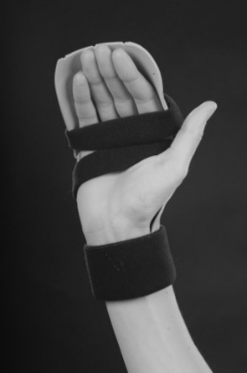**Protecting the repaired tendon from breaking**

In order to protect your repaired tendon, a light plastic splint will

be made which you must wear at all times until your tendon has healed.

Your therapist will advise you when you can start to remove your splint.

**Exercises**

Normally as you move your fingers your tendons glide in your hand. After a tendon repair they will not glide so well. The following exercises will help your tendon(s) to glide as it heals.

**Weeks 1-5**

Your splint should be worn at all times. You should do the following exercises as instructed:

1. **Passive Hook**

Push each of the fingers, one at a time, into a hook position, using the other hand.

Hold for 2 seconds, repeat 10 times. Then using the other hand maintain a 30 second hook stretch on each finger, repeat this twice. Repeat every 1-2 hours.

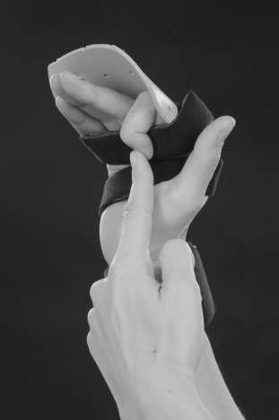

1. **Active finger extension with wrist flexion**

With your wrist held forwards, straighten all the fingers to touch the back of the splint, relax fingers as you bring your wrist into a straight position. Hold for 2 seconds, repeat 5-10 times, every 1-2 hour(s).

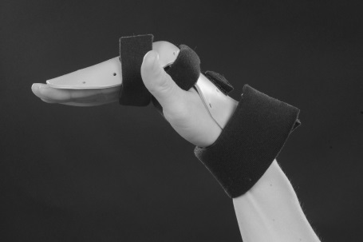

1. **Active finger flexion with wrist extension**

Hold your wrist backward, gently curl all the fingers, starting movement at the tips, towards a hook position. If the finger strap is in place, remove it for this exercise. Hold for 2 seconds, repeat 5-10 times, every 1-2 hour(s).

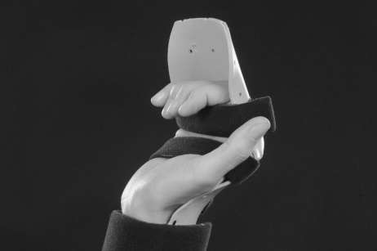

You must never force the fingers to make a full fist.

* Aim for ¼ hook fist in weeks 0 – 1
* Aim for ½ hook fist in weeks 2 – 3
* Aim for ¾ hook fist in weeks 3 – 4

Your therapist will clarify this with you at your appointments.

If you do not do the exercises as instructed, your hand may become stiff, or you risk damaging the tendon repair

**Optional Additional Exercises (to be prescribed by therapist as required):**

1. **Active flat fist:**

Gently straighten your fingers to the back of your splint, then keeping your fingertips straight, bend your finger middle joints to allow your tips to reach toward the base of your palm. Do this without using your other hand. Hold for 2 seconds, repeat 5-10 times, every 1-2 hour(s).



You should not use your affected hand for anything until specifically advised by your therapist.

**Week 2**

You may be able to begin to use your hand in the splint for very light activities. Your therapist will clarify this with you at your appointment.

|  |  |
| --- | --- |
| **Examples of Light Activities** | |
| **Personal Care** | * Putting on light clothes with easy fastenings |
| * Cleaning teeth (electric toothbrush) |
| * Shaving |
| * Putting on make up |
| * Brushing hair |
| * Tying shoelaces |
| * Using knife/fork/spoon, but not cutting meat |
| * Picking up small glass of water/cup of tea |
| **Work/home care** | * Writing/signing name |
| * Using computer keyboard/mouse/tablet |
| * Light dusting |
| * Using a light switch |
| * Handling money/card payments |
| **Leisure activities** | * Playing cards/board games |
| * Reading book/newspaper |
| * Computer games |

**Week 4**

At this stage you can progress towards making a full fist. Your therapist may show you some additional exercises.

You must continue to wear splint all the time. You may continue to use your hand for light functional tasks in the splint, as guided by your therapist.

**Weeks 5 - 6**

Continue to wear the splint at night and for protection during the day. You can use your hand for light function out of the splint and your therapist will advise you on how much you can use your hand.

You will be taught exercises by your therapist to improve the movement of your hand and wrist. If you do not do the exercises exactly as instructed, your hand may become stiff or you may risk damaging the tendon repair.

**Weeks 6 - 8**

At this stage you usually do not need to wear your splint anymore.

You will be instructed on further exercises and activities to improve movement, strength and use of your hand.

You can return to normal daily activities and **driving at 8 weeks**.

You will also be advised by your therapist whether you can return to your specific job or sport.

**Weeks 12+**

Normal use of your hand with no restrictions.

**Points to remember**

* Keep your hand above your heart all day and at night
* Do ‘pumping exercises’ every half an hour
* Do your exercises as frequently as you have been advised to do
* Do not remove your splint unless you have been advised to do so
* Do not attempt to alter your splint
* Do not get your splint wet
* Do not use your injured hand for anything unless you have been advised to
* Do not drive until you have been told you can

**Contact numbers**

Hand therapy: 01722 345530 (08:00 – 17:00 Monday to Friday)

Hospital switchboard: 01722 336262

Plastic Dressing Clinic nurses: ext 3254 (08:00 – 17:00 Monday to Friday)

Odstock ward: ext 3507/3139 (out of the above hours)

Your GP or NHS 111 is another source of assistance out of hours.

**Follow up**

You will be seen in the Outpatient Department within five days of your surgery. After this you will be seen every one to two weeks. Depending on where you live, you may be referred to a local hospital for hand therapy after your second appointment.