Referring a child with a Burn
- Do they need to be admitted now?
Is the child unwell following a burn, a burn more than 3% TBSA, electrical or chemical injury, or possibly one of the criteria in the box below.
Referrer needs to fill out MDSAS online referral form and then ring. We need to print a copy of the referral to put in the patients’ notes.
Inform Burns and Plastics Registrar through switch before accepting admission.
If >10% suggest starting Parkland Formula and insert catheter.
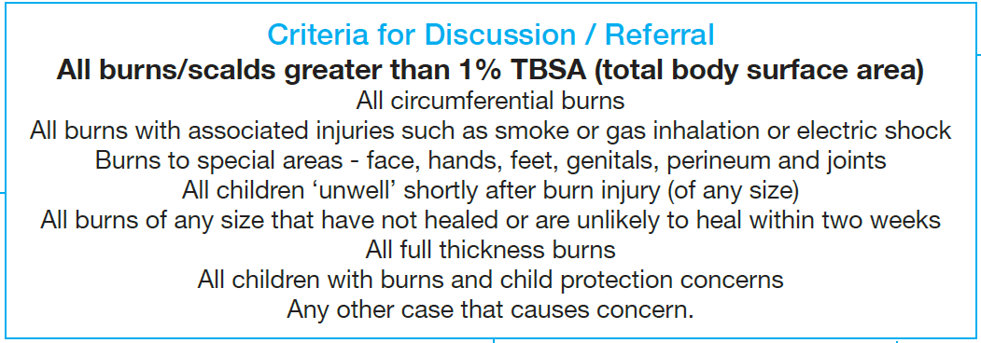
- Can it wait and be booked into clinic tomorrow?
All burns need following up in 24 hours as the burn could have got deeper. Ensure 20 minutes of cool running water has been achieved.
If deep partial or full thickness we definitely need to review it the following day in the burns clinic even if not on a special area of the body. If no clinic can Burns Outreach review – ring 07713083239.
Ensure referrer has used the MDSAS online referral form. Print a copy and put in the patients’ notes.
Give Toxic Shock advise
- Can it be dealt with locally?
All burns still need following up in 24 hours as the burn could have got deeper. Ensure 20 minutes of cool running water has been achieved.
If it is <1% burn (not to any special area) that is superficial or superficial partial thickness then this could be followed up by a Practice Nurse, District Nurse or A&E.
Ensure referrer has used the MDSAS online referral form. Print a copy and put in the burns telephone communication folder. Advise referring hospital to do the same so that the same QR code can be scanned the following day with the new photo using the SiD app.
Advise an appropriate non stick dressing and give Toxic Shock advise.

