**Appendix B**

**SYPOL Instructions**

The Trust uses Sypol CMS as their chosen software for the storing and managing of COSHH assessments. Staff can either be **Editors** or **Viewers**. Editors are designated by department leads to lead on their COSHH compliance, and act as the link between their department and Health and Safety. **This will require training by the Health and Safety team.**

Any staff can however log in to view assessments, should they require any information on a substance or material.

**Locating Sypol:**

Via the Trusts Sali page : *Home>Departments>Health&Safety>COSHH*

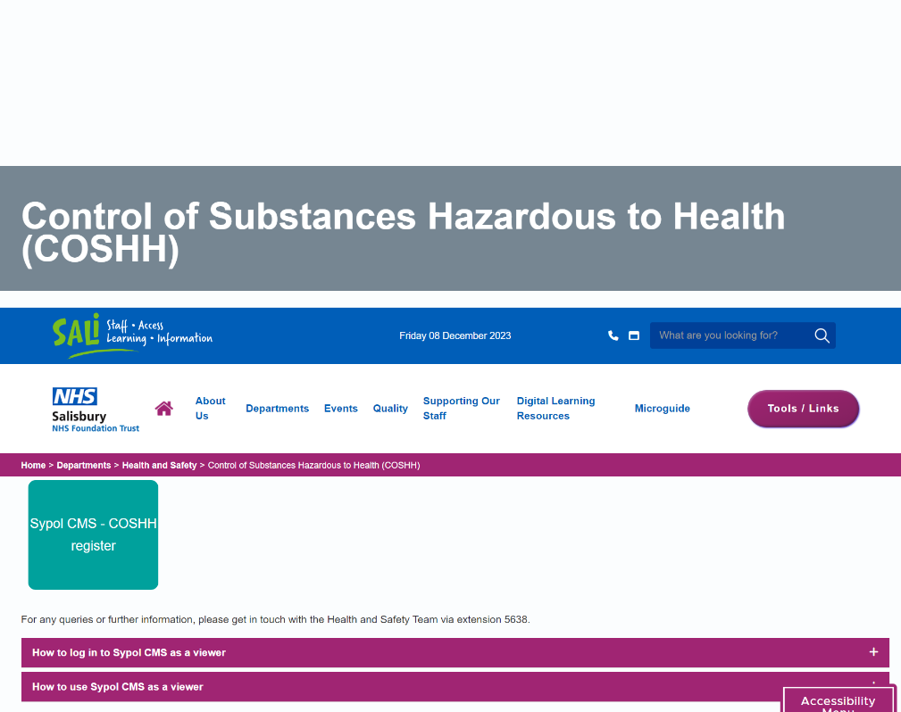

**How to log in to Sypol CMS as a viewer:**

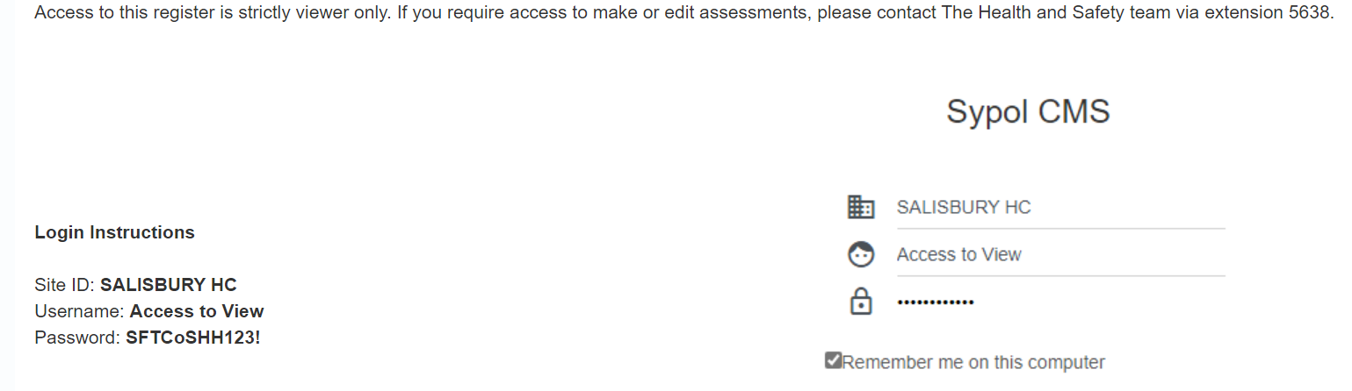

Log in instructions:

Site ID: **SALISBURY HC**

Username: **Access to View**

Password**: SFTCoSHH123!**

This will grant you access to view any assessments in any work area, but you will not be able to edit or make any assessments.

If you come across a substance that you believe hasn’t been assessed, get in touch with Health and Safety as soon as possible.

**How to log in to Sypol CMS as an Editor/COSHH Lead:**

Access Sypol as instructed above. But use the details provided to you by the Health and Safety team.

Once you are logged in as an editor you can access your work area via the dashboard as seen below:

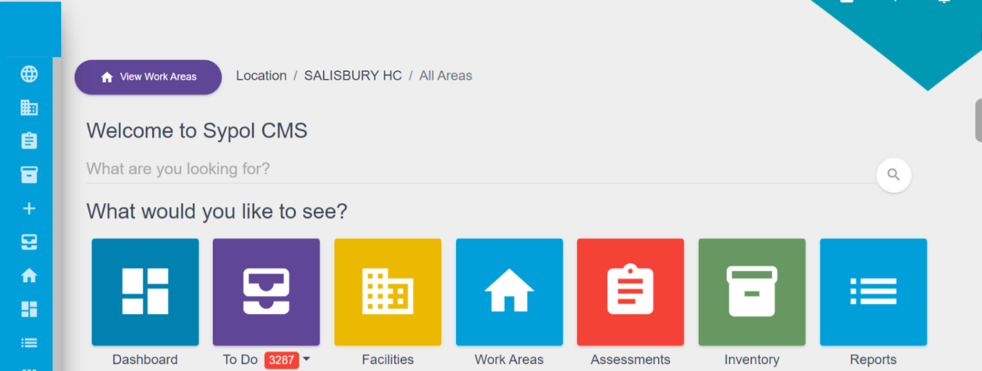

Within your work area you can view, edit, archive, or create assessments. Only trained staff can make assessments and training must be acquired through the Health and Safety team.

* For any questions related to COSHH call extension +5638
* For any Fit-Testing requirements call the Trusts Fit-Testing Department on x2335