INITIAL MANAGEMENT OF SUSPECTED MALIGNANT SPINAL CORD COMPRESSION (MSCC)

MSCC IS AN ONCOLOGICAL EMERGENCY

Failure to promptly investigate and manage this condition can result in permanent paralysis and premature death.

You must inform the Acute Oncology team AS SOON AS YOU SUSPECT MSCC - bleep 1480/1488 (during office hours Monday-Friday 08.30-5.00)

If you suspect MSCC or this has been confirmed please follow the below flow sheet, complete the checklist and liaise with the on call medical registrar on bleep 1361, outside of the AOS’ working hours.

Patients most at risk of MSCC include:
- Those with an advanced cancer- especially breast, lung, prostate, kidney, and thyroid.
- Those with known bone metastases or myeloma (especially if vertebral sites are known to be present in either condition)
- Those who have suffered a previous MSCC.

Please note that for 23% of patients with MSCC the presentation is the first evidence that they have a malignancy, so the diagnosis needs to be suspected in patients without documented history of cancer.

Red Flags in presentation of MSCC (NICE 2023)

If any of the below symptoms are present treat as MSCC until MRI proves otherwise.

Neurological symptoms suggestive of spinal metastases | Y/N | Symptoms suggestive of spinal metastases | Y/N
Radicular pain |  | Severe unremitting back pain
Limb weakness |  | Progressive back pain
Gait disturbance or difficulty walking |  | Mechanical pain (aggravated by standing, sitting, or moving)
Numbness, paraesthesia, or sensory loss |  | Backpain aggravated by straining (coughing, sneezing or bowel movements)
Bladder or bowel dysfunction |  | Nocturnal spinal pain preventing sleep
 |  | Localised tenderness

Suspected MSCC (Box 1)
Patient to be admitted to AMU.
Management of suspected spinal cord compression (MSCC) pathway
*If myeloma or suspected lymphoma discuss commencement of steroids with Haem Reg/Cons

Start:
Oral Dexamethasone 16mg STAT – Then 8mg BD (Box 2)
Omeprazole 20mg OD
Immobilisation with flat bed rest/partial elevation for comfort (Box 3)
Assess analgesia
Inform patient

Contact Acute Oncology Team Bleep 1488/1480 for advice and audit purposes,
(Monday – Friday 8.30- 17.00) or contact on call Med Reg bleep 1316 out of hours.

Urgent whole spine MRI – to be completed by AMU within 24 hours. Patient to remain on AMU until MRI reported.
To be requested b

Yes -Refer to management checklist (page 3). Transfer to Pembroke ward.
MSCC confirmed.
No
Stop steroids
Complete SINS Score for spinal stability, (see page 6)

Site specific Oncology
Refer to Spinal team, Salisbury maybe appropriate.
Refer to UHS Spinal team for spinal stability and operability via 'Refer a pt' www.referapatient.org

Bleep Clinical Oncology at UHS on 1414 for treatment advice.
Rehabilitation/ Discharge

Surgery

Box 1 – If patient at home call for blue light ambulance. Refer patient to med reg on call for admission to AMU.
Radiotherapy
Organise ward to ward transport (scan medical notes and send with pt) by ringing #6310 If unable to accommodate call emergency transport on 03003690074
Megan Marshall MSCC Co-ordinator for UHS
02380777222 bleep 1246

Box 2 -If myeloma or suspected lymphoma discuss commencement of steroids with Haem Reg/Cons but do not delay starting steroids if clinically indicated.

Box 3 – Consider immobilisation for patients with:
Suspected or confirmed spinal metastasis or MSCC and moderate to severe pain associated with movement (NICE 2023)
Clarify mobilisation status Rehabilitation/ Discharge.
.
If new diagnosis of metastatic disease, please arrange staging CT CAP. If known metastatic disease, consider restaging CT CAP if previous scan > 3months ago.

Spinal cord compression management checklist
PATIENT IDENTIFICATION LABEL
DAY OF ADMISSION

Referral date/ time to SFT: |  | Consultant
Admission date/ time:
Mobility on arrival: | Walking unaided Walking with aids  Wheelchair Bedbound
Time of clinical review on admission:

ACTION | YES/NO Rationale if NO | Signature
1.Flat bed rest with neutral spinal alignment | Yes/ No
2.Document baseline neurological examination (overleaf) | Yes/ No
3.Discuss MSCC with patient – AOS can provide an information leaflet | Yes/ No
4.Dexamethasone 16mg stat OD PO/IV then 8mg BD until MSCC excluded or treatment commenced  (if myeloma or suspected lymphoma discuss timing and dose of steroids with SpR/Consultant first)  PPI Omeprazole 20mg OD | Yes/ No  Date/Time Given:  ……………………………
5.Is the patient able to lie flat for MRI? The scan cannot be performed if unable to. | Yes/ No
6.Analgesia, is the patient comfortable? | Yes/ No
7.Urgent MRI whole spine | Referral Submitted? Yes/ No  Date/ Time:………………
8.Baseline blood glucose level (Pt now on Dexamethasone) if >7, continue to monitor twice daily
9. Inform AOS team  Bleep 1480/1488 (9-5 Mon -Fri)  On call Med Reg Bleep 1361 (OOH/ Weekends) | Name/ Time:  ……………………….

IT IS THE CLINICAL TEAM’S RESPONSIBILITY TO CHASE THE SCAN OUTCOME ONCE COMPLETED
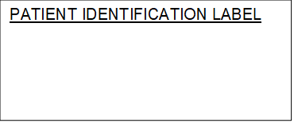

BASELINE NEUROLOGICAL EXAMINATION
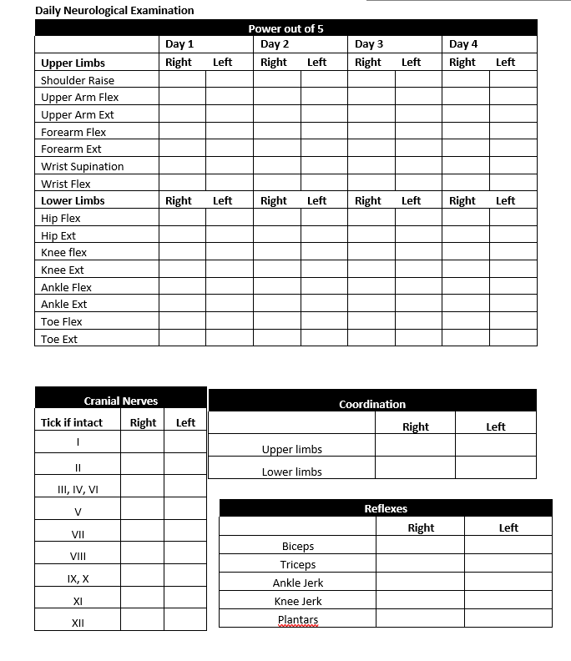

BASELINE NEUROLOGICAL EXAMINATION
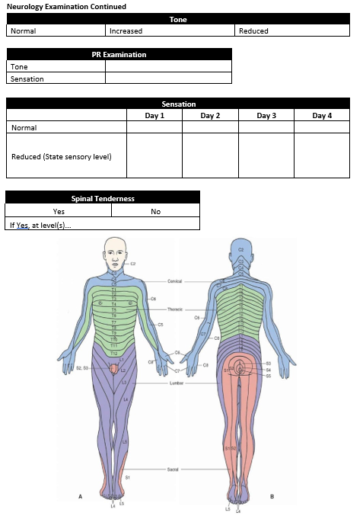

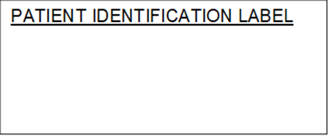

SPINAL CORD COMPRESSION
SINS SCORING SHEET

SINS Score: Please complete a www.referapatient.org referral following discussion with the spinal surgeons for all SINS score >6

SINS Component | Score
Location  3 points: Junctional (C0-C2, C7-T2, T11-L1, L5-S1)  2 points: Mobile Spine (C3-C6, L2- L4)  1 point: Semi-rigid (T3-T10)  0 points: Rigid (S2-S5) | …
Bone lesion (this may be assessed better on CT)  2 points: Lytic  1 point: Mixed (lytic/scoliosis)  0 points: Blastic | …
Radiographic spinal alignment  4 points: Subluxation/ translation present  2 points: De novo deformity (kyphosis/scoliosis)  0 points: Normal alignment | …
Vertebral body collapse  3 points: >50% collapse  2 points: <50% collapse  1 point: No collapse with >50% body involved  0 points: None of the above | …
Posterolateral involvement of the spinal elements (facet, pedicle or costovertebral joint fracture of replacement with tumour)  3 points: Bilateral  1 point: Unilateral  0 points: None of the above | …
Pain relief with recumbency and/or pain with movement/loading of the spine  3 points: Yes  1 point: No (occasional pain but not mechanical)  0 points: Pain free lesion | …
Interpretation  sum score 0-6: stable  sum score 7-12: indeterminate (possibly impending) instability  sum score 13-18: instability  SINS score of 7 to 18 warrant surgical consultation | Total  …

