CVAD Daily Care Record
Ward ____________
Electronic Patient label or
Name
DOB
Hospital Number

Insertion date and time
Type of CVAD
First dressing change after 24 hrs
Tunnel Line Suture Removal due / Actual date | /
Secure system in place | SecuraCath □ Stat lock □
CVAD removal date and time
CVAD removal reason
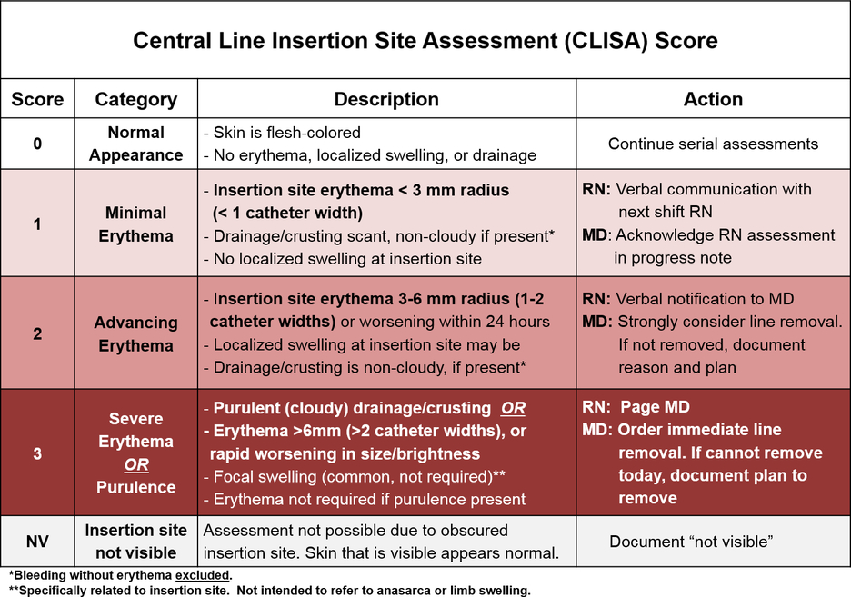
- Assess the CVAD using the CLISA scoring system 8 hourly and each time before accessing. Document the score and other information below
- Redress the CVAD and replace the free needle devices weekly or earlier if indicated
- Consider the need of line blood cultures and/or a swab of the insertion site if a new 1 score or above
- Use the Standard ANTT technique when accessing the line and Surgical ANTT technique when dressing it

If the CVAD is scoring
Gohil, S., Yim, J., Quan, K., Espinoza, M., Thompson, D., Kong, A., . . . Huang, S. (2020). Impact of a Central-Line Insertion Site Assessment (CLISA) score on localized insertion site infection to prevent central-line–associated bloodstream infection (CLABSI). Infection Control & Hospital Epidemiology, 41(1), 59-66. doi:10.1017/ice.2019.291
Date and time | CLISA score and comments | CVAD length if applicable | Dressing changed | Swab sent | Needle free devices changed | Lumens patency | Reason for accessing | Securing system in place | Sign

