SouthWest Stroke Network
Acute Ischaemic stroke thrombolysis guidelines
Page1 of 6, Version 3, Dr T Black 03/24
Whilst waiting, or directly following CT scan (but do not delay CT scan to do any of these):
· Take bloods (U+E, glucose, FBC, clotting and total cholesterol) and perform an ECG
· IV access x 1
· Check rt-PA exclusions (see next page) with patient or family member
· If blood pressure consistently >185 SBP or >110 DBP, consider intravenous nitrate or Labetalol (see page 5, Management of Blood Pressure)
· If blood pressure remains above 185/110 beyond the thrombolysis time limit, the patient is not eligible for thrombolysis. They may be still eligible for mechanical thrombectomy.
· Site manager to clear an appropriate bed on Farley stroke unit urgently.
Eligibility for consideration of IV treatment with alteplase or tenectaplase
Age >18 (no upper age limit)
Clinical diagnosis of stroke causing measurable neurological deficit
Time of symptom onset is known to < 4.5 hours (time last seen well if onset not known or wake up event)
Thrombolysis can be given to patients 4.5 to 9 hours and wake-up events if favourable CT perfusion criteria are met.
If ‘Yes’ to above criteria, proceed to Acute stroke thrombolysis pathway.
- Assess and briefly examine patient, including an estimate of the patient’s weight.
- Focussed history and examination, BM, GCS, NIHSS score.
- Immediate CT head scan (with CT angiography if eligible for mechanical thrombectomy and CT Perfusion if between 4.5 and nine hours for thrombolysis and 6 to 24 hours for mechanical thrombectomy)
Contact clinician authorised to deliver thrombolysis (Stroke Physician on call via switchboard)

Post CT scan
· Contact on call Regional Stroke Physician for advice (through switchboard). They may want to review the scan, don’t wait for the scan report. Make sure the radiographer sends the images to the Biotronics internet cloud system for viewing and activates the Brainomix AI report.
· If no radiological exclusion criteria briefly reassess patient to exclude rapidly improving signs
· Obtain patient verbal assent to rt-PA treatment
· If patient is unable to assent, discuss with family but act in patient’s best interest
· Do not await blood results unless currently on warfarin (may still be eligible for thrombolysis if INR< 1.7) - stop infusion if subsequent blood count results are outside tolerated limits
· Reconstitute rt-PA and start administration
· Dose of rt-PA: 0.9 mg/kg up to a maximum of 90 mg, whichever is the lesser. Give 10% as a bolus over 1-2 minutes and the remaining 90% as a 1-hour infusion.
· Withhold aspirin, heparin, DOAC and warfarin for 24 hours

Standard Post Thrombolysis Care for Stroke
· Avoid urinary catheterisation during thrombolysis and for 30 minutes after completion
· Avoid venous or arterial puncture during thrombolysis
· Avoid nasogastric tube placement for first 24 hours
· Consider CT scan @ 24 hours
Transfer patient to appropriate bed on Farley Stroke Unit when available
Check blood results and review eligibility to continue thrombolysis.
Monitor BP at 15-minute intervals during infusion, 1-hour intervals for 6 hrs and then 4-hourly up to 24 hrs
STOP infusion if:
· Anaphylaxis (incidence 1.5% in 1 study), marked hypotension
· Neurological deterioration –
- conscious level (2 points GCS eye/motor score).
- NIHSS >4 points
· BP >185/110 mm Hg if sustained or associated with neurological deterioration
· Major systemic bleeding

On CT brain:
· Intracranial haemorrhage
· Other pathologies
On Lab results (if they are available):
· Platelets < 100
· INR > 1.7
· APTR > 1.2
· Plasma glucose <2.8 or >22.0 mmol/l
On initial assessment:
· Coma (GCS <8)
· Severe stroke (NIHSS >25)
· NIHSS < 4 except isolated disabling symptoms (e.g., severe dysphasia, homonymous hemianopia)
· Rapidly improving symptoms or signs
· Capillary blood glucose <2.8 or >22.0 (if hypoglycaemic treat with 20% glucose and reassess; (See hyperglycaemic guidelines on ICID) if hyperglycaemic continue with protocol but await result of lab glucose before treating with rtPA)
From the history:
Absolute contraindications:
· Active internal bleeding
· Major surgery or serious trauma within last 14 days
· Clinical diagnosis of subarachnoid haemorrhage even if CT normal
· Treatment dose low molecular weight Heparin within 24 hours
Relative contraindications (please discuss with a senior clinician):
· Recent CVA, head injury or cranial surgery (within 3 months)
· Seizure at stroke onset
· Any history of intracranial haemorrhage, brain tumour, intracranial AVM, or aneurysm
· Recent (< 48 hours) lumbar puncture or (<1 week) arterial/venous puncture at non-compressible site
· Pregnancy – see notes below
N.B. Current warfarin treatment is not an exclusion if the INR is less than or equal to 1.7.

CLINICAL EXCLUSIONS FROM THROMBOLYSIS

Notes
Thrombolysis in pregnancy:
It is very difficult to give clear guidance on thrombolysis (TL) in pregnancy as this will be both a very rare clinical situation and one with very little evidence or RCT data to guide decision making. Each case will need to be assessed on an individual risk/benefit basis by an expert in the delivery of thrombolysis in stroke. The sparse evidence that does exist suggests that TL in acute ischemic stroke in pregnancy probably carries a higher than usual risk of symptomatic intra cerebral haemorrhage in the mother in the order of 10%.TL given for a few conditions including pulmonary embolism and stroke carries a risk of significant bleeding such as major uterine hematoma in the order of 8%. Foetal safety remains unproven. Anecdotal cases of successful resolution of maternal stroke post TL have been recorded in both the first trimester and the immediate post-partum period.

Page 2 of 6, Version 3, Dr T Black 03/24

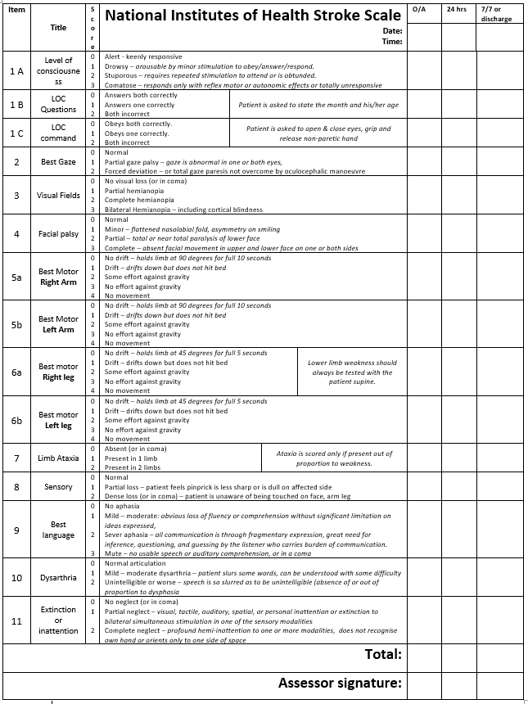

Page 3 of 6, Version 3, Dr T Black 03/24

- Unless the patient or companion knows their recent weight, estimate it to the nearest 5 kg.
- The total dose of rt-PA is 0.9 mg/kg or 90 mg, whichever is lower.
- When the decision to treat has been made do not delay.
- Make up one or two vials of rt-PA using the 50 ml diluent in each drug pack, making a solution of 1 mg/ml rt-PA.
- Draw up and give 10% as a bolus over 1-2 minutes using a 10 ml syringe.
- Draw up the remaining 90% (the ‘infusion dose’) into one or two 50 ml syringes and set up the syringe pump with the corresponding infusion rate in mls/hr. Doses above 50 mls will need a change of syringe at some point within the hour’s infusion.
- Do not give the cardiac dose.
- Do not give more than 90 mg.

 | 1 | 2 | 3 | 4 | 5
 | Estimate of  patients’ weight (kg) | Equivalent  Imperial weight | Total dose (mg at 1 mg/ml) | Bolus dose (mls)  given over 1-2 minutes | Infusion dose (mls) = infusion rate in mls/hr
One vial | 45 | 7 st 1 lb | 40 | 4.0 | 36.0
 | 50 | 7 st 12 lb | 45 | 4.5 | 40.5
 | 55 | 8 st 9 lb | 49 | 4.9 | 44.1
Two vials | 60 | 9 st 6 lb | 54 | 5.4 | 48.6
 | 65 | 10 st 3 lb | 58 | 5.8 | 52.2
 | 70 | 11 st 0 lb | 63 | 6.3 | 56.7
 | 75 | 11 st 11 lb | 67 | 6.7 | 60.3
 | 80 | 12 st 8 lb | 72 | 7.2 | 64.8
 | 85 | 13 st 5 lb | 76 | 7.6 | 68.4
 | 90 | 14 st 2 lb | 81 | 8.1 | 72.9
 | 95 | 14 st 13 lb | 85 | 8.5 | 76.5
 | ≥100 | 15 st 10 lb | 90 | 9.0 | 81.0

Page 4 of 6, Version 3, Dr T Black 03/24
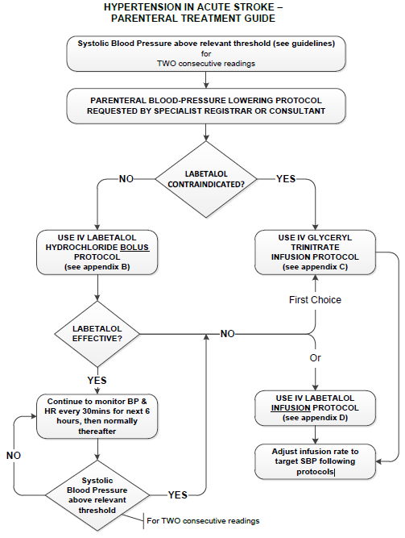

For appendices B, C and D, see intranet > microguide > Acute Medicine > Stroke medicine > Parenteral BP lowering appendices > labetalol and GTN

Page 5 of 6, Version 3, Dr T Black 03/24

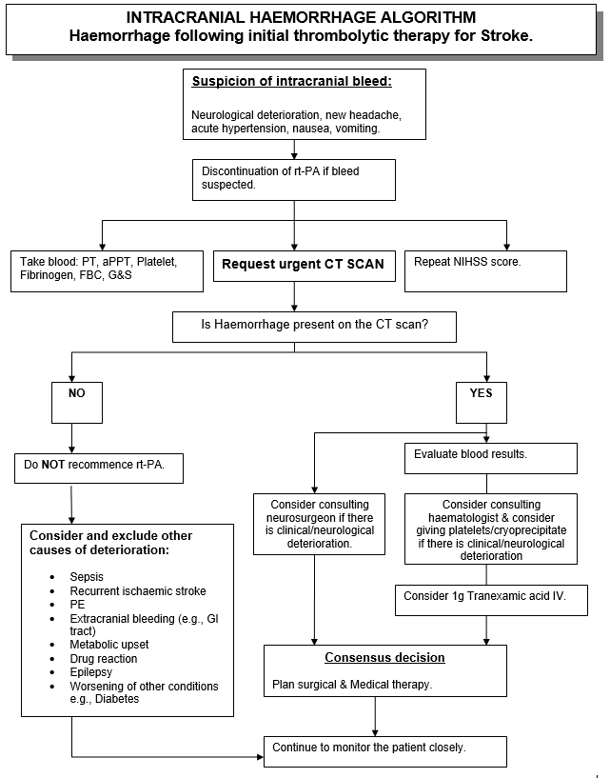

Page 6 of 6, Version 3, Dr T Black 03/24

