

**INITIAL MANAGEMENT OF SUSPECTED MALIGNANT SPINAL CORD COMPRESSION (MSCC)**

**MSCC IS AN ONCOLOGICAL EMERGENCY**

**Failure to promptly investigate and manage this condition can result in permanent paralysis and premature death.**

**You must inform the Acute Oncology team (AOT)**

**AS SOON AS YOU SUSPECT MSCC -bleep 1480**

**Patients most at risk of MSCC include:**

**Those with an advanced cancer- especially breast, lung, prostate, kidney, thyroid**

**Those with known bone metastases (especially vertebral metastases)**

**Those who have suffered a previous MSCC**



**Referring Doctor -----------------------------------------------------------------**

**Time of hospital arrival ---------------------------------------------------------**

**Time seen -------------------------------------------------------------------------**

**Time referred to the AOT----------------------------------------------------------**

**Time MRI spine requested----------------------------------------------------------**

**Time MRI spine performed------------------------------------------------------------**

**Time MSCC confirmed------------------------------------------------------------------**

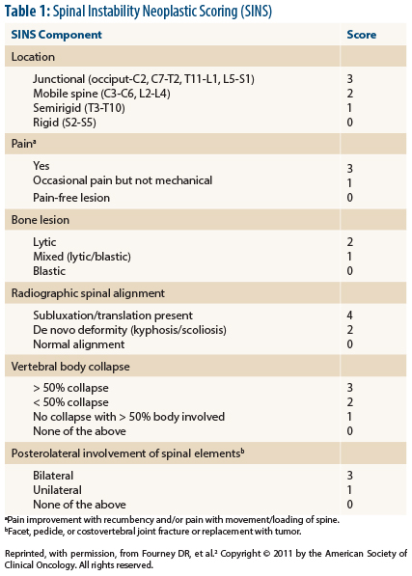

**REFERRAL TO AN MSCC TREATMENT CENTRE**

SINS Score

Calculate total score (0-18) = --------------

0-6 STABLE

7-12 POTENTIALLY UNSTABLE

13-18 UNSTABLE

SCORES >6 REQUIRE FLAT BED REST

**If MSCC confirmed then inform**

**the**

**‘**

**on**

**-**

**call**

**’**

**Clinical oncology registrar**

**in Southampton, Poole or Bath**

**For disease requiring a**

**Neurosurgical opinion**

**Bleep the**

**‘**

**on call**

**’**

**neurosurgical registrar at SUHT**

**And E**

**-**

**MDT request to**

**www.neurorefer.com**

**Urgently transfer**

**the patient to**

**the appropriate Cancer centre for**

**Radiotherapy or neurosurgery**

**E**

**-**

**transfer of scans**

**MSCC coordinator called bleep 1480**

**Calculate spinal instability score (SINS)**

**Flat bed rest if appropriate**

**Dexamethasone 16mg given**

**The continue 8mg b.d.**

**Lansoprazole 30mg o.d.**

**Analgesia**

**Clinical Oncology contacts**

**Southampton: 02380 777222 Bleep 1414**

**Poole: 01202 665511 Bleep 0600**

**Bath: 01225 428331 Bleep 7159**

**Neurosurgical contacts**

**Southampton: 02380 777222**

**Bleep 2877**

**Patient not known to have malignancy**

**Solitary lesion**

**Previous same site MSCC treated with DXT**

**Call the HPCT if:**

**Poor PS**

**Uncontrolled symptoms**

**Considered too unwell for transfer**

**Hospital palliative care team (HPCT)**

**Bleep 1293**

TIME CANCER CENTRE INFORMED

Name of Clinical oncologist, Southampton, Poole or Bath

Advice given:

TIME PATIENT REFERRED TO THE NEUROSURGEONS

Name of Neurosurgical registrar/consultant

Advice given:

**Signature of referring doctor -----------------------------------date---------------------**

**AOT to complete**

**Signature of AOT MSCC coordinator or deputy ---------------------date---------**

**Time patient transferred for definitive treatment------------------------------------**

**Time treatment received in the treating centre--------------------------------------**

**Referred for rehabilitation------------------------------------------------------------------**

**Entered in to rolling audit-------------------------------------------------------------------**