Visual Infusion Phlebitis (VIP) Score
All patients with an intravenous access device should have the IV site checked every shift for signs of infusion phlebitis. The VIP score and action(s) taken (if any) must be documented on POET/care plan evaluation sheet. The cannula site must also be observed:
- When bolus injections are administered
- IV flow rates are checked or altered
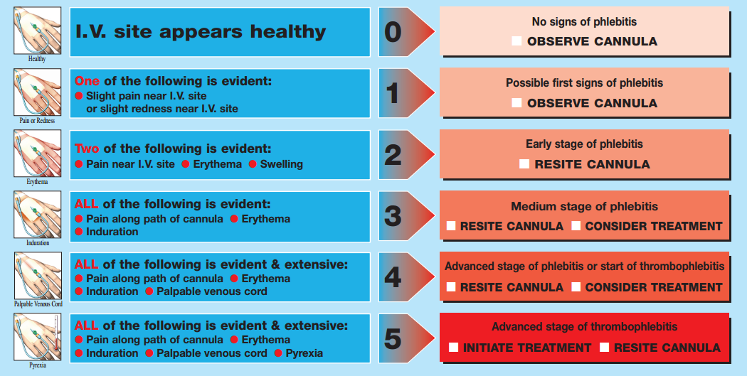
- When solution containers are changed

