South West Region Burn Care Network
Adult Transfer Information Document
Bwrdd Iechyd Prifysgol Tempest Burns ITU: 01792 703801/2/4
Abertawe Bro Morgannwg Powys Ward (Adult): 01792 703624/5
University Health Board Burns SHO: 01792 702222 bleep 3855
Morriston Hospital, Swansea, SA6 6NL Fax number: 01792 703803

North Bristol NHS Trust Gate 33a Level 2: 0117 414 3100 / 3102
Brunel Building, Southmead Hospital, Burns SHO: 0117 505050 bleep 1311 (via Switchboard)
Bristol, BS10 5NB Fax number: 0117 414 3372
Email: Burns@nbt.nhs.uk

Plymouth Hospitals NHS Trust Lynher Ward (Adult): 01752 792274
Derriford Hospital, Plymouth, Devon, PL6 8DH Plastics Trauma Ward Practitioner: 01752 202082 bleep 85440

Salisbury NHS Foundation Trust Burns Unit: 01722 345507
Salisbury District Hospital, Salisbury, Email: shc-tr.burns@nhs.net
Wiltshire, SP2 8BJ

Patient Details
Addressograph | Next of Kin:
Addressograph | Relationship:
Addressograph | Agreed Password (if applicable):
Addressograph | Contact Number(s):
GP Label | Religion:
GP Label | Ethnic Origin:
GP Label | First Language:
GP Label | Need for Interpreter: Yes No
Resuscitation Status: | Medication: Please see enclosed Drug Chart
Allergies:

Infection Status:

Location of Burn: | TBSA:
Date of Admission: | Non-Accidental: Yes No
Referring Consultant: | Receiving Consultant:
Adult Burn Area Assessment Chart
Welsh Centre for Burns & Plastic Surgery Adult Burn Area Assessment Chart Chart
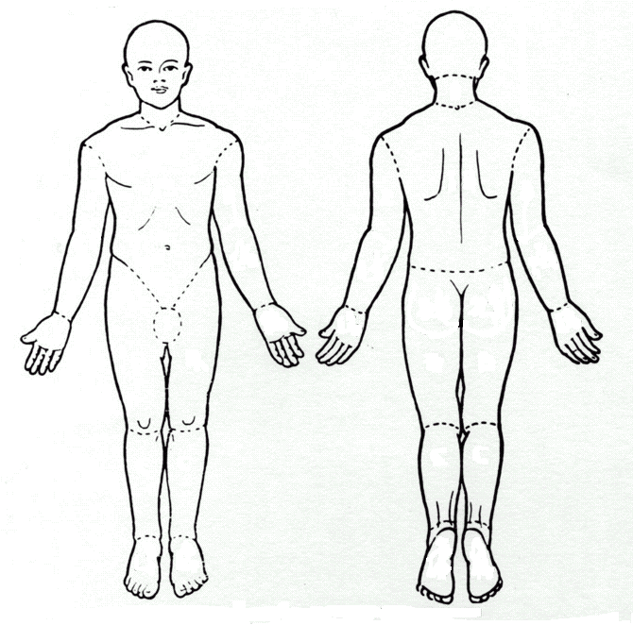
2
2
½
½
A
A
3
3
3
3
¾
¾
¾
¾
1
B
B
B
B
C
C
C
C
1¼
1¼
1¼
1¼
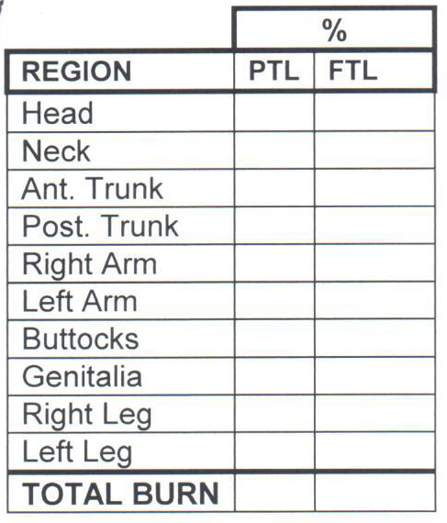
AREA | BMI < 30 | BMI 30-40 | BMI > 40
A = POSTERIOR OR ANTERIOR TRUNK | 17½ | 20 | 22
B = ½ OF ONE THIGH | 6¼ | 5½ | 4¾
C = ½ OF ONE LOWER LEG | 3½ | 3 | 2½

From Neaman et al. J Burn Care Res 2011; 32:421-428

Patient History
Burn History:

Past Medical History:

Living Circumstances
Type of Accommodation: | Employment □ Unemployed □ Retired □  Employment:
Housing Circumstances: | Main Carer:
Safety Issues
Is the Patient Deemed to be a Vulnerable Adult? | Yes □ No□
Does the Patient Have Mental Health Issues? | Yes □ No□  Details:
Are they under a Section? Yes □ No□ | Do they require 1:1 Nursing? Yes □ No□  RMN □ HCSW□
Actions Taken re Safeguarding:

Support
Is the Patient Known to Social Services?  Yes □ No□ | Are the Relevant Agencies Aware of Transfer?  Yes □ No□
Name of Agency 1: | Telephone:
Name of Agency 2: | Telephone:

Wound Map showing areas which have been grafted, areas left to heal conservatively, donor sites and any other wounds or skin damage at time of transfer
2
2
½
½
A
A
3
3
3
3
¾
¾
¾
¾
1
B
B
B
B
C
C
C
C
1¼
1¼
1¼
1¼

Multidisciplinary Discharge Summary
Date of Transfer: | How the Patient Feel About the Transfer:
Means of Transport: | Are Relatives Aware of Transfer:
Observations on Day of Transfer (08:00)
SATS: % | O2 required: | Resps: rpm | BP: mmHg
Pulse: bpm  Regular □ Irregular □ | Temp: °C | Pain Score: None □  Mild□ Moderate□ Severe□ | Itch Score: None □  Mild□ Moderate□ Severe□
Any Speech & Language Therapy Needs on Transfer: |  | Cannula: Yes □ No□  Date Inserted:

Nursing Handover

Washing & Dressing:

Condition of Pressure Areas:
SKIN check:
A = No skin Damage B = Red & Blanching F = covered by non-removable dressing /cast
ML = Moisture Lesion 1 = Non Blanching Redness (grade 1) 2 = Intact or Open Blister (grade 2)
S = Intact Skin with Dark Discolouration beneath (SDTI Suspected Deep Tissue Injury)
U = Ulcer with Slough and/or Necrosis or Deep Ulcer (Grade 3, 4 or Ungradeable)
Back of Head |  | Buttocks
Elbow (left) |  | Heel (left)
Elbow (right) |  | Heel (right)
Sacrum |  | Other.......................................
Bowels/Bladder
Is the patient known to have urinary problems? Yes □ No□
Is the patient catheterised? Yes □ No□ |  | Date Catheter Inserted:
Is a Bowel System in place? Yes □ No□ |  | Date Bowel System Inserted:

Date Bowels last opened:
Vision/Aids
Does the Patient Have Dentures Yes □ No□ |  | Are They with the Patient? Yes □ No□
Does the Patient Wear Spectacles Yes □ No□ |  | Are They with the Patient? Yes □ No□
Does the Patient Wear Contact Lenses Yes □ No□ |  | Are They with the Patient? Yes □ No□
Does the Patient Wear Hearing Aid(s) Yes □ No□ |  | Are They with the Patient? R □ L □ Both □ No□
Valuables/Property
Summary of Nutrition
Weight on Admission: Kg |  | Current Weight: Kg
Dietary Intake: |  | Poor □ Fair □ Good □
Ability to Eat:
Current Nutritional Support:
Special Dietary Requirements:
Summary of Speech & Language Therapy

Discharge Plans

Other Information:
Signed | Print:
Grade: | Date: | Time:

Document Attachments - Checklist | Yes | N/A
DNAR
Medical Discharge from Ward
Discharge Document from ITU (Appendix 1)
Copy of Operation Sheets
Latest Microbiology
Latest Blood Results
Copy of Latest Wound Care Chart (Appendix 2)
Wound Photographs
Pressure Ulcer Documentation
Copy of Drug Charts
Copy of Observation Charts
Copy of Latest Burns MDT Ward Round / Plan of Care (Appendix 3)
Copy of Latest Burns MDT Goal Planning (Appendix 4)
Physiotherapy & Occupational Therapy Handover Sheet (Appendix 5)
Psychology Handover Sheet (Appendix 6)
Mental Health Liaison Nurse Handover Sheet (Appendix 7)

Appendix 1 - Discharge Document from ITU
Addressograph | Summary of Care – Burns ITU / HDU
 | Admission Date: |  |  |  | Transfer Date:
 | From: |  |  |  | To:
 | Pre-transfer Visit: |  |  |  | Yes □ No□
 | Patient informed of transfer on:
 | Relatives informed of transfer date on:
History %Burn |  |  | Ventilated: |  |  | Inhalation Injury:
Significant Other Injuries: |  |  | Yes □ No□ |  |  | Yes □ No□
 |  |  | Date Intubated: |  |  | Bronchoscopy Result:
 |  |  | Date Extubated: |  |  | Tracheostomy:
 |  |  |  |  |  | Yes / No
 |  |  | Tracheostomy Type: |  |  | Tracheostomy Size:
Any Other Surgery |  |  | Date Tracheostomy Inserted: |  |  | Date Tracheostomy Removed:
 |  |  | Tracheostomy Dressing: |  |  | Comments:
 |  |  | Breathing
 |  |  | Physio Involved: Yes □ No□
Wound care |  |  | Sputum Spec Results:
See Skeletal & Wound care |  |  | Date:
Charts for Details |  |  | Repeat Sputum Results:
Wound care Chart Yes □ No□ |  |  | Date:
Updated on: |  |  | Suction Required: Yes □ No□
Recent Swab Results: |  |  | Comments:
Repeat Swabs Taken: Yes □ No□ |  |  | Eating & Drinking
Date |  |  | Independent: Yes □ No□
Pressure Areas: Intact / Broken |  |  | Aids used:
Documented on: Date |  |  | High Protein Drinks/Day:
Patient Aware: Yes □ No□ |  |  | Eliminating
Family Aware: Yes □ No□ |  |  | Independent: Yes □ No□
Nutrition |  |  | Continent: Yes □ No□
Dietician Referral: Yes □ No□ |  |  | Urine / Faeces
Date: |  |  | Catheter: Yes □ No□
Special Diet: Yes □ No□ |  |  | Inserted: Size:
Specify: |  |  | Bowels Last Opened: Date:
NG Feed: Yes □ No□ |  |  | CSU Results: Date:
Specify: |  |  | Repeat CSU Taken: Yes □ No□ Date:
NG Inserted on: Type: |  |  | Faeces Result:
Speech Therapy Referral: Yes □ No□ |  |  | Repeat Faeces Taken Yes □ No□ Date:
Date: |  |  | Comments:
Comments:
 |  |  | Significant Blood Results
Medication |  |  | Additional Referrals: Cons Date:
Allergies:
See Drug Chart for Details of Medication
Comments:
Pain Control: Good / Adequate / Fair / Poor |  |  | Occupational Therapy
Physiotherapy |  |  |  | Splints: Yes □ No□
Mobile: Yes □ No□ |  |  |  | Specify: Yes □ No□
Independent: Yes □ No□
Aids Used:
 |  |  |  | Pressure Garments: Yes □ No□
Manual Handling Risk: Date: |  |  |  | Specify:
Waterlow Score: Date:
Comments: |  |  |  | Silicone: Yes □ No□
 |  |  |  | Specify:
 |  |  |  | ADL Assessment: Yes □ No□
Washing & Dressing |  |  |  | Mental Health Needs
Independent: Yes □ No□ |  |  |  | Referral to Mental Health Liaison Nurse:
No of Staff Required: |  |  |  | Yes □ No□
Comments: |  |  |  | Comments:
 |  |  |  | Referral to Psychiatrist: Yes □ No□
 |  |  |  | Previous History of Psychological
Social Circumstances |  |  |  | Problems? Yes □ No□
Services in Place: Yes □ No□ |  |  |  | Consultant Name:
Specify: |  |  |  | Has Patient Looked at Wounds / Scars
Social Worker Referral: Yes □ No□ |  |  |  | Pre-transfer: Yes □ No□
Pre-existing Social Worker: Yes □ No□ |  |  |  | Comments:
Health Visitor Referral: Yes □ No□
Pre-existing HV: Yes □ No□
Comments:
 |  |  |  | Investigations
 |  |  |  | CXR: Sputum:
Family Background |  |  |  | ECG: CSU:
Lives With: |  |  |  | Blood Cultures:
 |  |  |  | Wound Swabs:
 |  |  |  | 24hr Urine:
Comments: |  |  |  | Other:
 |  |  |  | Signature
Name |  |  |  | Date

Appendix 2 – Wound Care Chart
WOUND CARE INFORMATION  Consultant:  DATE: POST BURN DAY: |  |  |  |  |  | Addressograph
Wound Swab Taken: | Yes □ No□ |  |  |  |  | Pain Assessment Score |  |  |  | 0 □ 1 □ 2□ 3 □
Date last wound swab taken: |  |  |  |  |  | Itch Score |  |  |  | 0 □ 1 □ 2□ 3 □
Photographed: | Yes □ No□ |  |  |  |  | Entonox Used |  |  |  | Yes □ No□
Analgesia: | Yes □ No□ |  |  |  |  | Analgesic Outcome:
Type / Dose Administered: |  |  |  |  |  | Wound Reviewed by:
Any concerns re psychological or emotional effects of burn injury on Patient? |  |  |  |  |  |  |  |  |  | Yes □ No□  Already Referred □
Description of Wound Bed:

Had the patient had the opportunity to see their wounds? |  |  |  |  |  |  |  |  |  | Yes □ No□
Has a mirror been offered to enable patients to see the burn (if relevant)? |  |  |  |  |  |  |  |  |  | Yes □ No□ N/A□
Distribution:  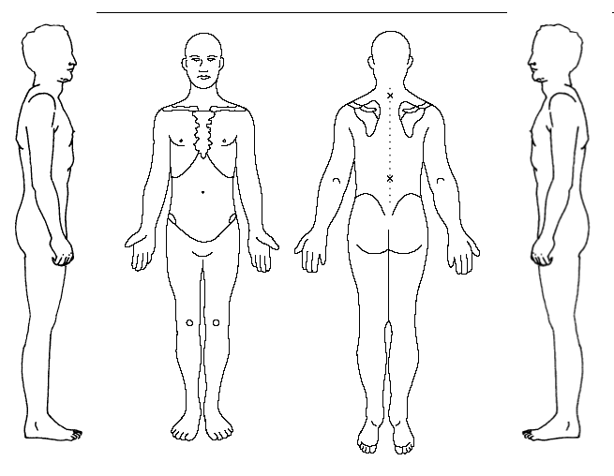 |  |  |  |  |  |  |  |  | Wound Depth:
 |  |  |  |  |  |  |  |  | %
 |  |  |  |  |  |  |  |  | Area:
Treatment / Dressing used:

Plan of Care:

SKIN check:
A = No skin Damage B = Red & Blanching F = covered by non-removable dressing /cast
ML = Moisture Lesion 1 = Non Blanching Redness (grade 1) 2 = Intact or Open Blister (grade 2)
S = Intact Skin with Dark Discolouration beneath (SDTI Suspected Deep Tissue Injury)
U = Ulcer with Slough and/or Necrosis or Deep Ulcer (Grade 3, 4 or Ungradeable)
Pressure Areas under Dressings checked? |  |  | Yes □ No□ | All Pressure Areas checked? |  |  |  |  |  |  | Yes □ No□
Back of Head |  |  |  | Buttocks
Elbow (left) |  |  |  | Heel (left)
Elbow (right) |  |  |  | Heel (right)
Sacrum |  |  |  | Other.......................................
Next procedure due on: |  |  |  | To be performed by:
Until then, ward staff to maintain & re-pad dressing as necessary, documenting interventions
Written or Verbal Advice Given to Patient/Carer Regarding:
Management of Pain Yes □ No□ |  | Scar Management Yes □ No□ |  |  |  |  |  | Care of Dressings Yes □ No□
Management of Itch Yes □ No□ |  | Sun Care Yes □ No□ |  |  |  |  |  | Nutrition Yes □ No□
Washing (Infracare) Yes □ No□ |  | Facial care +/- shave Yes □ No□ |  |  |  |  |  | Smoking Cessation advice Yes □ No□
Mobilisation Yes □ No□ |  | Work/School Yes □ No□ |  |  |  |  |  | Fire Hazard Form Yes □ No□
POVA or Safeguarding Concerns Yes □ No□ |  |  |  |  | Complications Yes □ No□
Location of Procedure: |  |  |  |  |  |  | Duration of Procedure:
 |  |  |  |  |  |  | No of Staff Involved:
 |  |  |  |  |  |  | Signature:

Appendix 3 – Burns MDT Ward Round / Plan of Care
PATIENT STICKER:

BURNS MDT WARD ROUND/ PLAN OF CARE
Admission date: ......................... Consultant: .............................
Estimated discharge date: ..........................................................
Present at MDT:
Doctor Physiotherapist Occupational Therapist Other:
Ward Nurse Dressing Nurse Psychologist
Outreach Dietician Mental health liaison

Previous Treatment Plan:
Medical:

MDT:

Goals for the following week:
Medical (inc medication, outstanding reviews/results, theatre, expected outcomes):

MDT (inc rehab, follow-up arrangements, onward referrals, discharge planning):

Review date: FAB score:

Medically fit for discharge? Yes □ No □ Date from:..................
Socially fit for discharge? Yes □ No □ Date from:..................
Has the plan been discussed and agreed with the patient ?

Functional Assessment for burns (FAB)
Admission score: Previous score:

 | SCORE: | PLANS TO IMPROVE:
Feeding

Washing

Toileting

Transfers
(bed, chair, toilet)
Dressing

Walking
(10m on level surface)
Stairs
(12 stairs with handrails)
Total
Predictor of discharge options:

Scoring:
1 – Fully dependent. Unable to complete any part of the activity. Full assistance required. Unable to assess – 1 point
2 – Completes activity with physical assistance – 2 points
3 – Requires supervision / verbal prompting / requires set up of activity – 3 points
4 – Independently completes activity with an assisting device / aid (adapted cutlery, walking stick, wheelchair) – 4 points
5 – Independently completes activity without devices / aids – 5 points

Appendix 4 – Burns MDT Goal Planning
GOAL PLANNING
NAME:
DATE:
PRESENT:

MAIN GOAL:

SUBGOALS:

WEEKLY GOALS:

REVIEW DATE:

Appendix 5 – Physiotherapy & Occupational Therapy Handover OPTION 2

BURNS THERAPY IN-PATIENT DISCHARGE SUMMARY/ TRANSFER OF CARE

Patient Name: Date of Birth: Hospital Number:

Summary of Social History:
Mobility: to include transfers
Activities of Daily Living: to include Washing, Dressing, Cooking/ cleaning:
Scar Management:
Splinting:
Summary of Therapy Intervention:
Current focus of therapy:
Discharge Planning:

Named Physio: Contact Number:
Named OT: Contact Number:
Date of Report Completion:

CPAX Scoring
Aspect of physicality | Level 0 | Level 1 | Level 2 | Level 3 | Level 4 | Level 5
Respiratory Function | Complete ventilator dependence. Mandatory breaths only. May be fully paralysed / sedated | Ventilator dependence. Mandatory breaths with some spontaneous effort | Spontaneously breathing with continuous invasive or non-invasive ventilator support | Spontaneously breathing with intermittent invasive or non-invasive ventilatory support or continuous high flow oxygen (>15L) | Receiving standard oxygen therapy (<15L) | Self ventilating with no oxygen therapy
Cough | Absent cough, may be fully paralysed / sedated | Cough stimulated on deep suction only | Weak ineffective cough, unable to clear independently (e.g. requires deep suction) | Weak, partially effective voluntary cough, sometimes able to clear secretions (e.g. requires Yankauer suctioning) | Effective cough, clearing secretions with airways clearance techniques | Consistent effective voluntary cough, clearing secretions independently
Moving within the bed (e.g. rolling) | Unable, maybe fully sedated / paralysed | Initiates movement. Requires assistance of two or more people (maximal) | Initiates movement. Requires assistance of at least one person (moderate) | Initiates movement. Requires assistance of one person (minimal) | Independent in >3 seconds | Independent in < 3 seconds
Supine to sitting on the edge of the bed | Dynamic unable / unstable | Initiates movement. Requires assistance of two or more people (maximal) | Initiates movement. Requires assistance of at least one person (moderate) | Initiates movement. Requires assistance of one person (minimal) | Independent in >3 seconds | Independent in < 3 seconds
Dynamic sitting (i.e. when sitting on the edge | Unable / unstable | Initiates movement. Requires assistance of two or more people (maximal) | Initiates movement. Requires assistance of at least one person (moderate) | Initiates movement. Requires assistance of one person (minimal) | Independent with some dynamic sitting balance (i.e. able to alter trunk position within base of support) | Independent with full dynamic sitting balance (i.e. able to reach out of base of support
Standing balance | Unable / unstable / bedbound | Tilt table or similar | Standing hoist or similar | Dependent on frame, crutches or similar | Independent without aids | Independent without aids and full dynamic standing
Sit to stand (starting position <90degrees hip flexion) | Unable / unstable | Sit to stand with maximal assistance (standing hoist or similar) | Sit to stand with moderate assistance (e.g. one or two people) | Sit to stand with minimal assistance (e.g. one person) | Sit to stand independently pushing through arms of the chair | Sit to stand independently without upper limb involvement
Transferring from bed to chair | Unable / unstable | Full hoist | Standing hoist or similar | Pivot transfer (no stepping) with mobility aid or physical assistance | Stand and step transfer with mobility aid or physical assistance | Independent transfer without equipment
Stepping | Unable / unstable | Using a standing hoist or similar | Using mobility aids and assistance of at least one person (moderate) | Using mobility aid and assistance of one person (minimal) | Using mobility aid or assistance of one person (minimal) | Independent without aid
Grip strength | 0/5 | 1/5 | 2/5 | 3/5 | 4/5 | 5/5
Admission score Discharge score
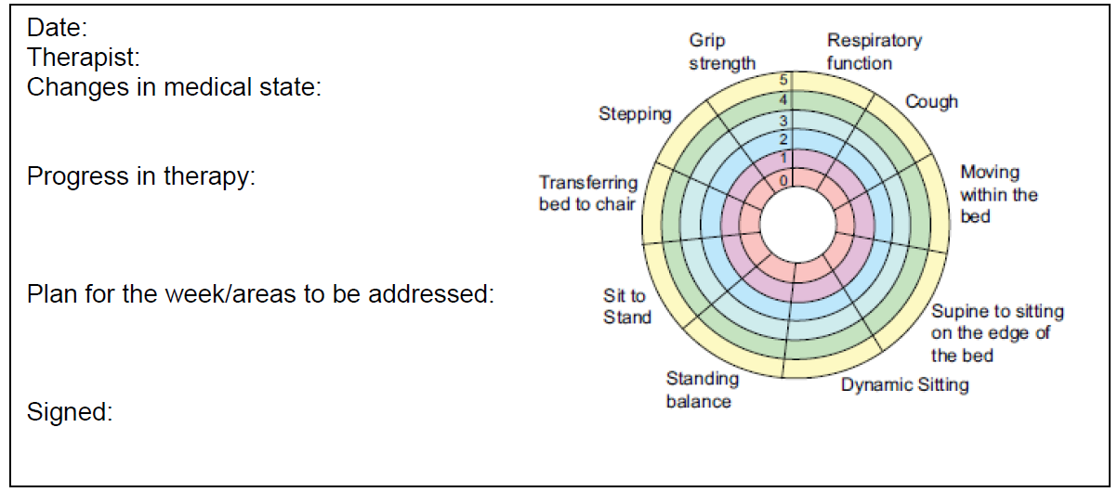

Appendix 6 – Psychology Handover
Psychology Handover
Overview of Current Care:

Background Information

Summary of presenting issues and input to date

Sign: | Date:

Appendix 7 – Mental Health Liaison Nurse Handover
Mental Health Liaison Nurse Handover
Overview of Current Care:

History of Presenting Complaint

Intervention provided

Management plan / outcome

Sign: | Date:

