How to add a new policy to Microguide
To add a new policy to Microguide it needs to be ratified by CMB. Create your policy/guideline in Microsoft word and make sure your department/peers/clinical lead/manager is happy with your proposed policy. If everyone is happy you will then need to do the following;
- Send an email to sft.microguide.cmb@nhs.net to get a date and time when your policy will be presented to the CMB members. (These are monthly meetings)

- If you do not already have a Microguide account or access to the secure CMB guide, Becky Hawtin will create an account and send details via email.

- Tell Becky the title of your new guideline/policy and let her know if your guideline/policy will have any appendices. Becky will set this up for you.

- Once you have completed your Microguide sign up or you already have an account you can now add your policy to CMB guide.

To do this, follow these steps;

- Login to the Microguide Admin URL

http://cms.horizonsp.co.uk/login/auth

You should then see something like the following;
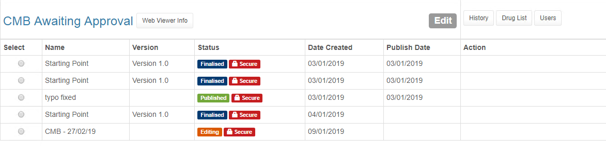

Let’s explain those statuses;
This status means that the section is finalised and cannot be edited. A new version would need to be created by the guide admin.
This means that the guide is secure; a secure passcode must be entered to view the guide. Or by visiting the secure link provided.
This is the Published (Live) version of the guide. A new version would need to be created by the guide admin if you want to make changes to a guide.
The guide is open and authors are able to edit policies inside the guide.

- I now want to add my policy to CMB 27/02/2019, lets select that. (Notice how the status is in editing mode)
Select
Once you’ve selected you should see some extra buttons appear in the right hand action column.
Select 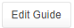
- You should now see something like the following;
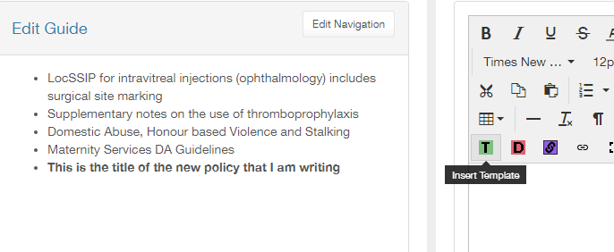
This is the title that you gave Becky
Click to pull up the template. Start writing here (or cut and paste from your word document). Don’t forget to
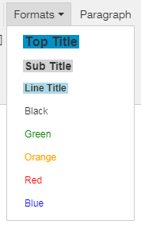
click on this only if you want to revert back to the version last saved

Some tips:
- Use the format drop down for your Top Title and sub Titles

- Don’t make the policy too long, remember people want key information and don’t want to scroll.
- Put the key information right at the top
- Add your name to the bottom of the policy/guideline
- Tell Becky when you have added your policy/guideline and she will add it to the CMB agenda

Make your text bold (or not)
Italicise your text
Underline (avoid using this too much as it makes your text hard to read)
Strikethrough xxx
Text colour (click on the arrow to open up your choices)
Background colour (only colours the space immediately behind your text)
Align text left, align text centred, align text right, justify text
Always use Sans Serif font text size 9pt
Cut, paste and copy (select the text that you want to do this to)
Numbered list. Click the arrow to choose exactly what you want for example lower case Roman, upper case alpha
Bulleted list. Click to choose bullet or circle, disc, square
Click to either add a link (link to internet page) or remove a link you have imported with your text
Insert an image. NB image must be small. If you get an error message then either your image is too large (try using https://tinyjpg.com to reduce the size) or the name of your file is too long (shorten it!) NB once you have added your image to the library you will find it right at the bottom of the file
Undo, redo
Click here to see the source code
Insert a table
Insert a horizontal line
Clear formatting
Show invisible characters
Superscript, subscript
Insert a special character
If your guideline has a drug named in it, you can select this box to link your drug to all the information that Pharmacy are adding to Microguide
If you want to link your guidance to another piece of information within the same Guide, click this and it will help you navigate to the title of the guideline (or appendix) you want to link to
Click this symbol to see the drug list
If using a table, click the Auto Width button to make your table responsive on all devices
Click this symbol to see what your guidance will look like on your phone (choose your phone from the list)
Click this symbol to see what your guidance will look like on a variety of different devices (such as iPad)

