|  |
| --- |
|  |

**Lymphoedema Referral Form Lymphoedema Provider:**

**Patient Details:**

|  |  |  |  |
| --- | --- | --- | --- |
| Name |  | NHS No. |  |
| Address |  | Date of Birth |  |
| Home Telephone |  |
| Work Telephone |  |
| Email |  | Mobile Telephone |  |

|  |  |  |  |
| --- | --- | --- | --- |
| **GP Details:** | | **Consultant Details:** | |
| Referring Clinician |  | Consultant |  |
| GP Practice |  | Address |  |
| Address |  | Telephone |  |
| Telephone |  | Date of Referral |  |

**Communication and Accessibility needs:**

|  |  |  |  |  |  |  |  |  |  |  |
| --- | --- | --- | --- | --- | --- | --- | --- | --- | --- | --- |
| Interpreter required? | Yes |  | No |  |  | Wheelchair access required? | Yes |  | No |  |
| Language: |  | | | | |  |  | | | |
| Communication & Accessibility Needs: | Hearing: | | | | | Learning Disability: |  | | | |
| Vision: | | | | | Other Disability: |  | | | |

|  |  |  |  |  |  |
| --- | --- | --- | --- | --- | --- |
|  | Military Service Person |  | Military Veteran |  | Member of Military Family |

|  |  |  |
| --- | --- | --- |
| Reason for referral | ☑ | Duration of symptom |
| Swelling |  |  |
| Heaviness |  |  |
| Numbness/tingling/altered sensation |  |  |
| Pain |  |  |
| History of cellulitis |  |  |
| Lymphorrhoea (leakage of lymph) fluid |  |  |
| Hyperkeratosis (hardening of the skin) |  |  |
| Papillomatosis (wart growths) |  |  |
| Lymphoedema secondary to cancer treatment |  |  |
| Lymphoedema secondary to limb dependency/immobility |  |  |
| Lymphoedema secondary to venous disease |  |  |
| Other – please specify |  |  |

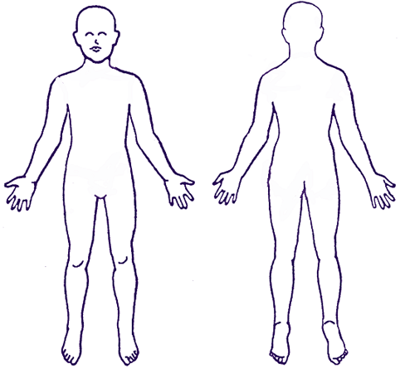

S = Swelling

C = Cellulitis

|  |  |  |  |  |  |
| --- | --- | --- | --- | --- | --- |
| **Medical History:** | | | | | |
|  | | Diagnosis  (with dates if known) |  | | Diagnosis  (with dates if known) |
| Heart failure |  |  | Rheumatoid arthritis (joint problems) |  |  |
| Renal failure |  |  | Obesity |  |  |
| Hypertension |  |  | Chronic skin disorder |  |  |
| DVT (within last 6 months) |  |  | Venous/peripheral vascular disease |  |  |
| Cellulitis/inflammation |  |  | SVC Obstruction |  |  |
| Thyroid disease |  |  | Lymphorrhoea |  |  |
| Psychiatric disorder (please state) |  |  | Hemiplegia |  |  |
| Mobility problems |  |  | IDDM  NIDDM |  |  |
|  |
| Other (please state): | | | | | |

|  |
| --- |
| **Medication list:** |
| **RISK MANAGEMENT CONCERNS (are there any safety or security issues involved in seeing this patient?)** |
| BMI: |
| Alerts (MRSA/Tissue viability/manual handling concerns): |
| Allergies (Drug allergies/skin sensitivities/latex allergies): |
| Other: |

**MULTI-DISCIPLINARY SERVICES INVOLVED**

|  |  |  |
| --- | --- | --- |
| Practice nurse/district nurse  Name: | | Other  Name: |
| Team: |  | Team: |
| Address: | | Address: |
| Telephone: | | Telephone: |
| Additional comments | | |

**SUPPORT INVOLVED**

|  |  |
| --- | --- |
| Next of kin  Name: | Main carer  Name: |
| Address: | Address: |
| Telephone: | Telephone: |

**DETAILS OF REFFERER**

|  |  |
| --- | --- |
| Name: | Job title: |
| Location/department: | Address: |
| Telephone: |  |
| Signature: | Date: |

Please make appointments via e-RS. For advice, you can contact the Vascular Nurse Co-ordinator in Salisbury during office hours on: 01722 336262 x 4937 or bleep 1112.