SUSPECTED URGENT SKIN CANCER REFERRAL FORM
With images, please organise imaging via the hub network who will send via eRS to Urgent Suspected Skin Cancer Telederm RAS. Without images please send via eRS to Urgent Suspected Skin Cancer RAS.
There is a single email address to use if eRS is unavailable for more than 24 hours.
For RUH please use ruh-tr.CancerReferrals@nhs.net
For Salisbury please use the Sarum Referral Centre bswicb.urgentsarumreferralcentre@nhs.net

For cases of diagnostic uncertainty please use Cinapsis lesion Advice & Guidance Pre-referral
Use this form for
- ALL suspected malignant melanoma, Squamous Cell Carcinoma (SCC) and rare skin cancer(s)
- Basal Cell Carcinoma (BCC) with HIGH risk features (see below)
DO NOT use this form for
- Routine BCC, please use BCC pathway
- Routine dermatology referrals

* If you are confident the patient has a high-risk cancer or requires this to be excluded, please continue with the referral on this urgent suspected cancer pathway. If not, please consider a discussion within the practice before proceeding. This may be particularly relevant if you are a trainee, advanced nurse practitioner, or allied health professional. This is because of the high number of patients referred with a benign condition. Regular feedback will be made available from secondary care

PATIENT IMAGES – Where your practice is engaged with a local imaging hub, please consider booking the patient into their service to photograph the patient’s lesion to facilitate virtual clinical assessment by a dermatology specialist unless there are exclusion criteria/ other circumstances e.g regarding consent. Where there is no local imaging hub, please refer as normal for a face-to-face appointment
Patient to be referred to a hub for images to be attached (localising, close up and dermoscopic images)
OR
Images above included from Advice & Guidance request or taken in practice (send via telederm RAS)
OR
No images attached as no local hub
OR
Patient is excluded (please select from exclusion criteria below) or ‘other’

- Age <18 or >85
- Does not have capacity to consent
- > 2 lesions for review
- Lesions > 2cm
- Subcutaneous lumps
- Lesions on mucosal surfaces / genital skin due to infection control procedures
- Lesions in non surgical scars, tattoos, hair-bearing sites (difficult to visualise)
- PMHx of high risk skin cancers / extensive sun damage (full skin examination recommended)
- Patients who are unable to or do not consent to have dermoscopic images taken
- Patients who require nursing input for re bandaging post images
- Other – please detail here

Where attending for images, please advise the patient that they do not need to attend a hospital clinic unless invited for appointment by the skin cancer service following review

Referrer Details
Name:
Address:

Tel No:

Patient Details Please ensure personal and contact details are current
Forename: | Surname: | DOB:
Address: |  | Gender:
 |  | Hospital No:
 |  | NHS No:
Tel No (1): |  | Email:
Tel No (2): |  | Email:
LESION(S) OF CONCERN
Please refer to dermatology referral management guidelines if required https://www.bad.org.uk/referrals/
MELANOMA – Refer patients to rule out suspected malignant melanoma if they have a suspicious pigmented skin lesion with a weighted 7-point checklist score of 3 or more (cross boxes and calculate total):
Major features (Scoring 2 points each) |  | Minor features (Scoring 1 point each)
Change in size |  | Largest diameter 7mm or more
Irregular shape |  | Inflammation
Irregular colour |  | Oozing
 |  | Change in sensation

SCC – to rule out suspected squamous cell carcinoma

BCC – Refer if HIGH RISK basal cell carcinoma and or where delay may significantly impact patient wellbeing
- Size – if diameter >2cm
- Site – tip of nose, near the eye or upper lip;
- Features – infiltrative, or fast pattern of growth
- Recurrence
- Immunosuppression
Please use BCC referral for all other suspected BCC

Clinical details (your assessment / diagnosis):

Duration / onset:
Symptoms (pain, bleeding, rate of growth, change):

Site of Lesion(s)  Please specify and mark diagram | Size of Lesion(s):

*If the site is not clearly identifiable the referral may be returned for clarification which could delay patient care*
Please refer for accuracy to https://edu.anatomymapper.com. To use this body map, click on the map and Word will display the Picture tab at the top of the screen. Click ‘Draw’ to annotate the area then ‘Save and Close’

HOW TO MARK THE DIAGRAM

Left Click:
Review
Restrict Editing
Stop Protection

Place the mouse cursor over the diagram at the position of the lesion. Click the left mouse button. Use the keyboard to mark the diagram (x marks the lesion.)

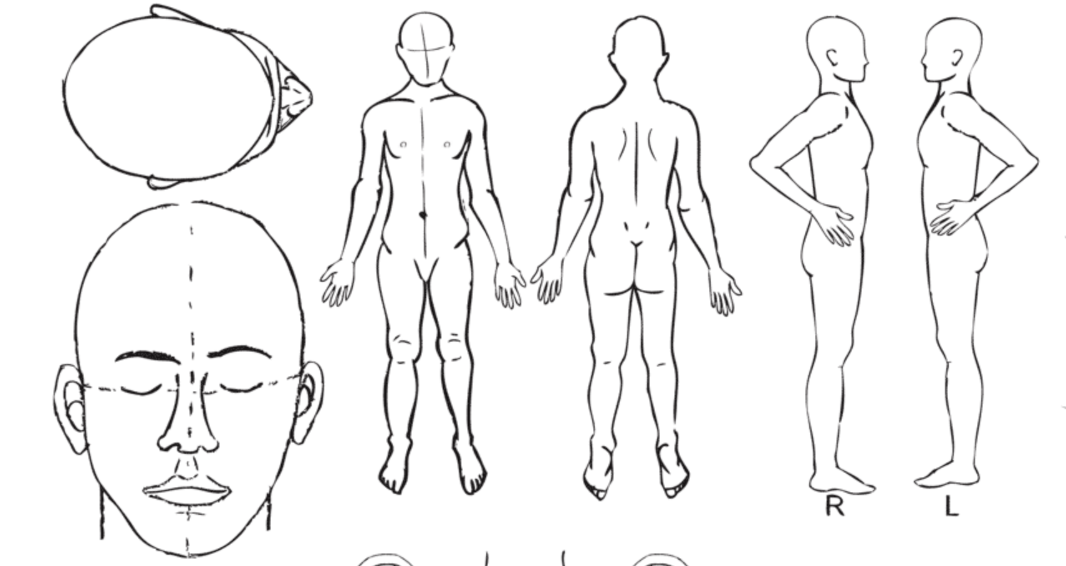

Skin cancer risk factors
Significant UV exposure (lived /worked in sunny climate, sunbed use, sunburn, UVB treatment)
Fair skin type |  | Multiple atypical naevi
Immunosuppression |  | Previous skin cancer
Family history

Past medical history
Existing conditions e.g diabetes and immunosuppression to be included in PMH | Please detail or attach summary
Current medications including anticoagulants
Allergies | Yes No Please detail
Pacemaker or Implanted Cardiac Device (ICD) | Yes No

Additional patient considerations
Transport required |  | If yes please give further relevant detail
Visual / hearing impairment |  | If yes please give further relevant detail
Carer required |  | If yes please give further relevant detail
Language difficulties |  | If yes please give further relevant detail
Translator required (please state language) |  | If yes please give further relevant detail
Mental capacity assessment required |  | If yes please give further relevant detail
Known safeguarding concerns |  | If yes please give further relevant detail
Mobility requirements (unable to climb on / off bed) |  | If yes please give further relevant detail
Requires hoist |  | If yes please give further relevant detail
Other (please detail) |  | If yes please give further relevant detail

WHO Performance Status:
0 Fully Active
1 Able to carry out light work
2 Up and about greater than 50% of waking time
3 Confined to bed/chair for greater than 50%
4 Confined to bed/chair 100%

Please confirm patient is aware that this is a suspected cancer referral and that they have received the patient information leaflet/ included in AccurX referral : Yes No
Where available and eligible, please confirm patient is aware they will attend for images to be taken to support this referral and that they consent for images to be used to aid diagnosis of their skin lesion(s) : Yes No n/a

Please provide an explanation if the above information has not been given:

Date(s) that patient is unable to attend within the next two weeks:

If the patient is not available for the next 2 weeks and aware of nature of referral, consider seeing patient again to reassess symptoms and refer when able and willing to accept an appointment.

Trust Specific Details:

For hospital to complete UBRN:
Received date:
Thank you for taking the time to complete this referral accurately

