Smoking and Alcohol Service
Patient drinking alcohol regularly
Audit C | 0 | 1 | 2 | 3 | 4
Drink how often? | Never | <Monthly | 2-4 times/mth | 2-3 times/wk | >4 times/wk
Units on a typical day? | 1-2 | 3-4 | 5-6 | 7-9 | >10
How often are >6 units(female) >8 units (male) single occasion in last yr? | Never | <Monthly | Monthly | Weekly | Daily or almost daily
Units guide | 1 | 1.5 | 2 | 3 | 9 | 30
 | Single shot spirits | Sml (125ml) wine  1 bottle (275ml) alcopop | Pint 4% beer  1 bottle (440ml) 4.5% beer | Lrg (250ml) wine  1 bottle (440ml) 6.5% beer | Bottle (750ml) 12.5% wine | Bottle (750ml) 40% spirits
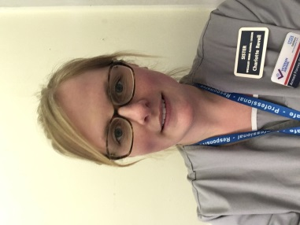
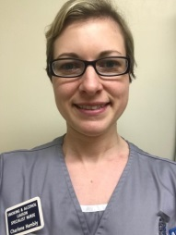
Referrals must include patient’s name and hospital number with a brief reason for referral along with your name and place of work.
Audit C score <8
Refer to Smoking and Alcohol Liaison Nurse Charlene Hambly 07717 808259 or charlene.hambly@nhs.net
Refer to Alcohol Liaison Nurse Charlotte Revell bleep 1022 or charlotte.revell@nhs.net
Patient smokes/vapes/using nicotine products
Audit C score >8

