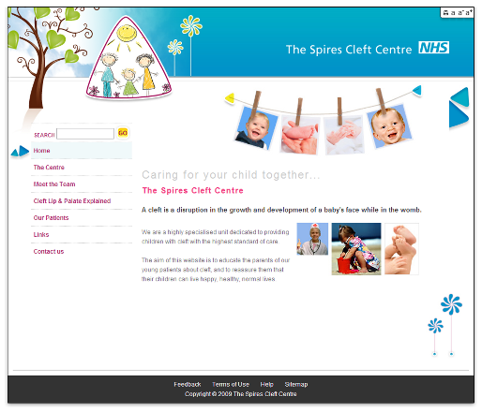
Did you know that the Spires Cleft Centre has a website: www.spirescentre.nhs.uk.

Would you like to share any of your experiences with others?

Or perhaps you would like to draw us a picture that we can share with others?

It is very easy…

You can complete the box below and hand it to anyone in the Cleft Team, or you can post it back to us. There is also space on the next page. You can even submit your story through the website.

Name:  Are you a (please circle): Patient/Parent(s) | Return address by post  Service Co-ordinator  The Spires Cleft Lip and Palate Centre  Salisbury District Hospital  Salisbury  SP2 8BJ

