Dear Patient

You have a stone in the urinary tract but the A & E team feel it is safe for you to go home with painkillers. Most stones pass naturally but you may get more episodes of pain and need to take further painkillers.

A member of the Urology Team will contact you to arrange clinic follow up for you within 4 weeks. It is important to have follow up to make sure the stone has passed out or plan treatment if it gets stuck.

If, despite taking painkillers, the pain becomes severe or if you develop evidence of an infection, (high temperature, shivery flu-like symptoms) please go back to A & E.

Urology Department
Salisbury District Hospital
01722 336262 extension 4866

What is renal colic?

Stones tend to form slowly in the kidney over many months but usually only cause pain when they move from the kidney into the ureter (the tube draining the kidney into the bladder). This pain is typically very severe and is called renal colic. The pain is felt in the back on one side just below the ribs (the loin) but can spread towards the groin. As the stone moves down the ureter you may start to feel some bladder pain and get a feeling of needing to pass urine frequently.

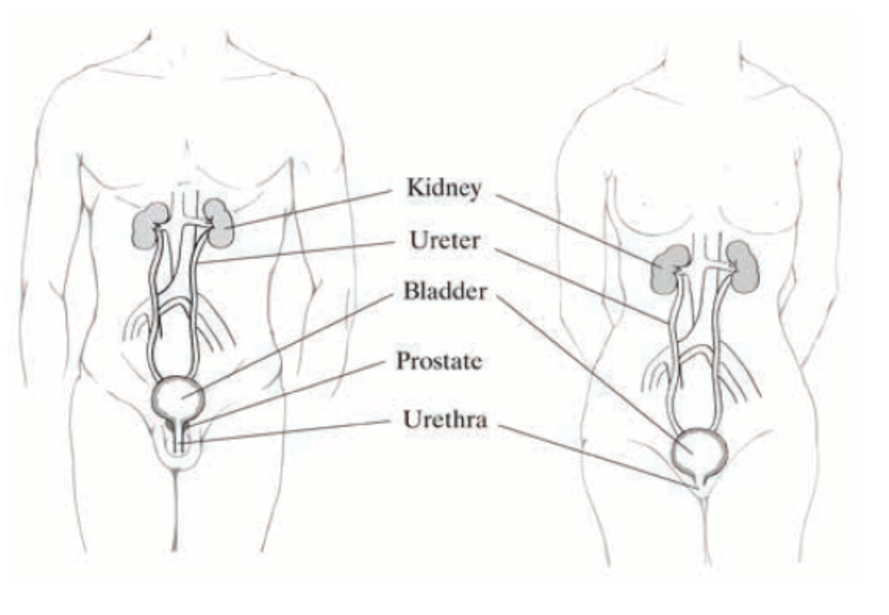
What will happen next?

Most stones are small enough to pass through the ureter into the bladder. When this happens the pain stops and the stone is passed out in the urine (this is usually painless). If you see the stone, please keep it as it can be analysed to see what it is made from (there are several different types of stone). Often the stone is so small you cannot see it pass out.

Smaller stones (less than 6mm) tend to pass out on their own but most patients need pain killers during this time. The pain typically comes and goes and it may take 2 or 3 weeks for the stone to pass. You can help the stone to pass by staying well hydrated and keeping active. Your doctor will arrange further scans to make sure the stone passes out as occasionally even small stones can remain in the ureter without causing further pain.

If the stone is very large and unlikely to pass you may be advised by the urology team to have an operation to remove the stone (ureteroscopy) or shock wave treatment to break up the stone into smaller pieces so that it can pass (lithotripsy). These treatments are occasionally needed for small stones that do not pass.

What is ureterosocpy?

This is an operation performed under anaesthetic where a tiny camera is passed through the urethra (water pipe) and up the ureter to the stone. The stone is then broken and the fragments removed with a basket-like instrument.

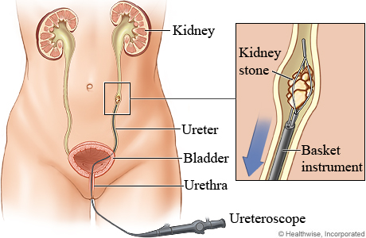

What is lithotripsy?

Lithotripsy does not require an anaesthetic and is done as an outpatient. During the procedure you will lie on a bed and shock waves are passed through your back and focused on to the stone to break it up. This is not suitable for all stones as it depends on where your stone is sitting in the ureter.

What do I need to look out for?

If you develop any signs of infection such as high temperature, shivers, sweats or you feel as if you have ‘flu please go to your nearest emergency department as this may be a sign of a urinary infection that needs urgent treatment.

Usually painkillers can control the pain of renal colic but occasionally the pain is so severe that patients need emergency treatment (ureteroscopy or lithotripsy) to remove the stone.

If your pain can’t be controlled please return to A+E.

