Appendix B,

Procedure for the monitoring and the inspection of patients own sling.

Introduction

Patients who use a sling at home in order to transfer safely from one surface to another, may on occasions attend an appointment as an out- patient or be admitted as an in- patient and wish to use their own sling.

We the must ensure that the patient’s own sling meets with safety requirements prior to its use.

The patient’s own sling must be inspected by a competent member of staff; details pertaining to the sling must be recorded in the patient nursing care plan.

The Trust, should ideally supply patients with a sling of known providence in order to address the issues raised above. This isn’t always possible when patients have specific medical conditions /physical characteristics that indicate that a specialist sling is required to ensure the patient’s comfort and safety. If in doubt contact the manual Handling Advisor on bleep 1013

The risk to the Trust-

- The patient sling may not be compatible with the ward /departmental hoist
- The patient sling may not have been inspected and tested in line with the Lifting Operations and Lifting Equipment Regulations {LOLER} 1998
- If soiled the hospital would not be able to launder the sling before it was required again.
- The sling may be misplaced.

If in any doubt contact the Manual Handling Advisor on bleep 1013

The inspection of the patient’s own sling -

Ensure that;

- The sling is compatible with the hoist (loop style).

- Check that all the stitching, loops, handles are intact

- Label information is visible

- Ensure that there no holes, fraying and the overall condition is good.

- SWL (Safe Working Load) is visible

- LOLER inspection carries out or evidence of the inspection.

- Size of the sling can be identified

- Sling is clean

- Safe Working Load (SWL) will not be exceeded

- General wear and tear of sling

- Label is clear and easy to read

Remember – that all patient slings are patient specific and must not be shared between patients.

How to identify a disposable sling?



Look for the above symbol on the back or on the label of the sling

The fabric of disposable slings is very different to launderable slings and staff must be clear on the type of sling being used in order to prevent any incidents or accidents.

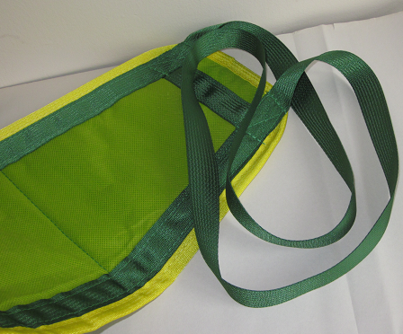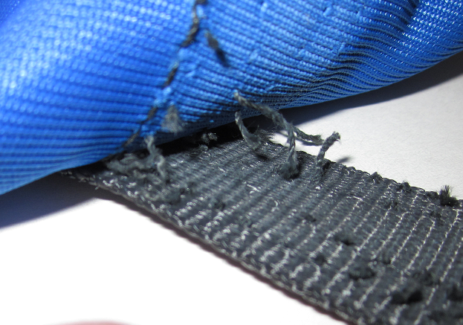

Loop attachment, compatible Sling damaged, frayed stitching
DO NOT USE

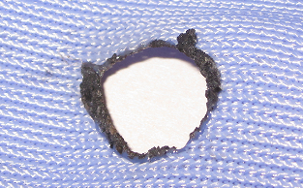

Holes in the sling DO NOT USE

Can I use the patient’s own sling

Is the sling compatible with the ward/departmental hoist?

Loops
Yes

Loops
No

Are seams intact
Change to Trust sling
NO

Do I need a Bariatric Sling and hoist
Is the SWL visible

Contact the Manual Handling Advisor on Bleep 1013
Is fabric intact?
• No holes
• No fraying

Patient’s own sling can be used with Trust hoist

