Thumb EXTENSOR tendon injury – Extensor Pollicis Brevis/Abductor Pollicis Longus
Early Active Motion
The injury you have sustained is to the tendon(s) that straighten the thumb and move it away from the hand. You have received very delicate surgery to repair these tendons.
Although the tendon(s) have been repaired surgically, it will take 2-3 months for the repair to be strong enough to cope with normal use of your hand.
Care of your hand after the operation
Preventing swelling
If you let your hand hang down, it will make swelling worse. This will make your hand painful and stiff, and stop it from working properly. Your hand must be kept above the level of your heart until it is no longer swollen, which may take a few weeks. At night you should rest your hand on pillows.
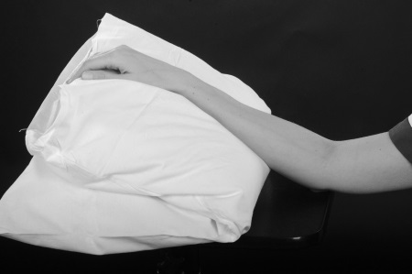
To stop your hand becoming too swollen and to stop your elbow and shoulder from becoming stiff you will need to do ‘pumping exercises’ with your whole arm 10-15 times every half an hour. This is done by reaching up towards the ceiling and then back down to shoulder level.
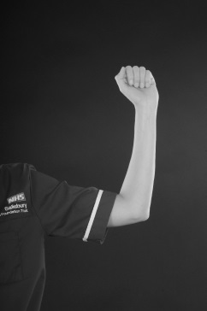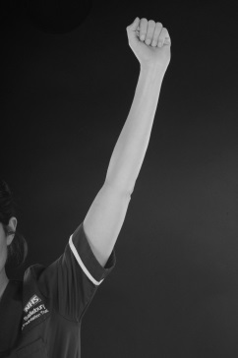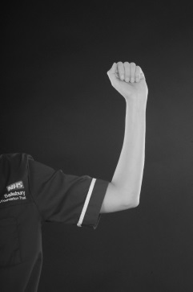

Looking after your wound
To assist with healing and make it easier to do your exercises, your wound will be left with minimal or no dressings. It is important that you keep your wound clean and dry until it is fully healed. You must monitor your wound for signs of infection which include increasing pain and swelling, redness and discharge/fluid which may be foul smelling. If you are concerned that your wound may be infected please contact the Plastic Dressings Clinic on the telephone number below.
Protecting the repaired tendon from breaking
In order to protect your repaired tendon, a light plastic splint will be made which you will wear at all times until your tendon has healed. Your therapist will advise you when you can start to remove your splint.
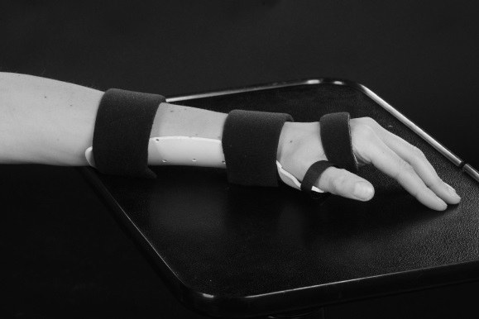
Exercises
As you move your thumb your tendons will glide in your hand. After a tendon repair they will not glide so well. The following exercises will help your tendon(s) to glide as it heals.
Weeks 1 to 4
Your splint should be worn at all times.
You must do the following exercises as instructed:
- Lift your thumb away from the splint using the uninjured hand, then lower it back down slowly without the help of your other hand.
Hold for ____ seconds, repeat ____ times, every ____ hour(s).

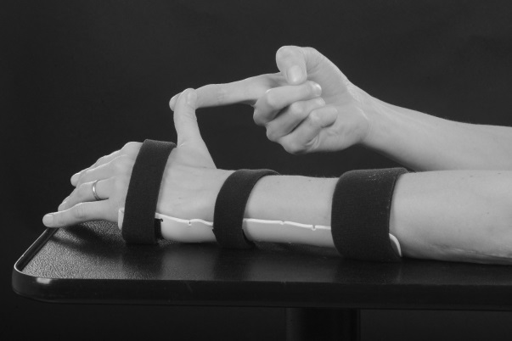

- Lift your thumb away from the splint on its own, making sure your wrist and fingers are relaxed
Hold for ____ seconds, repeat ____ times, every ____ hour(s).

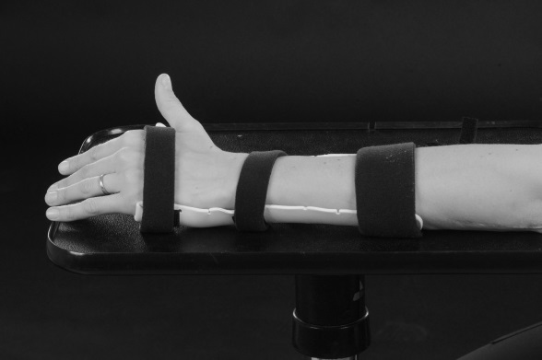

- Keeping the splint on, bend and straighten the tip joint of your thumb.
Hold for ____ seconds, repeat ____ times, every ____ hour(s).

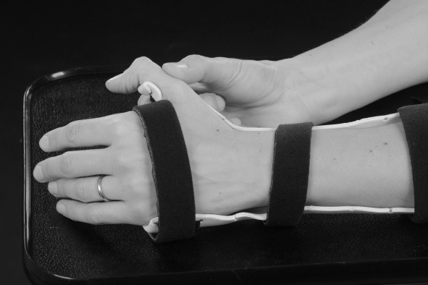
You can use your fingers for very light function only – up to 1kg. You can start gentle scar massage when the wound is completely healed, as shown by the therapist.
Additional advice/exercises
………………………………………………………………………………………………………………………………………………………………………………………………………………………………………………………………………………………………………………………………………
Weeks 4 to 6
Your splint should be worn at night and to protect your thumb when you leave the house.
You will be taught exercises by your therapist to improve the movement of your hand and wrist. If you do not do the exercises exactly as instructed, your hand may become stiff or you may risk damaging the tendon repair.
You can start to include the thumb for light function, up to 1kg. Avoid holding objects with you thumb for longer than a few seconds.
Week 6
At this stage you usually do not need to wear your splint any more.
You will be instructed on further exercises and activities to improve the movement and use of your hand, these exercises may involve strengthening you hand.
You will be advised by your therapist how much you can use your hand at this stage, but should remain light use, up to 2kg
Weeks 8 – 12
You can return to normal daily activities and driving at this stage.
You will also be advised by your therapist whether you can return to you specific job or sport.
Weeks 12+
Normal use of your hand with no restrictions.
Points to remember
- Keep your hand above your heart all day and night
- Do ‘pumping exercises’ every half an hour
- Do your exercises as frequently as you have been advised to
- Do not remove your splint unless you have been advised to
- Do not attempt to alter your splint
- Do not get your splint wet
- Do not use your injured hand for anything unless you have been advised to
- Do not drive until you have been told you can do so.
Contact numbers
Hand therapy: 01722 345530 (08:00 – 17:00 Monday to Friday)
Hospital switchboard: 01722 336262
Plastic Dressing Clinic nurses: ext 3254 (08:00 – 17:00 Monday to Friday)
Odstock ward: ext 3507/3139 (out of the above hours)
Your GP or NHS 111 is another source of assistance out of hours.
Follow up
You will be seen in the Outpatient Department within 7 days of your surgery. After this you will be seen every 1 to 2 weeks. Depending on where you live, you may be referred to a local hospital for hand therapy after your second appointment.
Author: M Robson Date written: April 2020
Date for review: April 2023 Version: 1.0

