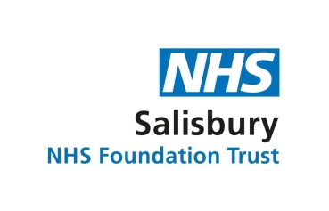

describe the

**results** of your changes...

the benefits to the patient, the service/team

**I guess by adapting the training**

**provision, we made sure that**

**Bank staff/new staff/ redeployed**

**staff are safe to use key devices**

**and know who to contact for**

**help. Part and parcel of training**

**is reporting of faulty devices and decontamination. This is crucial information with the current pandemic as it ensures that we can continue to provide safe and efficient service.**

**describe your idea,**

your ‘lightbulb moment’...

1. **Created Powerpoint presentations with videos of**

**devices. Some are our own and some are from national**

**links from NAMDET (National Association of Medical Device Educators and Trainers) and NHSI.**

1. **Worked with ward staff and modified our competency forms so new clinical staff can complete this in the wards, where there will be available devices. Some staff came back to Medical Devices to have a 1:1 session or hands on practical demonstration.**
2. **Utilised MS Teams to show and tell some devices and offer reassurance on its safe use - i.e. Falls Mat & Monitor**

Is there anything else to improve or something you couldn’t get done this time? *(your next lightbulb moment)*

Next time...what would you do **differently** or what **advice** would you give to others?

**Perhaps a faster response on training, utilising MS Teams more – but it is an unprecedented time, very different for all of us but will strive to do better.**

**Start date Finish date**

describe what you **enjoyed** and

what **surprised** you...

*Plan SMART: Specific, Measurable, Achievable Realistic, Timescale*

**Who** was on your dream team and which department/ ward/area are you from?

**In responding to COVID-19 what did you need to change and why?**

**Staff upskilling needed to be expanded at pace for emergency preparedness.**

**Due to the restructuring of wards and preparation for COVID patients, we had to be creative with how we show and tell devices and how we check for competencies. We also had to take into consideration, the social distancing and availability of rooms for training.**

**Who did you need help from? (managers/ other depts)**

**I needed advice of our Medical Device Safety Officer, Clare Goodyear and our Head of MDMS , Mandy Cripps  as they both have extensive knowledge on current situation, locally and nationally.**

How long did it take? (it might be hours/ days/ months)

**Not long. As soon as I have assessed that there would be an influx of clinical staff (bank and students nurses too) we adapted the delivery of training and method of assessment, without compromising patient safety.**

*The five W’s, who, what, when, where, why*

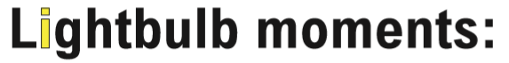

***Extra details on this side if you need more space...***

***What next?***

**Keep** a copy for your personal annual appraisal

**Give** a copy to your manager for your department’s collection of lightbulb moments

**Send** a copy to the PMO (Project Management Office)