Ferinject® for adult outpatients
With heart failure
Intravenous iron treatment for iron-deficiency in adult patients with heart failure

Patient consent and prescription form
This form contains:
- Information about when to prescribe intravenous iron
- Risks, side effects and patient consent form
- Ferinject prescription form and dose calculation table
Date ____________ Patient’s consultant ____________ Clinical Area___________
Weight (kg) ________________ See pre-prescription checks on page 3
ALLERGIES: ________________________________________________________________
When to offer treatment with intravenous iron (Ferinject®):
Ferinject is indicated when ALL the following are true:
- The patient has a functional iron deficiency

- The patient consents to intravenous iron

Tick to confirm if true

Risks and side effects of Ferinject®
Ferinject® is generally given without issue. The most frequently reported side effect, nausea, occurred in 2.9% of patients during clinical studies¹. It is important to ensure the patient is aware of the risks and potential side effects below:

CONTRAINDICATIONS
1st Trimester pregnancy (see separate prescription for Maternity services), severe asthma, severe renal or hepatic impairment, eczema, atopy, active rheumatoid arthritis, infection

Risks
Hypersensitivity and anaphylaxis can occur with parenteral iron infusion although this is uncommon².
Patients experiencing new musculoskeletal symptoms such as weakness or bone pain, or worsening of tiredness should report these symptoms to their GP or hospital consultant who can check for hypophosphataemia.

SIDE EFFECTS²
Common (1 in 10 to 1 in 100) – Headache, dizziness, flushing, hypertension, nausea, injection site reactions.
Uncommon (1 in 100 to 1 in 1000) - Abdominal pain, vomiting, cramps, dyspnoea, arthralgia, numbness, itching, rash chest pain, diarrhoea, dizziness, fatigue, hypotension, myalgia
Rare (1 in 1,000 to 1 in 10,000) – Angioedema, impaired consciousness, anxiety, bronchospasm

Patient consent for intravenous iron (Ferinject®) infusion
I acknowledge and understand that the proposed treatment of an intravenous iron infusion(s) (Ferinject®) has been explained to me and is to be performed on me, the patient:
- Benefits – To treat iron deficiency
- Risks – Intravenous iron can cause serious hypersensitivity reactions which can be fatal. The risk of sensitivity is increased in patients with known allergies, immune or inflammatory conditions as well as patients with a history of severe asthma or eczema.
- Side effects as listed above

- I have been given a copy of the patient information leaflet about intravenous iron.
- I have been given the opportunity to ask questions about the treatment.
- I understand I can withdraw my consent at any time.
Patient signature: _________________________________ Date: ________________
Patient name: ____________________________________

Pre-prescription checks
Both ferritin and TSAT should be checked prior to starting iron treatment and rechecked at the next scheduled clinic visit (preferably after 3 months). Levels should continue to be monitored usually once or twice a year but more frequently if clinically indicated.
Date | Ferritin µg/l | TSAT % | Hb g/l | Gender
 |  |  |  | M/F

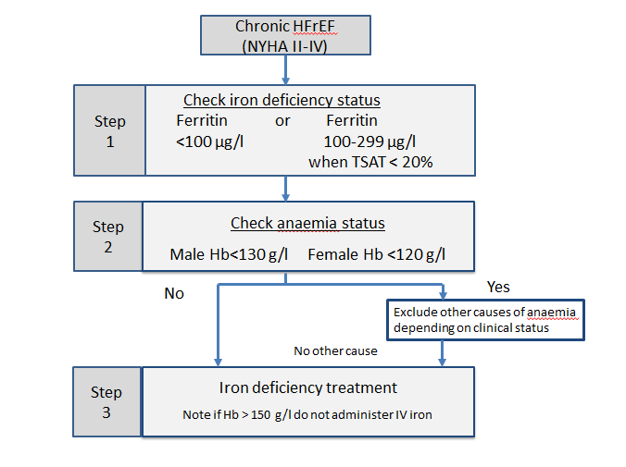

Ferinject® prescription and dose calculation table
- The figure in the box represents the dose of IV iron (Ferinject®) required in mg.
- Ferinject® may be administered by intravenous infusion up to a maximum single dose of 1000 mg of iron or not exceeding 20 mg/kg body weight.
- The recommended doses and numbers of infusions are shown in the table below.
- For some clinical circumstances a clinician may decide to administer fewer infusions but the doses must not exceed those stated below.

Weight | Current Haemoglobin (g/l)
 | <100 | 100-<140 | ≥140
35 kg- <50kg | 1500 mg total  (As three 500 mg infusions) | 1000 mg  (As two 500 mg infusions) | 500 mg
50-<70kg | 1500 mg total  (As one 1000 mg and one 500 mg infusion) | 1000 mg  (As a single infusion) | 500 mg
≥ 70 kg | 2000 mg total  (As two 1000 mg infusions) | 1500 mg  (As a single infusion) | 500 mg

TOTAL DOSE OF IV IRON (Ferinject®) = ……………..…mg to be administered over ……….. infusion(s).

*Planned infusion dates | *Ferinject® dose | Infusion duration and Sodium Chloride 0.9% volume | Administered by / date | Pharmacy  Screen | Pharmacy  Disp.
Infusion 1: | …………mg | □ 250 ml over 30 mins  □ 100 ml over 15 mins$
Infusion 2: (if required) | …………mg | □ 250 ml over 30 mins  □ 100 ml over 15 mins$
Infusion 3: (if required) | …………mg | □ 250 ml over 30 mins  □ 100 ml over 15 mins$
*Signature of prescribing Consultant/Registrar…………………………………..Date:………………
$ Note 100 ml volume only applicable for 500 mg doses

Appendix
Preparation
Ferinject® infusions will normally be prepared at ward/clinic level by nursing staff. Please send the prescription to the hospital pharmacy dispensary in advance to obtain Ferinject® supplies
Administration
Add the required volume of Ferinject®to a 250 ml infusion bag of sodium chloride 0.9% and administer by the intravenous infusion over 30 minutes. Doses of 500 mg may be administered in a smaller volume, 100 ml sodium chloride 0.9%, and given over at least 15 minutes. Note a slower infusion rate is used for patients with heart failure in order to prevent rapid fluid shifts.
Monitor the patient during the infusion and for 30 mins after each administration of an IV iron product. IV iron products should only be administered when staff trained to evaluate and manage anaphylactic reactions as well as resuscitation facilities are immediately available. Patients should be monitored for signs or symptoms of anaphylaxis, mild allergic reactions, hypotension and extravasation.
PLEASE RETAIN A COPY OF THIS COMPLETE FORM IN THE PATIENTS NOTES

References
- Ferinject Summary of Product Characteristics, Electronic Medicines Compendium accessed 09/07/2020. (https://www.medicines.org.uk/emc/product/5910#CLINICAL_PRECAUTIONS)
- JOINT FORMULARY COMMITTEE, 2020. British National Formulary. 78. London: BMJ Group and Pharmaceutical Press.

