Pressure ulcer prevention
Information for Patients, Families and Carers
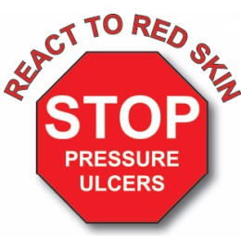
What is a Pressure Ulcer?
A pressure ulcer is localised damage to the skin and/or underlying tissue; it usually occurs over a bony prominence and is the result of sustained pressure in one area (including pressure associated with movement/friction or related to the position of medical equipment). The damage can present as unbroken skin or an open ulcer and may be painful.
- Pressure ulcers can also be known as pressure sores or bed sores and can be painful, debilitating and sometimes life threatening.
- Pressure ulcers can cause pain, sepsis, infections, prolonged stay in hospital and, when severe, can cause bone infection and other serious complications.
- Pressure ulcers are categorised by severity. If you develop a pressure ulcer in hospital, nursing staff or the Tissue Viability team will assess the area and categorise it to help create a care plan to aid healing where possible.
The images below show common areas where pressure ulcers can form.
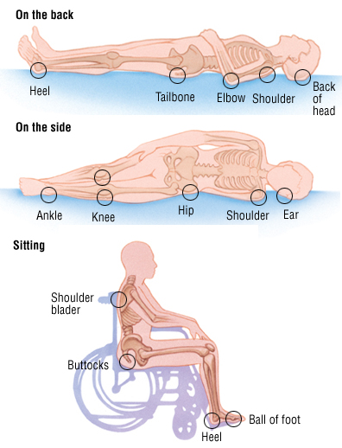
What you can do
- It is important to keep moving as much as possible; this means getting up and walking if able and/or changing your position regularly when in bed. This should be done every 2-4 hours to reduce pressure-related skin damage.
- Make sure you are eating and drinking well. If you are unable to do this for any reason please discuss other nutritional options (such as alternative menus or supplements) with the nursing staff.
- Report any areas of skin that feel sore, itchy or in any way different to the nursing team, so this can be checked and any further action can be taken if needed.
- Moisturise dry skin; if you normally use an emollient or moisturiser please inform the nursing staff so this can be prescribed while in hospital and ask nursing staff to help you to apply it if needed.
Pressure ulcers can range from a red, non-blanching area of skin (category 1), an intact blister or superficial skin loss (category 2), a full thickness wound where subcutaneous fat may be visible (category 3) or a deep full thickness wound where tendon or bone is visible (category 4).
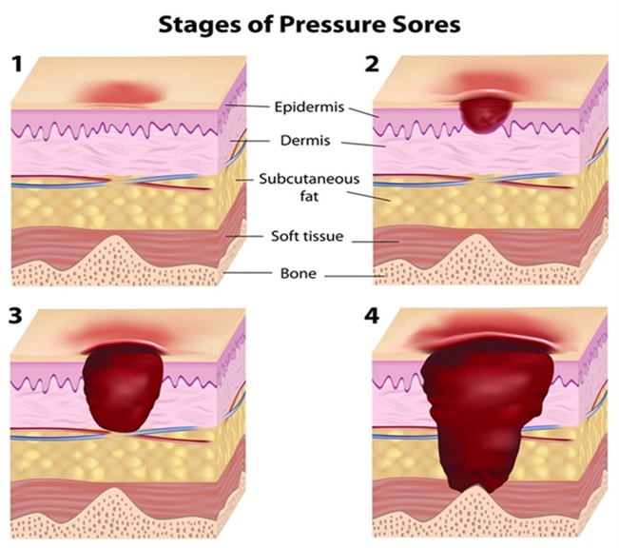
What we will do
Nursing staff will carry out a pressure ulcer risk assessment for every patient. Nursing staff will encourage regular movement and can help with this where needed, for example repositioning in bed.
Nursing staff will inspect your skin each time they help you to move. They do this to check for new marks or areas at risk of breaking down. If you are up and about and moving independently a member of the nursing team will ask if they can inspect your skin at least once during the day to ensure there are no areas of concern. Results of all skin inspections will be carefully documented in your medical records.
Nursing staff will give you pressure relieving equipment to use if you are at risk of developing pressure damage or have confirmed pressure damage. Nursing staff will also involve the dietician team for nutritional support if required. You will be fully informed and involved during this process.
Nurses will also take medical photographs of any wounds for accurate records and monitoring purposes. These will be kept with your medical records.
Nutrition and pressure-relieving equipment
Eating well is important when you are unwell, it can help to prevent pressure ulcers from forming and help with healing wounds. Staff can discuss dietary options with you to ensure you are eating and drinking well. Staff may also provide you with nutritional supplements such as drinks with protein to boost your nutritional intake and refer you to Dieticians to give you further support.
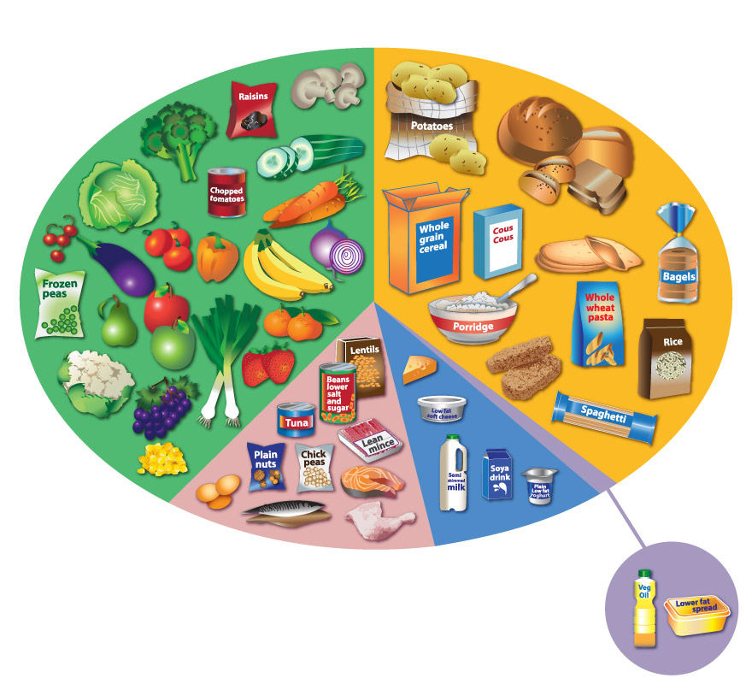
If you have skin damage or are thought to be at high risk of developing pressure ulcers, nursing staff will put in pressure relieving equipment such as an air mattress or orthotic pressure-relieving boots to reduce this risk. It is important to remember that pressure relieving equipment does not eliminate the risk of developing pressure ulcers so it is important to also move around regularly.
Why do they occur?
- Reduced mobility after an operation or being unwell can cause prolonged pressure to an area of skin.
- Friction or shear caused by an object (such as a bed sheet) consistently chafing over an area of skin can cause skin damage.
- Significant weight loss due to illness will reduce muscle and fat tissue causing more bony areas which will increase chances of skin breakdown due to pressure or friction.
- Poor nutrition causes a lack of adequate nutrients to help wounds heal.
- Poor circulation means that blood flow is not adequate and can cause skin to breakdown over a shorter period of time. Poor circulation can be caused by either a medical problem or from not moving around as much due to being unwell or after an operation.
- Reduced sensation means you may not be able to feel pain from pressure and therefore not act to relieve it increasing the risk of skin damage.
- Incontinence or moisture (such as from sweating) can cause skin breakdown and therefore increasing the vulnerability of skin to pressure ulcers.
Author: Amy Hargrave
Role: Tissue Viability Clinical Nurse Specialist
Date written: Oct 2020
Last updated: November 2020
Date for review: November 2023

