Suspected Lower GI Cancer Two Week Wait Referral Form

Please complete all elements of this form, including the completion of a FIT test prior to referral

Referrer Details | Patient Details
Name: | Name: | DOB:
Address: | Address: | Gender:
 |  | Hospital No.:
 |  | NHS No.:
Tel No: | Tel No. (1): | Please check telephone numbers
 | Tel No. (2):
Email: | Carer requirements (has dementia or learning difficulties)? | Capacity concerns?
Decision to Refer Date: | Translator Required: Yes No Language……. | Mobility:

 | Military Service Person |  | Military Veteran |  | Member of Military Family
FIT test prior to referral
As per cancer alliance and ICB endorsement, and in line with new national guidance to GPs, all patients should undertake a FIT test prior to referral on this pathway, unless presenting with anal mass/ulceration OR abdominal/rectal mass OR Iron Deficiency Anaemia (consider TTG/faecal calprotectin in younger patients and menorrhagia in menstruating patients prior to referral on this pathway).
Please await the result of the FIT test before referring, unless agreed via Advice and Guidance with a Consultant via sft.salisburycolorectaladvice@nhs.net

FIT Value ………. μg
Patient has a FIT value of ≥ 10 μg Hb/g faeces; positive FIT

Patient unable to undertake qFIT (pls complete Frailty below and outline reason in Clinical Details section)
If the patient has a negative FIT value of <10μg Hb/g, please do NOT refer the patient via a 2ww pathway unless you have sought advice and guidance from a secondary care clinician, or the patient has progressive or alarming symptoms on subsequent review, which are defined in the clinical details.
Please also consider repeating qFIT at 4-6 week (patients with two negative FIT test results have a colorectal cancer risk of <0.04%)

Clinical details
Please detail your conclusions and what needs to be excluded or attach a referral letter.

Colorectal cancer – PLEASE TICK ALL RELEVANT BOXES

Unexplained weight loss and FIT ≥ 10
Unexplained abdominal pain and FIT ≥ 10
Change in bowel habit and FIT ≥ 10
Overt rectal bleeding and FIT ≥ 10
Non-iron deficiency anaemia and FIT ≥ 10

Iron Deficiency Anaemia
Palpable abdominal mass
Palpable rectal mass on PR

Anal cancer

Unexplained anal mass or unexplained anal ulceration

Information required to book patient into the right type of appointment (which is essential to allow the majority of patients to progress quicker via ‘straight to test’ and reduce patient harm)

- Due to Frailty/Old Age/ Co-morbidity, the patient requires an OPA for assessment before diagnostics?

- Is the patient likely fit for bowel preparation/endoscopy and willing to undergo this type of procedure
Yes No

- Please confirm that the following results are available:
  - Ferritin, FBC, Hb - within last 8 weeks
  - Renal function including eGFR - within the last 8 weeks

- Has the patient had previous bowel cancer or related surgery? Yes No

- Are you aware of the patient having an allergy to iodine/contrast medium (e.g. Gastrograffin, Primovist)? Yes No

- Is the patient diabetic? Yes No

Complete below where not fully detailed/included when form auto-populates re current medications:

- Is the patient on any Anticoagulant or Antiplatelet agents? Yes No

- Is the patient on any ACEi/ARB? Yes No

- Is the patient on any diuretics? Yes No

- Is the patient on any NSAIDs? Yes No

- Is the patient on Lithium? Yes No

Do you consider it safe for the patient to stop all above medications for a period of up to 72 hours? Yes No
If no, please provide further detail below

Smoking status | Height/Weight/BMI if available

PLEASE TICK AS APPROPRIATE- THIS MUST BE COMPLETED AS IT IS ESSENTIAL TO ALLOW THE MAJORITY OF PATIENTS TO PROGRESS QUICKER VIA ‘STRAIGHT TO TEST’
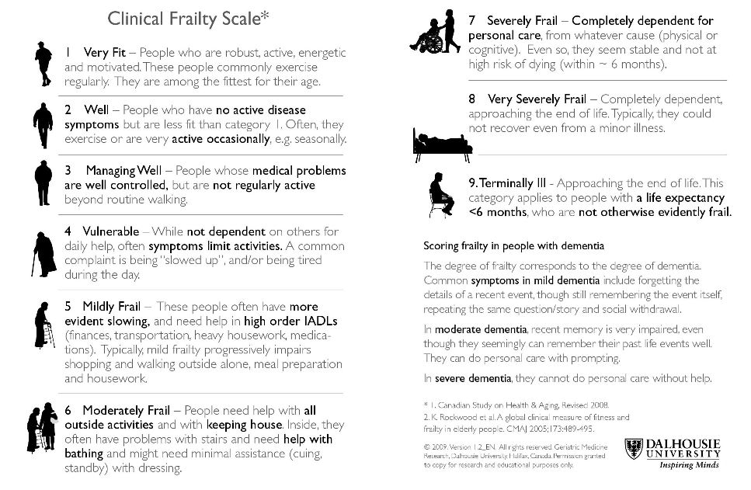

Please confirm that the patient has been made aware that this is a suspected cancer referral: Yes No

Please confirm that the patient has received the two-week wait referral leaflet: Yes No

Please confirm whether the patient has had a previous bowel investigation in the last 2 years: Yes No

If yes, please state what investigation has been performed:
Colonoscopy
Flexi sigmoidoscopy
CT Colonography

Please provide an explanation if the above information has not been given:

If your patient is found to have cancer, do you have any information which might be useful for secondary care regarding their likely reaction to the diagnosis (e.g. a history of depression or anxiety, or a recent bereavement from cancer might be relevant) or their physical, psychological or emotional readiness for further investigation and treatment?

Date(s) that patient is unable to attend within the next two weeks

If patient is not available for the next 2 weeks, and aware of nature of referral, consider seeing patient again to reassess symptoms and refer when able and willing to accept an appointment

Please attach additional clinical issues list from your practice system
Details to include:
Contraindications, current medication, significant issues, allergies, relevant family history, alcohol status and morbidities

Please send via ERS

