4C Mortality Risk Score for Covid-19 Infection https://isaric4c.net/risk
Use online calculator
Co-morbidites
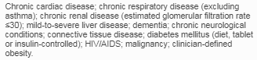
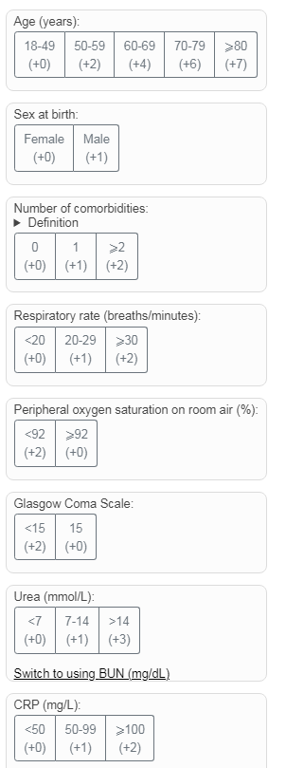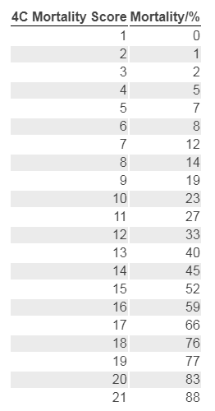
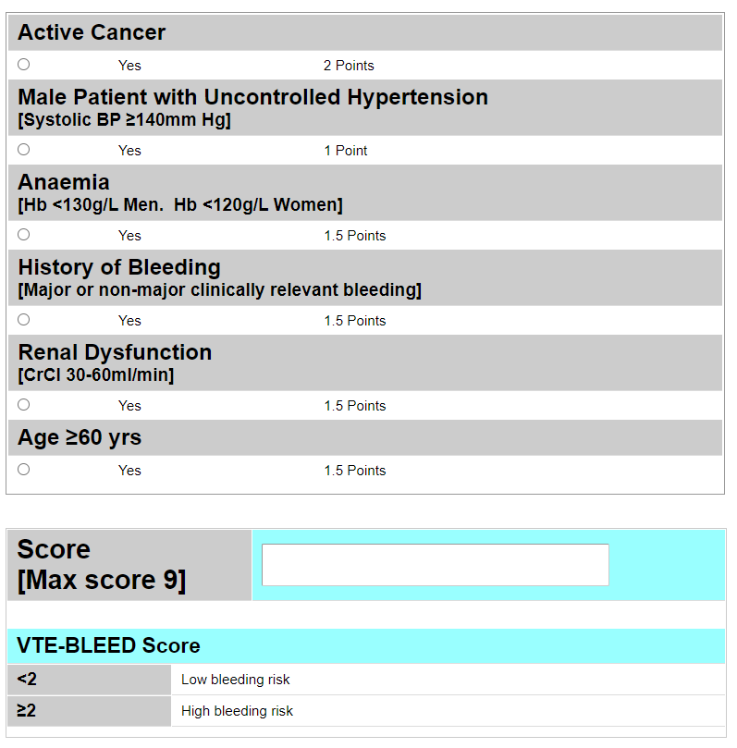

Venothromoembolic Prophylaxis in Covid-19 Infection
If platelets <50 or deranged clotting discuss with Haematology
- Mild ie no O2 requirement- Standard prophylactic dose LMWH
- Moderate/Severe -on O2 but not ventilatory support.
Assess bleeding risk (VTE-BLEED Algorithm -Microguide)
If Low risk of bleeding (<2): Consider Treatment dose LMWH (based on weight)
If High risk of bleeding (≥2): Consider Standard prophylactic dose LMWH
- Severe & on ventilatory support- Intermediate dosing LMWH (5000units bd)
Step up to intermediate dosing LMWH (5000units bd) if previous on standard prophylaxis
Step down to intermediate dosing LMWH (5000units bd) if previous on treatment dose
(unless clinical need for full anticoagulation)

The VTE-BLEED Algorithm (practical-haemostasis.com)
https://viewer.microguide.global/guide/1000000295#content,7f081fd3-6d95-403c-b65c-d5d5eb9f92ee

Disseminated Intravascular Coagulation (DIC) Score
https://www.mdcalc.com/isth-criteria-disseminated-intravascular-coagulation-dic
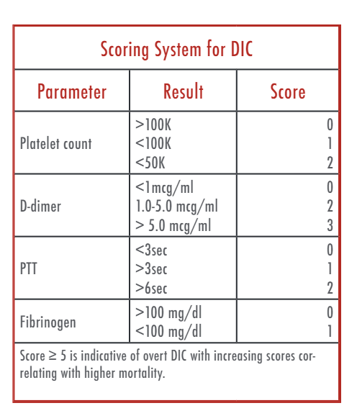
See NICE Covid-9 Rapid guideline: Managing Covid-19 (NG191) June 2021 https://www.nice.org.uk/guidance/ng191
& Microguide for detailed SFT guidance on managing all aspects Covid-19 infection CST/SLE 21st July 2021v15 p2

Covid-19 Pneumonia Management Pathway SFT *
Admission to Respiratory Care Unit (via RAZ/ward transfer)
If Pregnant alert the On call Obstetric Cons/Labour Ward

Clinical Assessment – History/Examination/Risk factors for Covid19/Investigations(bloods/ECG)
CXR – alternative diagnosis likely/ uncertain diagnosis

CXR - Suggestive of CV19 Pneumonia
(ensure Covid-19 PCR swab sent)
*Use in conjunction with Patient Admission & Management Summary (Microguide) & complete for every patient
- Severity assessment-based on clinical review & consider 4C Mortality score https://isaric4c.net/risk ;
Severe: Clinical signs of severe pneumonia; tachypneoa, SpO2 ≤90% air, requiring O2 to keep SpO2≥94%; if ↑O2 requirement / ↓SpO2 then re-consider escalation plan/refer ICU; Moderate: No signs of severe disease, SpO2 90-93% on air; Mild – no O2 requirement; SpO2 ≥94% on air; stable
- Supportive treatment eg IV fluids, aim for euvolaemia/slightly positive fluid balance/mouth care ( Microguide/pt info)
- VTE prophylaxis: Mild - standard VTE prophylaxis; Severe requiring ventilatory support (CPAP/NIV/HFNO/IMV) - intermediate dose prophylaxis; Moderate/severe but not on ventilatory support – consider treatment dose dalteparin > bleeding risk assessment The VTE-BLEED Algorithm (practical-haemostasis.com)
- Consider complications eg cardiac-myositis/ischaemia, heart failure, arrhythmia, delirium
- Consider other investigations at any stage eg CTPA; repeat ECG, ECHO
- Regular bloods – daily if severe, to include DIC score /fibrinogen, ferritin, LDH
- Consider stopping antibiotics for CAP (Microguide) if no evidence of bacterial infection
- ** Escalation plan & CPR status - review daily
- Suitability for clinical trial – discuss with Respiratory Team /Clinical Trials team (Ext. 4447/Bleeps 1169/1121)
- Ensure patient managed in appropriate ward/ICU in isolation bed according to current Covid IPC
- ***See Respiratory Care Unit (RCU) guidelines for further information (Microguide) including ventilatory support
- Be alert for ↑O2 requirement – refer all patients of concern to Respiratory Team (Bleep 1582 weekdays) +/- ICU

Moderate Disease - Consider Remdesivir IV 5 days
if early stage of severe illness (≤10 days), on O2 and not requiring ventilatory support (See Microguide)
See NICE Covid-9 Rapid guideline: Managing Covid-19 (NG191) June 2021 https://www.nice.org.uk/guidance/ng191
& Microguide for detailed SFT guidance on managing all aspects Covid-19 infection CST/SLE 21st July 2021v15 p1

Give Tocilizumab 8mg/kg (max 800mg) IV
if requiring supplemental O2 & CRP ≥75 OR < 48hrs of requiring ventilatory support (See Microguide)
Oxygen +/- CPAP/NIV/HFO2/IMV***
Moderate/Severe Disease
Mild Disease
VTE Prophylaxis
Depends on disease severity, ventilatory support
& bleeding risk assessment (see below/ Microguide)

Supportive treatment,+/- IV fluids, nutrition, physio, standard VTE prophylaxis, +/- Antibiotics for CAP
Do not give Dexamethasone
Be alert for ↑ O2 requirement
Severity assessment* & Escalation plan** including CPR status
Supportive treatment: Awake proning/physio, +/- IV fluids, nutrition,+/- Antibiotics for CAP,CCOT
Give Dexamethasone 6mg IV/PO OD
for 7 to 10 days (or Hydrocortisone 50mg IV QDS)
Consider ICU referral - HFNO/CPAP/IMV; therapy
Consider other investigations e.g CTPA, ECHO

