Lying ‘prone’
What is lying ‘prone’?
This is the term we use to describe lying on your front.
Why have I been asked to lie on my front?
Being on your front can improve ventilation and get more oxygen into the body. Evidence also shows this can open up areas in the lungs that might have some signs of collapse. It can also help you clear any secretions that may be present in your lungs.
If you have a lung condition, the medical team may ask you to lie on your front to help your lungs recover.
For the best results, evidence suggests that prone positioning should be considered early on after the start of acute lung injury.
You will be encouraged to gradually increase the time that you are able to lie in the prone position.

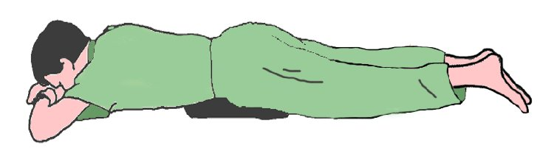
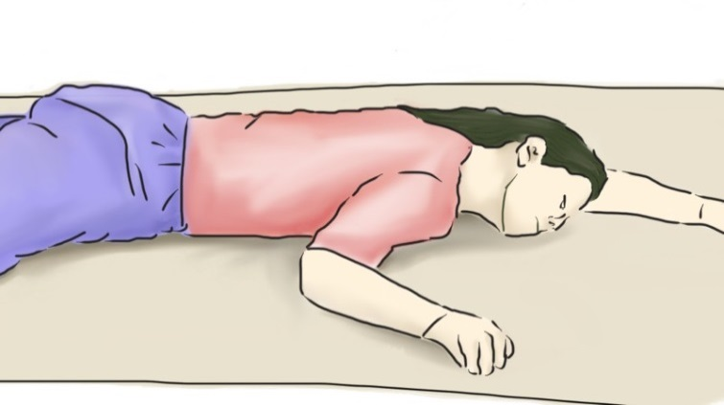

prone
Supine
Lateral

Self-Prone Plan
Time | Date
00:00
01:00
02:00
03:00
04:00
05:00
06:00
07:00
08:00
09:00
10:00
11:00
12:00
13:00
14:00
15:00
16:00
17:00
18:00
19:00
20:00
21:00
22:00
23:00

Timed Position Changes:
If patient fulfils criteria for proning ask the patient to switch positions as follows. Monitor oxygen saturations 15 minutes after each position change to ensure oxygen saturation has not decreased. Continue to monitor oxygen saturations as per the National Early Warning Score (NEWS)
• 30 minutes to 2 hours lying fully prone (bed flat)
• 30 minutes to 2 hours lying on right side (bed flat)
• 30 minutes to 2 hours sitting up (30-60 degrees) by adjusting head of the bed
• 30 minutes to 2 hours lying on left side (bed flat)
• 30 minutes to 2 hours lying prone again
• Continue to repeat the cycle…….

References used in the preparation of Table 1
1. Ding L et al. Critical Care 2020;24(1):28
2. Emergency Department Critical Care (EMCrit). 2016. PulmCrit Wee- Proning the non-intubated patient. Retrieved from
https://emcrit.org/pulmcrit/proning-nonintubated/ [Accessed 10th April, 2020]

