Breathlessness
We hope this information may be helpful if you have Heart Failure and breathlessness has become a normal part of your life. If your breathlessness has become worse recently please contact your Heart Failure team and let them know. Our Contact is 01722 336262 extension 5405.

Why am I breathless?
- This symptom has many causes including Heart Failure, lung conditions, being an unhealthy weight, being unfit or having anxiety. Some people have more than one cause for their breathlessness.
- Some breathlessness is completely normal, after running for a bus for example. When you have Heart Failure you may experience breathlessness regularly. This may worsen over time (chronic breathlessness) so that it may be triggered by minimal exertion such as household chores, walking, or talking.
- It is important to learn how to manage your breathlessness so that you can live the best life possible with it.

What can you do to help?
- Being active is important. Improving your activity levels can improve breathlessness, strength, reduce anxiety and improve your sense of wellbeing. Cardiac Rehabilitation is a supervised activity programme and your Heart Failure team can refer you for this.
- Pace yourself, plan your day. Aim to achieve all your goals for the day in a measured calm way without rushing.
- Eat healthily and manage your weight. If you are underweight your breathing muscles may be weaker. If you are overweight you are more likely to be breathless, carrying weight around your middle can make your breathlessness worse.
- Having your regular flu vaccine and your once only pneumonia vaccine helps protect you from episodes of acute ill health which may make your breathing worse.
- Stop smoking if you are a smoker.
- Be sure to take all of your medications as prescribed. Missing doses or stopping prescribed medications can worsen your heart failure and breathlessness.
- Some people find that standing by an open window or door helps with breathlessness, this sensation of fresh, cool air moving over the nose, lips and side of your face can be replicated by holding a hand held fan 15-20cms from the face for a few minutes and many breathless people find this extremely helpful .

Breathing Control
- When we are breathless, we tend to breathe faster, taking shallow breaths.
- Learning to control how you breathe may help you relax. If you practice when you are not breathless you may be more confident to use theses techniques when you are.
- Sit in a comfortable and supported position.
- Relax your shoulders.
- Place one hand on your upper chest, and one on your tummy
- Breathe in through your nose (you should feel your tummy expand under your hand)
- Breathe out through your mouth (tummy should fall under your hand)
- Continue this slow relaxed breathing, you should feel tension leaving your body as you and your breathing relaxes.
Useful links:
British Heart Foundation – www.bhf.org.uk, Pumping Marvellous – www.pumpingmarvellous.org, Cardiomyopathy Society – www.cardiomyopathy.org NHS Weight www.nhs.uk/live-well/health-weight/start-the-nhs-weight-loss-plan, Smoking cessation www.nhs.uk/live-well/quit-smoking/nhs-stop-smoking-services

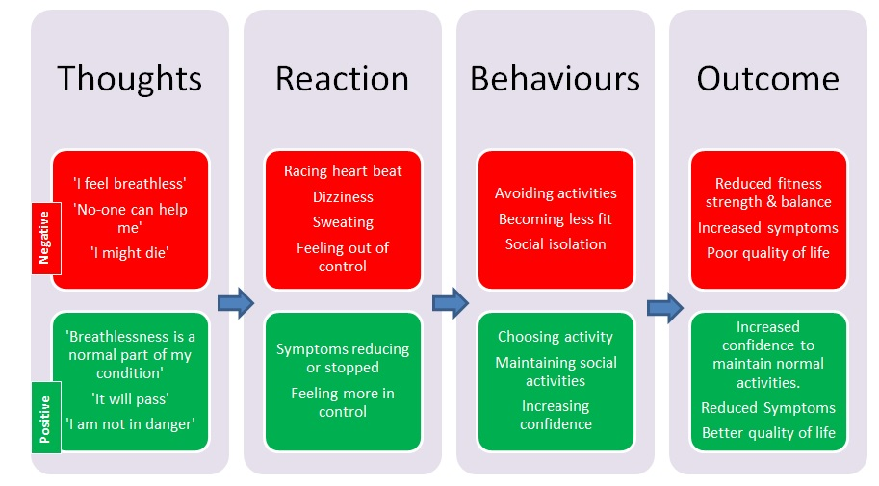
The Chain of Breathlessness

