When you are feeling unwell - Continuous insulin pump users
When you are unwell it is not always easy to know how to manage your diabetes. You are likely to need more insulin during a period of illness so never stop giving your insulin.
To try to simplify things we have developed a flow chart to use when you are unwell that will help you to improve your blood glucose levels quickly. It works by first deciding whether you have ketones (toxin found in the blood or urine when blood glucose levels are high and there’s a lack of insulin ) in the urine or blood, if you are using a blood ketone testing machine, or not, together with the current level of your blood glucose.
We talk about minor and major illness and it is important to remember you may have to swap from one side to the other side of the flow chart during your illness depending on blood glucose and urine/blood ketone levels.
It is important that both you and your carer become familiar with this guidance so you know what to do if your bgls (blood glucose levels) be high.
If you don’t feel you can manage these guidelines then please make contact with us in the Diabetes Nursing Office on 01722 425176.
Important information for pump users
Remember, that if you have high bgls that don’t seem to be coming down with a correction, you must consider that your pump may have failed. You may not be receiving any insulin.
Check the following:
- the pump is in run mode and not suspended
- the rates are correctly set
- last Bolus (shot of insulin given with food or to correct high blood glucose levels) delivered fully
- any alarms are dealt with
- the site for infection, inflammation, leakage. Cannula not leaking or dislodged
- the reservoir is not empty
- insulin looks normal and not out of date
- the set has been primed
- test the infusion set with a bolus
- battery power normal
- carry out a self test.
If the pump is working proceed to the next section on illness management.
If your pump has failed, immediately correct using your pen device with rapid acting insulin as you are no longer receiving any insulin via the pump. Use a cautious corrective dose to begin with.

Next:
- fill a new reservoir
- prime a new set
- insert a new cannula
- give a corrective dose via the pump
- review after 15 minutes.
If bgls do not start to correct you must assume a mechanical failure and contact your diabetes nurse or the pump customer services at the earliest convenience. You will need to go back to injecting your rapid acting insulin and long-acting insulin as you did pre-pump.
Remember:
Always keep pens and cartridges in the house in case of a pump failure.
Check regularly to ensure insulin remains in date.
Illness management
During illness it may be suggested that you use 10 or 20% of your last days total insulin intake every few hours to manage high blood glucose levels and ketones (see flow chart overleaf). The ready-reckoner below makes this easier for you to calculate.
How do I know what my total daily dose is?
On your pump you can look at the total daily dose (TDD) of all the insulin basal and boluses in a 24 hour period for the proceeding days running up to your illness. This is usually in the utilities section. Otherwise you can add up your total Basal (insulin running in the background) insulin for 24 hours along with all the boluses you have had. You may have to take an average over a few days.
Total daily dose | 10% | Total daily dose | 20%
15 | 2 | 15 | 3
20 | 2 | 20 | 4
25 | 3 | 25 | 5
30 | 3 | 30 | 6
35 | 4 | 35 | 7
40 | 4 | 40 | 8
45 | 5 | 45 | 9
50 | 5 | 50 | 10
55 | 6 | 55 | 11
60 | 6 | 60 | 12
65 | 7 | 65 | 13
70 | 7 | 70 | 14

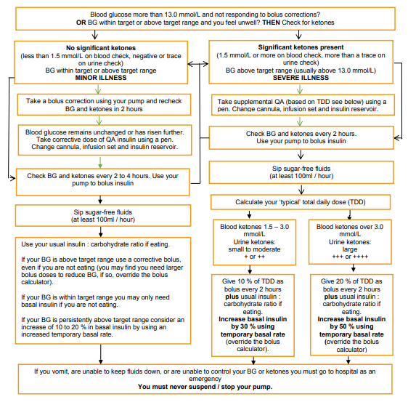

For more information: https://dafne.nhs.uk/wp-content/uploads/2020/03/HG.01-003-v3-Sick-day-rules-Pump.pdf

Author: Greg Smith
Role: Diabetes Specialist Nurse
Date written: July 2009
Last revised: July 2021
Review date: July 2024
Version: 2.4

