What to do when your blood sugars are high - (Type 1 diabetes managed with basal bolus insulin)
When you are unwell it is not always easy to know how to manage your diabetes. You are likely to need more insulin during an illness, so never stop giving yourself insulin.
To try to simplify things we have developed a flow chart to use when you are unwell, that will help you to improve your blood glucose levels quickly. It works by first deciding whether you have ketones in the urine or not, together with the current level of your blood glucose.
We talk about minor and major illnesses. It is important to remember you may have to swap from one side to the other side of the flow chart during your illness, depending on your blood glucose and urine ketone levels.
If you don’t feel you can manage these guidelines then please make contact with us on 01722 425176 in the Diabetes Nursing Office, or your GP practice.
During illness it may be suggested that you use 10% or 20% of your last day’s total insulin intake. An example of how to calculate this is below, together with a ready-reckoner to make things easier for you.
How to calculate your total daily dose – TDD
Add up all yesterday’s quick-acting insulin, that used with meals and to correct, plus all doses of long-acting insulin.
e.g. breakfast 10 units, lunch 12 units, evening meal 14 units plus 30 units at bed-time = 10 + 12 + 14 + 30 = TDD of 66 units
- 10% would be 7 units immediately then every 2 hours
- 20% would be 13 units immediately then every 2 hours
10% and 20% easy ready-reckoners
Total Daily Dose | 10% | Total Daily Dose | 20%
15 | 2 | 15 | 3
20 | 2 | 20 | 4
25 | 3 | 25 | 5
30 | 3 | 30 | 6
35 | 4 | 35 | 7
40 | 4 | 40 | 8
45 | 5 | 45 | 9
50 | 5 | 50 | 10
55 | 6 | 55 | 11
60 | 6 | 60 | 12
65 | 7 | 65 | 13
70 | 7 | 70 | 14

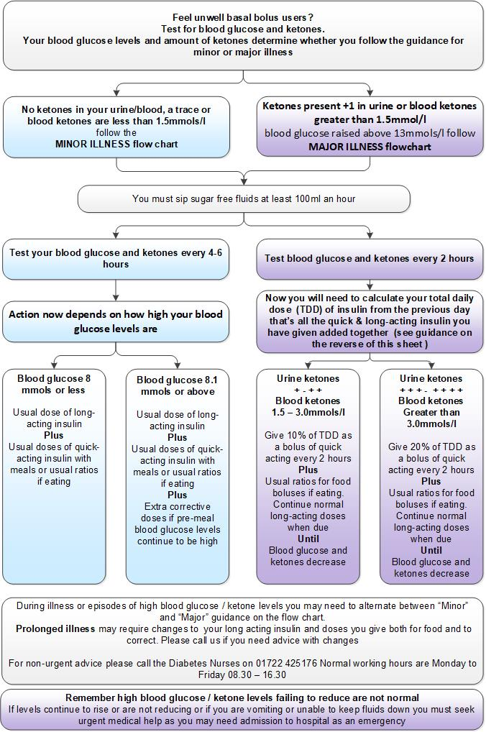
Author: Martin Smith Role: Consultant Endocrinologist
Date written: June 2006 Last revised: June 2021
Review date: June 2024 Version: 3.1

