Advice and Guidance in SFT
Standard Operating Procedure v.8.4 (July 2021)
Table of Contents
- About Advice and Guidance (A&G) 1
- Why is this needed? 2
- What is it? 3
- What should it be used for? 3
- What shouldn’t it be used for? 4
- Expectations 4
  - Primary Care (GP Practice) 4
  - Secondary Care (Specialty Services) 5
  - Patients 5
- What will you need to access A&G? 5
  - Primary Care (GP Practice) 5
  - Secondary Care (Speciality Service) 6
- How does the system work? 7
  - Creating a request 7
  - Reviewing requests and responses to requests 8
  - Responding to requests 9
  - Closing a request 9
- Frequently Asked Questions 6

- About Advice and Guidance (A&G)
Provision of an interactive A&G platform responds to a need from clinicians working in primary and secondary care to be able to manage and treat patients more collaboratively.

Advice and Guidance enables clinicians to seek advice from one another, providing digital communication between two clinicians (usually Primary Care to Secondary Care): the requesting clinician and the provider of a service, the responding clinician. Advice and guidance responses are delivered either by the consultant or by another senior clinician, where the consultant retains responsibility for the service and the advice provided.

A&G via Cinapsis provides a mechanism for clinicians to establish a direct dialogue to agree a treatment plan for patients through a secure online platform. Cinapsis is able to be tailored to each speciality, enabling greater flexibility of pathway design. The reporting facilities provide granular level data, designed to be easily read and interpreted. Cinapsis was developed by secondary care clinicians who used their professional insights to provide a service that is designed with clinicians in mind.

- Why is this needed?
- Responds to a demand that pre-dates COVID-19, from clinicians in the Salisbury area for improved mechanisms to communicate with colleagues in a different setting and by different means
- Positive impact on patient experience of care, for example reducing the number of appointments required to attend
- Reduces unnecessary referrals, freeing up space on waiting lists
- During the COVID-19 pandemic, it became apparent that firmly establishing new and alternative methods of communicating with GP/secondary care colleague was necessary and increased functionality would be required to meet the Trust’s needs

SFT conducted a pilot of a specifically designed A&G system called Consultant Connect. The qualitative and quantitative evidence from that pilot was evaluated and has been used to support the statement above and the procurement and deployment of a suitable solution.

- What is it?
National guidance surrounding the use of A&G can be found here:
NHS England » Advice and Guidance

A&G via Cinapsis is a tool to enable multi-way interaction between clinicians in different settings. Functionality in the system allows for immediate communication by telephone, non-immediate communication by written email and planned call backs. These can be designed per speciality depending on requirements and capacity. Sharing of images and documents is simple and voice conversations are recorded as an MP4 file stored securely in the cloud which can be easily accessed by the clinician at any time (both within Primary and Secondary care).

A&G represents a modern way of sharing patient information, providing a secure forum to collaboratively manage patients more effectively.
- Synchronous
  - Direct call
- Asynchronous
  - Call back
  - Written format – e-Opinion

Throughout an A&G ‘request’, responsibility for managing the patient will lie with the Primary Care clinician until/if care is transferred by a referral which is accepted by the specialist service in secondary care.

The process is as below:
- What should it be used for?
Cinapsis should be used in the following scenarios:
- GPs will use asynchronous A&G (where available) for non-urgent or semi-urgent queries
- GPs will use synchronous for more urgent A&G queries
- GPs to request guidance if unsure what test is appropriate
- GPs to request review of results of a test completed in primary care and query a proposed course of action
- GP to query the most appropriate clinic for referral and to check what information might be required
- GP to query a proposed course of treatment, e.g. change in medication

Some examples:

Respiratory
- Query in relation to a new or abnormal CXR finding
- Query in relation to concern over discontinuation of certain therapies (like step down in COPD treatment)
- To confirm which clinic a patient should be referred to
- Patient has had full investigations with no identifiable pathology to explain symptoms and wants further investigation – what would you recommend?

Cardiology
- Query in relation to medication changes to manage cardiovascular disease
- To confirm which clinic a patient to be referred to e.g. rapid access chest pain
- Hypertension – if high blood pressure is identified, whether other diagnostics could be performed to help manage, e.g. ambulatory monitoring to help make a decision on referral

- What should it not be used for
- As a mechanism to circumvent standard wait times for patients to access specialist diagnosis and treatment
- If cancer is suspected and an urgent 2WW referral would be more appropriate
- To answer generic questions about a condition / clinic – A&G requests must relate directly to a specific patient
- To challenge the allocation of follow up actions or recommendations following a transfer of care from secondary care back to primary care (e.g. follow up actions in a discharge summary)

- Expectations (to be reviewed annually)
Primary Care (GP Practice)
- Asynchronous methods of requesting A&G is for non-urgent or semi-urgent A&G
- Synchronous methods of requesting A&G is for more urgent A&G
- GPs must assume Secondary care will not have access to any patient records and so advice will be based solely on the information provided in the request
- For exceptional cases, GPs may request advice from a specific consultant via the asynchronous request methods if available and agreed with the Speciality
- The A&G report will be automatically added to the patient record
- A notification will alert the GP when a report has been received:
  - If logged into the Cinapsis desktop app when in the clinical system (SystmOne), an alert will be generated in the form of a task
  - If logged into the mobile app, a notification will come through titled Case Summary Received and the name of the Specialist who completed case ID xxxx
  - On any device, a badge number will show on the inbox in Cinapsis when a new report is sent back

Secondary Care (Specialist service)
- Secondary care will endeavour to answer all synchronous A&G requests but there may be instances when this is not achievable due to clinical or operational circumstances
- Secondary care must record an outcome at the end of all A&G requests, which can be completed by voice recognition
- The A&G platforms and methods available will be clearly publicised and shared with Primary Care to support accessibility
- A record of the request and subsequent reply will be made available as a digital letter to be uploaded to the PAS. This will be emailed to a shared speciality secure nhs.net email account for admin staff to access and act on. A copy of this letter is not routinely retained by secondary care but can be retrieved from Cinapsis should it be needed or should specialty teams wish to upload it onto the PAS
- There will be an expectation that all appropriate specialties will provide asynchronous A&G (e.g. non-urgent queries, non-admitting specialties)
- Job planning should be utilised to support clinicians in the implementation and embedding of A&G into their services. Collaboration across BSW should be considered to support resilience where needed

Patients
- When a GP requests a specialist opinion, this may result in advice to the GP to manage your condition within the community, request some community or hospital tests, or the need for a formal referral with the aim of a virtual or face to face appointment with the hospital specialist

- What will you need to access A&G for SFT
Primary Care (GP Practice)
Your Practice will need to have access to Cinapsis. This is a downloadable App and can be used on desktop, laptop or mobile device. The App can be integrated into SystmOne TPP and EMIS.

Practices will need to establish a robust and reliable system to ensure that all responses to requests for advice and guidance are reviewed within three working days of submission. If you do not receive a response within this time frame, GPs are advised to consider whether the request should be converted to a full referral. You are responsible for closing all requests and therefore will need to regularly monitor and action responses from secondary care colleagues.

Depending on your practice, requests and responses may be reviewed by individual GPs or by whole practice / admin teams. This may require time to be job planned.

Secondary Care (Speciality service)
Specialties will need to have access to Cinapsis. This is a downloadable App and can be used on desktop, laptop or mobile device.

Specialties will need to establish a robust and reliable system to ensure that all requests received in to your service via A&G can be routinely and regularly checked by nominated clinicians. Written (asynchronous) requests need to be reviewed and responded to within three working days by a clinician. This may require dedicated time to be job planned and should be discussed and agreed before the launch of the Cinapsis service within the specialty. If a response is not provided within three working days, GPs will be advised to convert requests into a referral where appropriate.

A step by step process for new members joining a team already using Cinapsis is below:
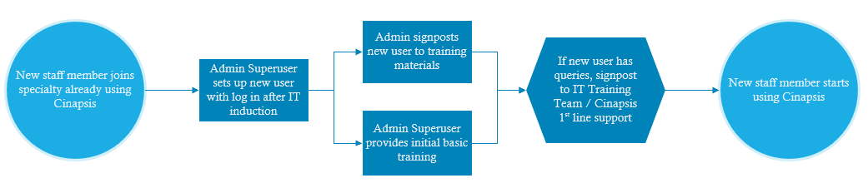
- How does the system work?
User Training in Primary Care
- It is expected that the individual Practice will organise this via the CCG and Cinapsis
User Training in Secondary Care
- For new specialties joining the Cinapsis A&G system, training will be provided by Cinapsis
- For new starters within a team already set up and using Cinapsis, the nominated admin super-user will be able to add the new user, provide basic training and direct towards training materials
- Training materials will be available in power point presentations, instructional video and system demonstration videos
- Further questions or troubleshooting can be directed to the first line support via SFT IT Training Team or the Cinapsis Support Line

If required, 1:1 virtual or face to face training using Cinpasis to manage and deliver A&G can be made available to primary and secondary care staff. This training will be designed to enable key individuals to demonstrate the use of the system within their local settings, supporting clinicians to access and use A&G via Cinapsis.

For new users within Specialities already using Cinapsis, it is expected that Admin leaders or Super-users will set up and train as required.

Creating a request (GP Practice)
The Cinapsis App is downloadable to mobile devices, and available on desktops. It integrates with TPP SystemOne and EMIS and it will appear as an App icon.

There are two ways to submit a request
- Via a desktop with the PAS system open
- Via a mobile device

Process 1 is as follows:
- Have your intended patient record open
- Click the app icon
- Select ‘Create a New Case’
- Confirm patient details
- Choose your Service
- Choose your pathway
- Choose your contact method – these are tailored per speciality
  - Direct call – conversations are recorded and stored as MP4 files
  - Request call back at pre-determined specialty agreed times
  - Send written request
- Enter the clinical details
- Add documents or pictures as required – there is no limit to file size
- Submit request
  - The request is then automatically filed in the patient record

Process 2 is as follows:
- Click the app icon
- Enter the NHS number
- Confirm correct details
- Select ‘Create a New Case’
- Confirm the patient details
- Choose your Service
- Choose your pathway
- Choose your contact method – these are tailored per speciality
  - Direct call – conversations are recorded and stored as MP4 files
  - Request call back at pre-determined specialty agreed times
  - Send written request
- Enter clinical details
- Add documents or pictures as required – there is no limit to file size
  - These can be taken directly from your phone and are never stored on your device or personal cloud storage
- Submit request

Reviewing the response (GP Practice)
- A notification will be generated indicating when a response has been received – this will appear as a task within SystmOne, a standard notification on a mobile device, and a badge on the inbox within Cinapsis
- The response from Secondary care will be automatically available in the patient’s record
- The response from Secondary care will be automatically available in the patient’s record
- It will be in PDF format and will show the initial request together with the reply
- The clinical outcome will be visible

Responding to e-Opinion (written) requests
- All A&G requests will appear on a work list in a shared secure inbox within the Cinapsis application
- Select ‘Start’ to begin work on a request
- The request will appear in a consistent format with the A&G (clinical) information on the left hand side of the page and the response sections on the right hand side (as below)
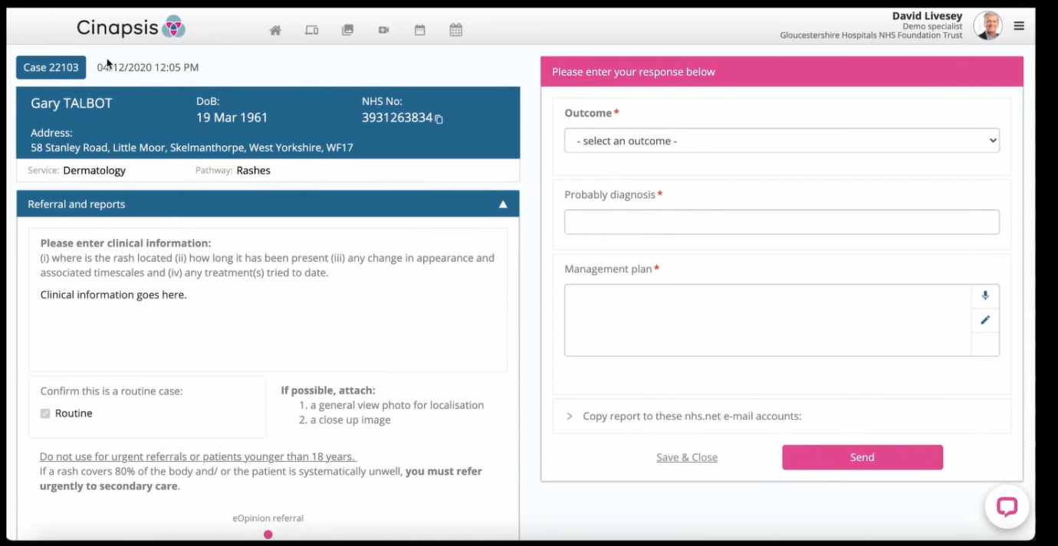
  - If files are attached, the system will not allow you to complete the A&G request without opening the files

- Select the desired outcome
- Select probable diagnosis
- Enter management plan
- Choose to copy the report to nhs.net accounts (if applicable)
- Send the reply back to the GP
  - If you long-hold the send button, you will be able to view a preview of the report
  - You will have 30 seconds to recall the report should you wish to edit it
  - You can add an addendum after the 30 second period

Closing a request
- A request is closed once the outcome field is completed – this is a required field

- Frequently asked questions
When can I expect a response?
The agreed response window for all requests is a maximum of three working days (excluding Bank Holidays). Response times will be monitored to ensure this is maintained and to identify and address any issues. If you are a GP and do not receive a response within three working days, you should consider whether this request should be converted into a referral and will need a robust system to monitor and action requests.

When does the Refer to Treat (RTT) week clock start?
If the requesting clinician is seeking advice prior to or instead of referring a patient, this will not ‘start’ the clock. The RTT clock start date is the date the provider receives notice of a referral, not a request for advice. For e-RS referrals, this is the earliest date that a patient converts (books) their Unique Booking Reference Number or enters the ‘Defer to Provider’ (appointment slot issue) process.

Does Advice & Guidance attract a tariff payment?
A tariff is awarded to every instance of A&G given by Secondary Care. The SFT Finance Team monitor and collate all instances of A&G via Cinapsis. Any instances of A&G that occur outside of Cinapsis should be recorded within Departments and sent to Finance.

