4C Mortality Risk Score for Covid-19 Infection https://isaric4c.net/risk
Use online calculator
Co-morbidites
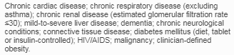
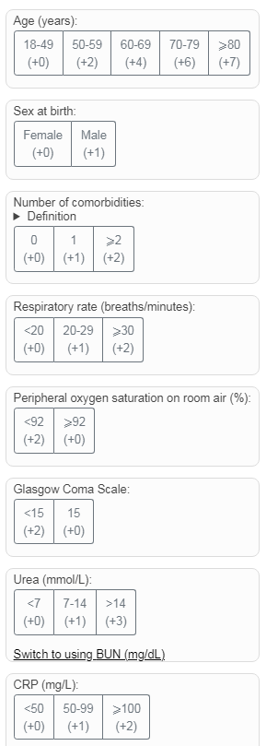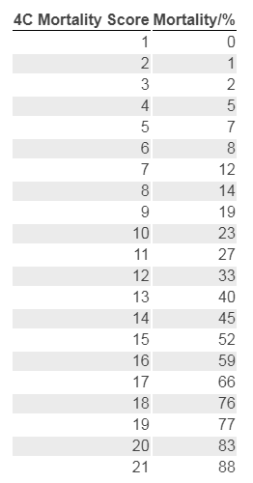
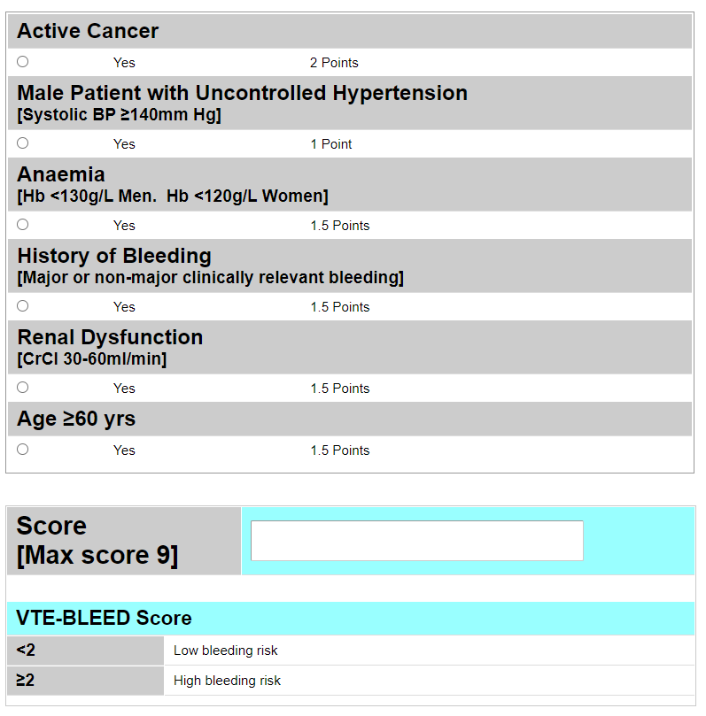
The VTE-BLEED Algorithm (practical-haemostasis.com)
https://viewer.microguide.global/guide/1000000295#content,7f081fd3-6d95-403c-b65c-d5d5eb9f92ee

Venothromoembolic Prophylaxis in Covid-19 Infection
If platelets <50 or deranged clotting discuss with Haematology
- Mild ie no O2 requirement- Consider Standard prophylactic dose LMWH
- Moderate/Severe -on O2 but not ventilatory support.
Assess bleeding risk (VTE-BLEED Algorithm -Microguide)
If Low risk of bleeding (<2): Consider Treatment dose LMWH (weight based)
If High risk of bleeding (≥2): Consider Standard prophylactic dose LMWH
- Severe & on ventilatory support- Consider Intermediate dosing LMWH (5000units bd)
Consider step up to intermediate dosing LMWH (based on weight) if previous on standard prophylaxis
Consider step down to intermediate dosing LMWH (based on weight) if previous on treatment dose
(unless clinical need for full anticoagulation)

Non-Omicron (DELTA) Infection only - IV neutralising Monoclonal Antibodies
(see Patient Admission & Management Summary & separate guidance Microguide)
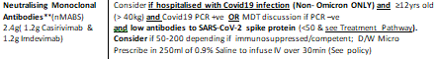
¥ ¥ Spike Covid Antibody interpretation (Non-Omicron/Delta variant only)
If Immunocompetent or Immunosuppressed
>200 Positive – not for nMABS
<50 Negative – strongly consider giving nMABS
50 – 200 Intermediate, discuss with Consultant/Micro, especially if immunosuppressed

UK Clinical Commissioning Policy on Use of nMonoclonal Antibodies in the management of Covid19

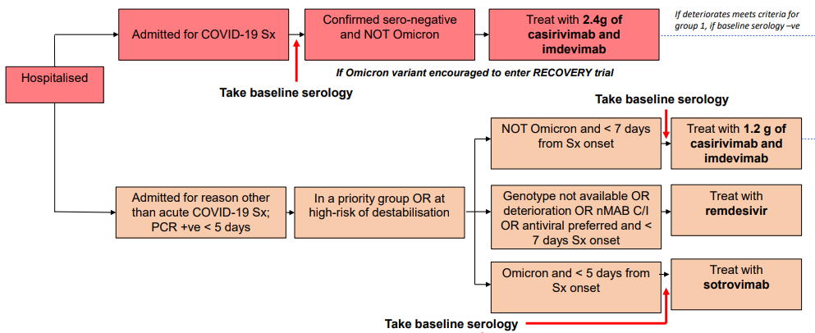
See NICE Covid-9 Rapid guideline: Managing Covid-19 (NG191) 16th Dec 2021 https://www.nice.org.uk/guidance/ng191; UK Clinical Commissioning Policy for NMABS 24th Dec 2021 & Microguide for detailed SFT guidance on managing all aspects Covid-19 infection CST/SLE 24th Jan 2022 v28 p2

Covid-19 Pneumonia Management Pathway SFT *
Admission to Respiratory Care Unit (via RAZ/ward transfer)
If Pregnant alert the On call Obstetric Consultant/Labour Ward immediately

CXR – alternative diagnosis likely / unclear

Clinical Assessment – History/Examination/Risk factors for Covid19/Investigations (bloods/ECG)
Mild Disease or Incidental PCR +ve**
Be arter for increasing O2 reuirement
Do not give Dexamethasone; be alert for ↓SpO2
¥¥ Consider IV nMonoclonal Antibodies
OR Remdesivir (3 days) even if well

CXR - Suggestive of CV19 Pneumonia
(ensure Covid-19 PCR swab sent, urgent TYPING)
Moderate Disease - Consider Remdesivir IV 5 days
if early stage of severe illness (≤10 days), on O2 and not requiring ventilatory support (See Microguide)
VTE Prophylaxis
Depends on disease severity, ventilatory support
& bleeding risk assessment (see below/ Microguide)

Supportive treatment,+/- IV fluids, nutrition, physio, standard VTE prophylaxis, +/- Antibiotics for CAP
¥¥ Send urgent blood for SARS-CoV-2 Spike Antibodies

Consider Tocilizumab 8mg/kg (max 800mg) IV
(or Sarilumab 400mg IV, platelets > 150) ***
if requiring supplemental O2 & CRP ≥75 OR < 48hrs of requiring ventilatory support
Use with Patient Admission & Management Summary, complete for every patient, can give all drugs if criteria met(Microguide)
- *Severity assessment-based on clinical review & consider 4C Mortality score https://isaric4c.net/risk ;
Severe: Clinical signs of severe pneumonia; tachypneoa, SpO2 ≤90% air, requiring O2 to keep SpO2≥94%; if ↑O2 requirement / ↓SpO2 then re-consider escalation plan/refer ICU; Moderate: No signs of severe disease, SpO2 90-93% on air; Mild – no O2 requirement; SpO2 ≥94% on air; stable; Consider prophylactic nMABS/Remdesivir (see over)
- Supportive treatment eg IV fluids, aim for euvolaemia/slightly positive fluid balance/mouthcare ( Microguide/pt info)
- VTE prophylaxis: Consider Mild - standard VTE prophylaxis; if Severe requiring ventilatory support (CPAP/NIV/HFNO/IMV) - intermediate dose prophylaxis; Moderate/severe but not on ventilatory support – consider treatment dose dalteparin > bleeding risk assessment The VTE-BLEED Algorithm (practical-haemostasis.com)
- Consider complications eg cardiac-myositis/ischaemia, heart failure, arrhythmia, delirium, diarrhoea, dizziness
- Consider other investigations at any stage eg CTPA; repeat ECG, ECHO
- Regular bloods – daily if severe, to include DIC score /fibrinogen, ferritin, LDH
- Consider stopping antibiotics for CAP (Microguide) if no evidence of bacterial infection
- ¥¥ Send Urgent SARS-CoV-2 Spike Antibodies in all cases, result only required for Delta variant(see over)
- ** Escalation plan & CPR status - review daily; Be alert for ↓SpO2 in Mild/Incidental infection
- Suitability for clinical trial – discuss with Respiratory Team /Clinical Trials team (Ext. 4447/Bleeps 1169/1121)
- Ensure patient managed in appropriate ward/ICU in isolation bed according to current Covid IPC
- ***See Respiratory Care Unit (RCU) guidelines for further information (Microguide) including ventilatory support
- Be alert for ↑O2 requirement – refer all patients of concern to Respiratory Team (Bleep 1582 weekdays) +/- ICU

¥¥ DELTA variant only –
Consider IV nMonoclonal Antibodies
2.4g (1.2g Casirivimab & 1.2g Imdevimab)
if PCR +ve) , low antibodies to SARS-CoV-2 spike protein
and ≥ 12yrs
See NICE Covid-9 Rapid guideline: Managing Covid-19 (NG191) 16th Dec 2021 https://www.nice.org.uk/guidance/ng191;
& Microguide for detailed SFT guidance on managing all aspects Covid-19 infection CST/SLE 24th Jan 2022 v 28p1

Consider ICU referral CPAP/HFNO/IMV
Give Dexamethasone 6mg IV/PO OD
for 7 to 10 days (or Hydrocortisone 50mg IV QDS)
Severity assessment* & Escalation plan** including CPR status
Consider other investigations e.g CTPA, ECHO

Moderate/Severe Disease
Supportive treatment: Awake proning/physio, +/- IV fluids, nutrition,+/- Antibiotics for CAP; CCOT
¥¥ Send urgent blood for SARS-CoV-2 Spike Antibodies
Oxygen +/- CPAP/NIV/HFO2/IMV***

